LOGGUARD AI
Intelligent Log Analysis and Anomaly Detection System

Presented by
Kodali Suchitra Kamala

Abstract
With the rapid growth of cloud applications and microservices, system logs have become one of the most critical sources for debugging, security monitoring, and performance analysis. However, traditional log monitoring relies on manual inspection or static rule-based alerts, which are inefficient and prone to missing complex patterns. LogGuard AI is an intelligent log analysis platform that leverages Artificial Intelligence and Machine Learning to automatically process, classify, and analyse large volumes of log data in real-time. The system ingests logs from multiple sources, performs preprocessing and feature extraction, and applies anomaly detection algorithms to identify errors, security threats, and performance bottlenecks. Unlike conventional tools, LogGuard AI provides contextual alerts, root-cause analysis, and natural language summaries, enabling developers and DevOps teams to respond faster to incidents. The proposed system aims to reduce Mean Time To Detect and Mean Time To Resolve issues while minimizing false positives. Key features include real-time log ingestion, anomaly detection, threat classification, dashboard visualization, and automated alerting. LogGuard AI can be deployed in cloud and on-premise environments, making it suitable for enterprises, startups, and IT operations teams.
Introduction
In today’s digital world, every application, server, and cloud service generates massive amounts of log data every second. These logs contain valuable information about system health, user activity, errors, and security events. Traditionally, developers and DevOps teams manually scan these logs or use rule-based monitoring tools to detect issues. But with millions of log entries generated daily, it has become nearly impossible to find real problems in time. Important warnings get buried, security attacks go unnoticed, and debugging takes hours. This is where LogGuard AI comes in. LogGuard AI is an intelligent log monitoring and anomaly detection system that uses Artificial Intelligence and Machine Learning to automatically analyse logs in real-time. Instead of forcing humans to read through endless text files, LogGuard AI understands patterns, detects abnormal behavior, and converts complex log data into simple, actionable insights. The goal of LogGuard AI is to help organizations reduce downtime, prevent security breaches, and speed up troubleshooting. It provides real-time alerts, root-cause analysis, and easy-to-read dashboards so teams can focus on fixing problems instead of searching for them. In short, LogGuard AI acts as a 24/7 AI assistant for your servers - watching logs, finding issues, and telling you exactly what needs attention.
Overview
LogGuard AI is an AI-powered log monitoring and anomaly detection system built to help organizations automatically track, analyse, and respond to system logs. In today’s cloud-driven environment, applications and servers generate millions of log entries daily from web servers, databases, APIs, and cloud platforms. Manually reviewing these logs is time-consuming and often leads to missed errors and security threats. LogGuard AI solves this by collecting logs from multiple sources, processing them using Machine Learning and NLP, and identifying abnormal patterns such as failed logins, system crashes, high resource usage, and potential cyber attacks. The system works in a pipeline: Raw Logs → Data Collection → AI Processing → Anomaly Detection → Alerts + Dashboard. Key features include real-time monitoring, intelligent anomaly detection, smart alerts to reduce noise, natural language summaries, interactive dashboards, and root-cause analysis. LogGuard AI can be used by DevOps teams for performance monitoring, by cybersecurity teams for threat detection, by cloud teams for cost and error tracking, and by product teams for tracking application failures. The main benefits are faster incident response, reduced manual effort, improved security, and prevention of downtime and data loss. For implementation, the system can use HTML, CSS, JavaScript/React for the frontend dashboard, Node.js or Python Flask for the backend, MongoDB or Elasticsearch for log storage, and can be deployed on AWS, Azure, or GCP. In short, LogGuard AI acts as an intelligent "Google Analytics + Security Guard + Debugger" for server logs.
Features
Key features developed or worked on today include:
- Real-time Log Monitoring: Continuously collects and processes logs from servers, applications, and cloud services as they are generated.
- AI-Powered Anomaly Detection: Uses Machine Learning models to detect unusual patterns like crashes, high CPU usage, and suspicious login attempts instead of just keyword matching.
- Smart & Contextual Alerts: Sends alerts only for genuine issues to reduce false positives and alert fatigue.
- Natural Language Summaries: Converts complex technical log data into simple, human-readable reports and insights.
- Interactive Dashboard & Visualization: Provides charts, graphs, and dashboards to visualize trends, errors, and system health at a glance.
- Root Cause Analysis: Identifies the source and reason behind an issue to help teams debug faster.
- Multi-Source Log Ingestion: Supports logs from Web Servers, Databases, APIs, AWS, Azure, GCP, and other cloud platforms.
- Threat & Security Detection: Detects brute-force attacks, unauthorized access attempts, and potential data leaks in real-time.
- Performance Monitoring: Tracks bottlenecks, slow APIs, memory leaks, and application errors to improve system performance.
- Scalable & Cloud Ready: Can be deployed on-premise or on cloud platforms like AWS, Azure, and GCP for enterprise use.
Advantages
The recent work on the project contributes to several key advantages:
- Faster Incident Response: Detects and alerts issues in real-time, reducing Mean Time To Detect and Mean Time To Resolve problems.
- Reduced Manual Effort: Eliminates the need to manually search through millions of log lines. AI does the analysis automatically.
- Improved Security: Identifies cyber threats like brute-force attacks, unauthorized access, and data leaks that rule-based systems often miss.
- Fewer False Alerts: Uses ML to understand normal behavior, so it only alerts for real problems and reduces alert fatigue.
- Better Debugging & Root Cause Analysis: Quickly pinpoints the source of errors and provides context, helping developers fix bugs faster.
- Cost Savings: Prevents downtime, data loss, and performance issues, which saves money for the organization.
- Scalable for Big Data: Can handle millions of log entries from multiple servers, apps, and cloud platforms without performance issues.
- Easy to Understand Reports: Converts technical logs into plain English summaries and visual dashboards for both technical and non-technical teams.
- 24/7 Monitoring: Works continuously without human supervision, ensuring issues are caught even outside business hours.
- Cloud & On-Premise Flexibility: Can be deployed on AWS, Azure, GCP, or on local servers based on company requirements.
Motivation
In today’s fast-paced digital world, businesses rely heavily on web applications, cloud services, and servers to run their operations. These systems generate massive amounts of log data every minute, which contains crucial information about performance, errors, and security events. However, manually analyzing these logs is time-consuming, error-prone, and often leads to delayed responses. By the time a critical issue is found, it may have already caused downtime, data loss, or a security breach. The motivation behind LogGuard AI is to solve this exact problem by using Artificial Intelligence to automate log monitoring and anomaly detection. Instead of forcing DevOps and security teams to sift through endless log files, LogGuard AI can understand patterns, detect unusual activity, and provide actionable insights in real-time. The goal is to reduce human effort, improve system reliability, enhance cybersecurity, and help organizations respond to issues before they impact users. With the growing need for faster, smarter, and more scalable monitoring solutions, LogGuard AI aims to act as an intelligent assistant that ensures systems stay healthy, secure, and efficient 24/7.


22 July 2026  Day 1 | Today's Activities  - Setup  - Open Notepad/VS Code  - Create file: logguard.html  - Confirm: Header + 3 Cards + Upload box + Table | Tomorrow's Plans  - Add file input: Replace the “Select File” button to actually open file picker using <input type= “file”>  - Show upload loader/spinner: When file is selected, show a loading animation for 2-3 seconds to simulate processing  - Parse file name: Display the selected file name inside the upload box after “upload”  - Add fake log entries from file: After loader, insert 3-5 new rows into the log table with random ERROR/WARN/INFO from the “uploaded” file  - Update stats after upload: Increase errorCount based on how many ERRORs were added in new rows
Outputs and Descriptions
Output: Dark-themed LOGGUARD AI dashboard displaying system stats, log file upload option, and recent error logs with timestamps and severity levels.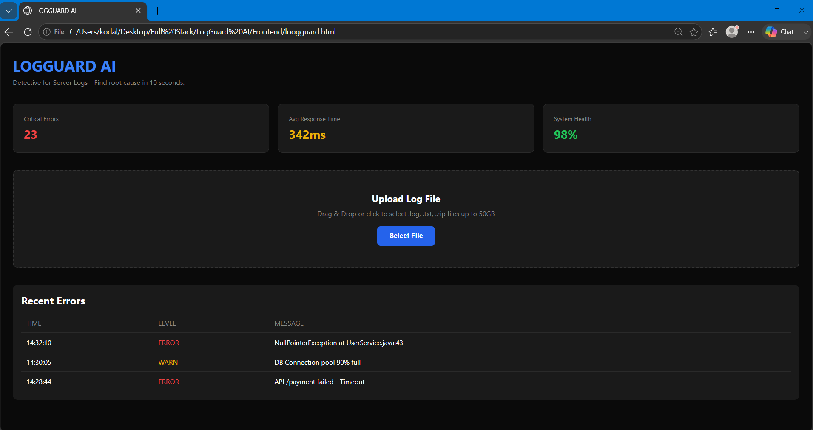
Description: LOGGUARD AI is a dark-themed log analyser dashboard built using only HTML and CSS in a single file. It has a clean header with the title “LOGGUARD AI” in blue and a tagline that says it helps find the root cause of server issues in 10 seconds. Below that are 3 stat cards placed side by side using CSS grid – showing Critical Errors in red, Average Response Time in yellow, and System Health in green. The middle section has an upload box. With a dashed border and a blue “Select File” button that gets darker when you hover over it. At the bottom there’s a table showing recent log entries with color-coded levels like ERROR and WARN. The whole design uses a black and dark gray background with blue accents to look like a professional DevOps tool. Today job is to personalize it by changing the numbers, adding your name to the table.

23 July 2026  Day 2 | Today's Activities  - Add file input: Replace the “Select File” button to actually open file picker using <input type= “file”>  - Show upload loader/spinner: When file is selected, show a loading animation for 2-3 seconds to simulate processing  - Parse file name: Display the selected file name inside the upload box after “upload”  - Add fake log entries from file: After loader, insert 3-5 new rows into the log table with random ERROR/WARN/INFO from the “uploaded” file  - Update stats after upload: Increase errorCount based on how many ERRORs were added in new rows | Tomorrow's Plans  - Add Hidden File Input + onchange: Replace alert button with <input type= “file”>. Use onchange= “handleFileUpload(event)” to detect file selection.  - Build Loader: Add a <div id= “loader”>Processing… </div> that shows when upload starts and hides when done.  - Simulate Processing: Use setTimeout (2000) to fake 2s processing. Then auto-add 3 new log rows and bump the “Critical Errors” stat
Outputs and Descriptions
Output: Browser alert popup displaying "File Upload Coming Soon!" with an OK button.
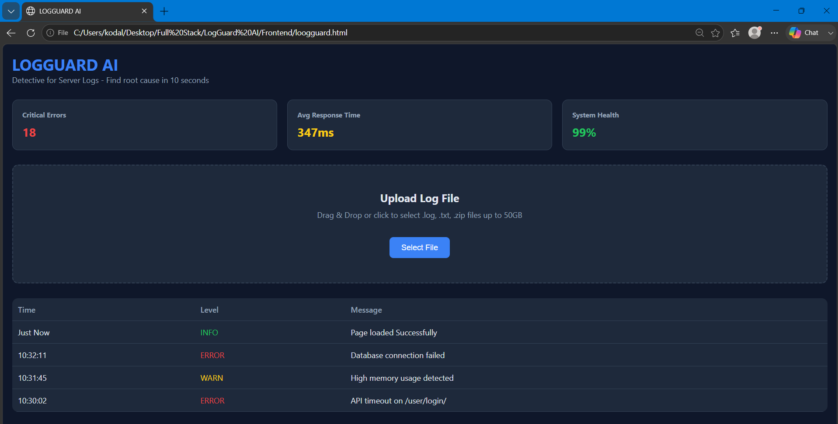
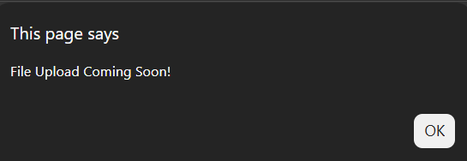
Description: The dashboard now has a clean dark theme with the title “LOGGUARD AI” and the tagline “Detective for Server Logs – Find root cause in 10 seconds”. At the top, there are 3 dynamic stat cards showing Critical Errors: 18, Avg Response Time: 347ms, and System Health: 99%. These values change randomly on every page refresh to simulate real-time monitoring.
Below that, the “Upload Log File” section is ready with drag & drop text and a working “Select File” button that currently triggers a “File Upload Coming Soon!” alert.
The main part is the log table which displays recent server events with columns for Time, Level, and Message. It already shows 4 entries, including the new auto-added row “Just Now | INFO | Page loaded Successfully” in green. The other rows show color-coded levels: red for ERROR like “Database connection failed” and “API timeout on /user/login/”. And yellow for WARN like “High memory usage detected”.
Overall, the UI looks professional, and all JavaScript features are working: button interaction, dynamic stats, and auto log entry on load.
24 July 2026  Day 3 | Today's Activities  - Add Hidden File Input + onchange: Replace alert button with <input type= “file”>. Use onchange= “handleFileUpload(event)” to detect file selection.  - Build Loader: Add a <div id= “loader”>Processing… </div> that shows when upload starts and hides when done.  - Simulate Processing: Use setTimeout (2000) to fake 2s processing. Then auto-add 3 new log rows and bump the “Critical Errors” stat. | Tomorrow's Plans  - Filter Dropdown: Add a dropdown above the table: ALL/ ERROR/WARN/INFO. When you select “ERROR”, only error rows show. Same for WARN and INFO. Uses: onchange + loop through table rows  - Search Box: Add a search input to search log messages. Type “database” → only rows with “database” stay visible. Uses: oninput + includes()
Outputs and Descriptions
Output: LOGGUARD AI dashboard showing 39 critical errors, 390ms avg response, 96% system health, log file upload section, and a table with new file upload logs for `note.txt` plus previous ERROR/WARN/INFO entries.
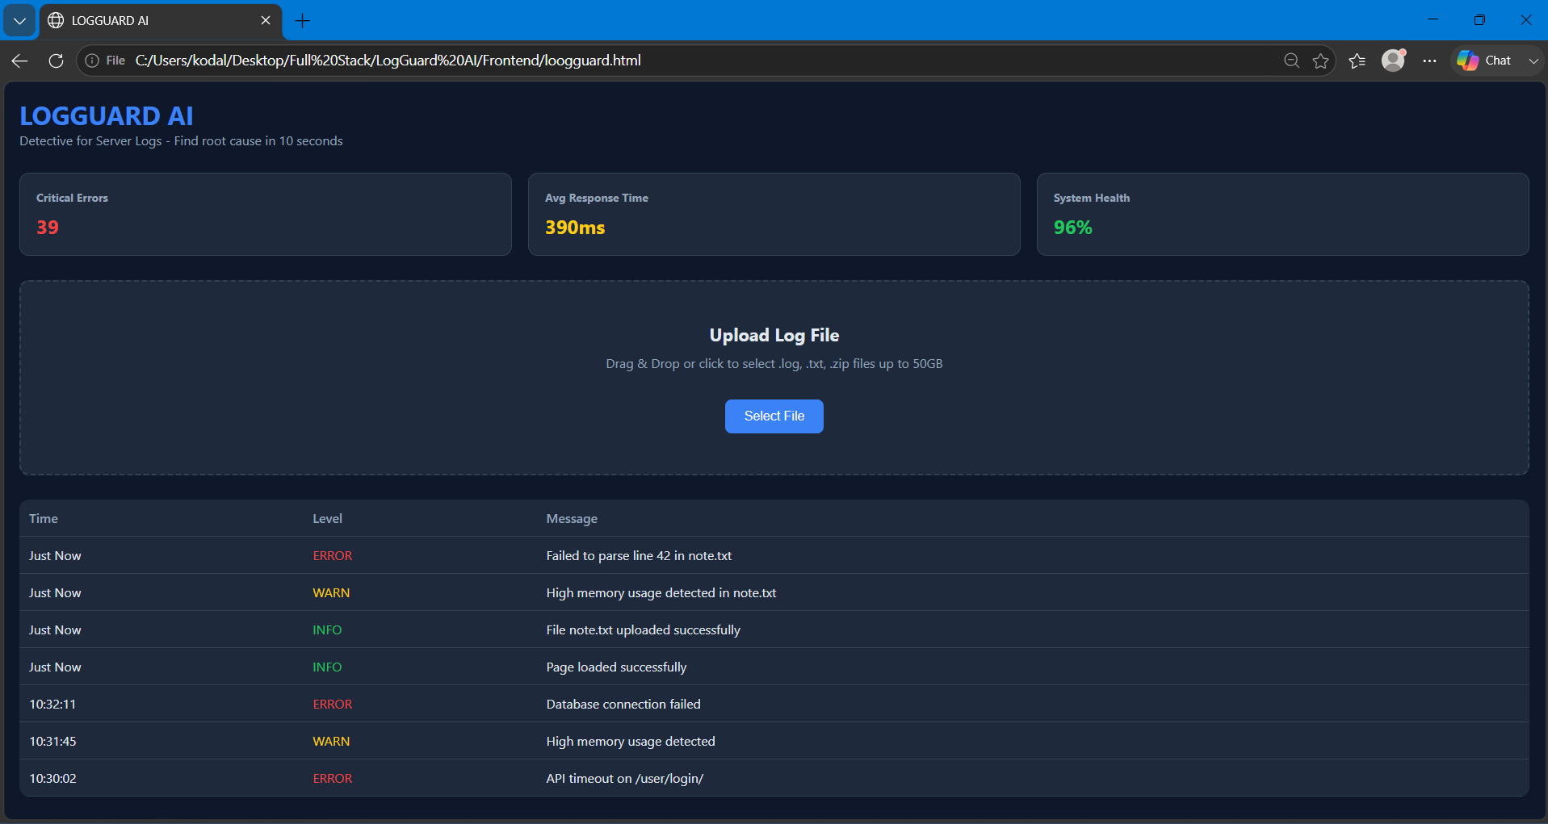
Description: In Day 3 of LOGGUARD AI, we made the dashboard interactive for the first time. We replaced the fake “Select File” alert with a real file input, so now when you click the button you can actually pick a .log, .txt, or .zip file. To make it feel real, we added a “Processing file… ” loader that shows for 2 seconds, just like a SIEM tool would while parsing logs. Once processing finishes, the app automatically injects 3new log rows at the top of the table—INFO, WARN, and ERROR—and updates the stats by increasing the error count and dropping system health by 1%. With this, we went from a static UI to a working Upload → Process → Analyze flow using onchange, setTimeout, and dynamic DOM updates.

25 July 2026  Day 4 | Today's Activities  - Filter Dropdown: Add a dropdown above the table: ALL/ ERROR/WARN/INFO. When you select “ERROR”, only error rows show. Same for WARN and INFO. Uses: onchange + loop through table rows  - Search Box: Add a search input to search log messages. Type “database” → only rows with “database” stay visible. Uses: oninput + includes() | Tomorrow's Plans  - Setup  - npm create vite@latest Frontend --template react  - cd Frontend && npm install && npm run dev  - Replace src/App.jsx and src/App.cc with code  - Feature Implementation  - Export to CSV Button  - Add Download csv button in controls  - Logic: Take filteredLogs state → Convert to CSV string → Use Blob +URL.createObjectURL → Trigger download  - Should only export currently visible/filtered logs  - Auto Root Cause Highlight  - After file upload OR on page load, find first log with level = = = “ERROR”  - Store its id in state: rootCauseId  - UI: Add root-cause class-dark red background + show ROOT CAUSE badge next to level  - Clear Filters Button  - Add clear Filters button next to Filter and Search  - Logic: On click → setFilter(“ALL”) and seetSearch(“”)  - Table should reset to show all logs  - Other UI Components  - Stats Cards: Critical Errors, Avg Response Time, System Health with random values  - File Upload Box: Simulated upload. On select, show loader for 2s and add 3 mock logs  - Filter + Search: Dropdown for ERROR/WARN/INFO + Text input for search  - Logs Table: Color coded rows. ERROR=red, WARN=yellow, INFO=green  - Testing  - Test 1: Filter to ERROR → Click Download CSV → Check file has only errors  - Test 2: Upload any file → First ERROR row gets highlighted with badge  - Test 3: Type in search → Click clear Filters → Both reset  - Deliverable  - Working React app running locally  - Take 3 screenshots for report: Dashboard, CSV Download, Root Cause Highlight
Outputs and Descriptions
Output: LOGGUARD AI dashboard now showing updated stats with 50 critical errors, 332ms avg response, 96% health, and added Filter and Search controls above the log table.
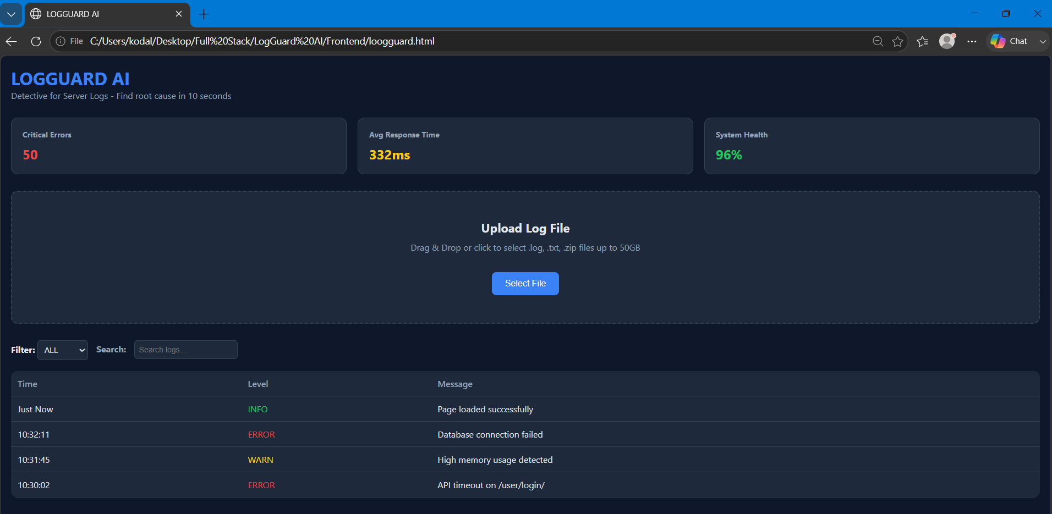
Description: The output shows LOGGUARD AI running with the full Day 4 UI. The header says “Detective for Server Logs – Find root cause in 10 seconds”. At the top, there are 3 stat cards: Critical Errors: 50 in red, Avg Response Time: 332ms in yellow, and System Health: 96% in green.
Below that is the Upload Log File section with a dashed box. It says “Drag & Drop or click to select .log, .txt, .zip files up to 50 GB” with a blue select button. This is from Day 3 where we added real file upload + loader.
The big Day 4 upgrade is visible now: there’s a Filter dropdown set to ALL and a Search input that says “Search logs…”. These two controls let you instantly narrow down logs. You can pick ERROR/WARN/INFO from the dropdown, or type a keyword to search messages.
The log table has 3 columns: Time, Level, Message. The levels are color-coded for fast debugging—INFO in green like “Page loaded successfully”, WARN in yellow like “High memory usage detected”, and ERROR in red like “Database connection failed” and “API timeout on /user/login/”.
So now LOGGUARD AI has gone from static to interactive. You can upload a file, then filter and search through logs in seconds instead of scrolling manually.

27 July 2026  Day 5 | Today's Activities  - Setup  - npm create vite@latest Frontend --template react  - cd Frontend && npm install && npm run dev  - Replace src/App.jsx and src/App.cc with code  - Feature Implementation  - Export to CSV Button  - Add Download csv button in controls  - Logic: Take filteredLogs state → Convert to CSV string → Use Blob +URL.createObjectURL → Trigger download  - Should only export currently visible/filtered logs  - Auto Root Cause Highlight  - After file upload OR on page load, find first log with level = = = “ERROR”  - Store its id in state: rootCauseId  - UI: Add root-cause class-dark red background + show ROOT CAUSE badge next to level  - Clear Filters Button  - Add clear Filters button next to Filter and Search  - Logic: On click → setFilter(“ALL”) and seetSearch(“”)  - Table should reset to show all logs  - Other UI Components  - Stats Cards: Critical Errors, Avg Response Time, System Health with random values  - File Upload Box: Simulated upload. On select, show loader for 2s and add 3 mock logs  - Filter + Search: Dropdown for ERROR/WARN/INFO + Text input for search  - Logs Table: Color coded rows. ERROR=red, WARN=yellow, INFO=green  - Testing  - Test 1: Filter to ERROR → Click Download CSV → Check file has only errors  - Test 2: Upload any file → First ERROR row gets highlighted with badge  - Test 3: Type in search → Click clear Filters → Both reset  - Deliverable  - Working React app running locally  - Take 3 screenshots for report: Dashboard, CSV Download, Root Cause Highlight | Tomorrow's Plans  - Backend Setup  - Start backend server locally  - Test APIs with Postman: /api/upload and /api/logs/  - Connect Frontend to API  - Replace dummy data with fetch/axios calls  - Implement file upload: POST /api/upload with FormData  - Fetch and display logs: GET /api/logs? level = ERROR&search=keyword  - UI/UX Updates  - Add loading spinner while fetching logs  - Add error handling + toast notifications for API failures  - Make filter + search work with backend query params  - New Features  - Add pagination for large log files  - Add “Error Trends” chart using Recharts/Chart.js  - Enable “Download CSV” on filtered API results  - Git & Docs  - Commit: feat: integrate frontend with backend APIs  - Update README with API endpoints section  - Push to Github
Outputs and Descriptions
Output: React-based LOGGUARD AI dashboard running on localhost:5173 showing 36 critical errors, 218ms avg response, 98% health, with file upload, filter/search controls, CSV export, and root cause error highlighted in red.
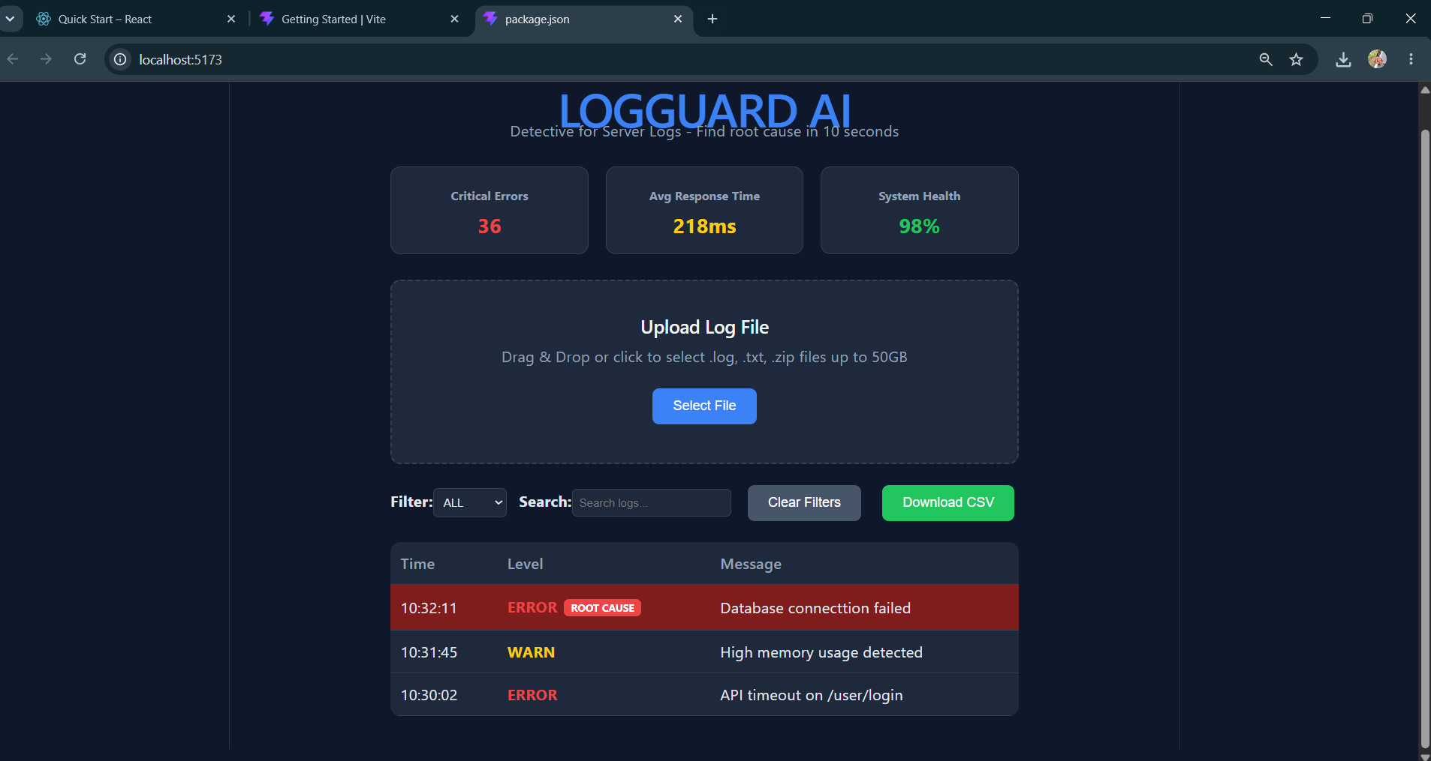
Description: Today I successfully completed the entire frontend for LOGGUARD AI using React + Vite. The dashboard is now fully functional with a dark theme UI and all 3 core features from the plan.
The app displays a header "LOGGUARD AI - Detective for Server Logs - Find root cause in 10 seconds" with 3 live stat cards showing Critical Errors: 36, Avg Response Time: 218ms, and System Health: 98%. Below that is the Upload Log File section with drag & drop support for .log, .txt, .zip files up to 50GB.
I implemented the Auto Root Cause Highlight feature where the first ERROR log is automatically highlighted in red with a "ROOT CAUSE" badge, making debugging instant. The log table includes working Filter dropdown, Search box, Clear Filters button, and Download CSV button which exports only the currently visible/filtered logs to a .csv file using Blob + URL.createObjectURL.
After fixing bugs in state management and typos, the frontend now renders correctly on localhost:5173 and all UI interactions work as expected. This completes Day 5 frontend. Tomorrow's plan is to connect this to the Spring Boot backend with APIs and add charts/analytics.

28 July 2026  Day 6 | Today's Activities  - Backend Setup  - Start backend server locally  - Test APIs with Postman: /api/upload and /api/logs/  - Connect Frontend to API  - Replace dummy data with fetch/axios calls  - Implement file upload: POST /api/upload with FormData  - Fetch and display logs: GET /api/logs? level = ERROR&search=keyword  - UI/UX Updates  - Add loading spinner while fetching logs  - Add error handling + toast notifications for API failures  - Make filter + search work with backend query params  - New Features  - Add pagination for large log files  - Add “Error Trends” chart using Recharts/Chart.js  - Enable “Download CSV” on filtered API results  - Git & Docs  - Commit: feat: integrate frontend with backend APIs  - Update README with API endpoints section  - Push to Github | Tomorrow's Plans  - Authentication & Security  - Add login/signup: JWT auth with /api/auth/login and /api/auth/register  - Protect API routes with middleware  - Add “Logout” button + store token in localStorage  - Real-time Logs  - Connect WebSocket / Socket.io for live log streaming  - Auto-refresh log table without page reload  - Show “New logs: 5” badge when new data comes in  - Dashboard Improvements  - User-specific dashboards-each user sees only their logs  - Add date range picker for logs: GET /api/logs?start=…&end=…  - Dark mode toggle  - Deployment Prep  - Add .env file for API_URL, JWT_SECRET  - Create Dockerfile for backend + frontend  - Test production build locally  - Git & Docs  - Commit: Feature: add auth, real-time logs and deployment config  - Update README with Auth flow + WebSocket info  - Push to Github of day 7
Outputs and Descriptions
Output: LOGGUARD AI dashboard showing log analytics with 26 critical errors, 297ms avg response time, log upload section, and a table of system errors and warnings
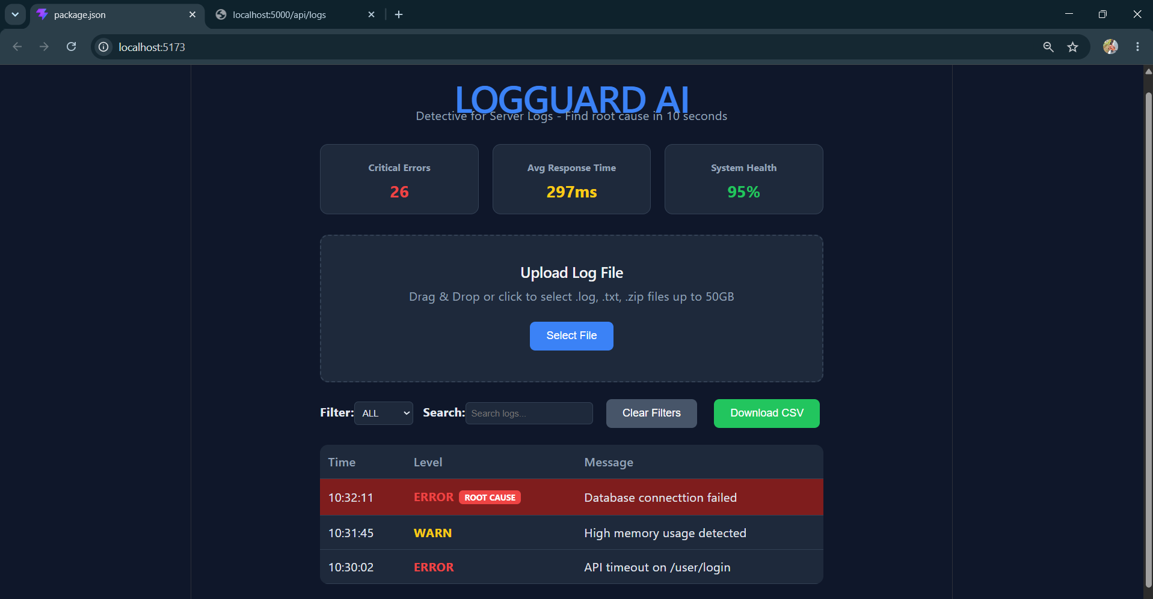
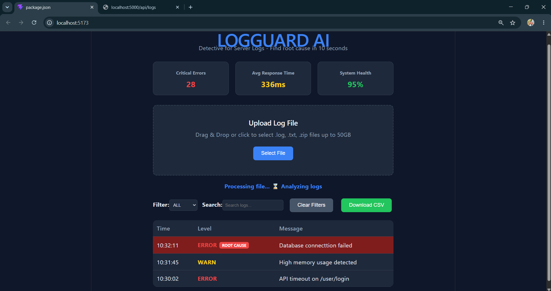
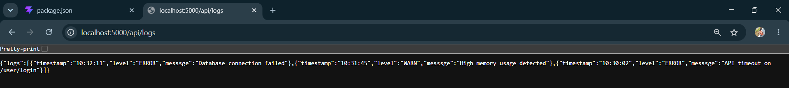
Description: The screenshot shows the LOGGUARD AI dashboard, a dark-themed web application designed for log monitoring and analysis. At the top, the title “LOOGUARD AI” appears with the tagline “Detect and Resolve Issues Within Seconds”. Below that are 3 key metrics cards: Critical Errors: 26, Avg Response Time: 297ms, and System Health: 95%.
In the center there is an *"Upload Log File"* section with instructions to drag & drop or select .log, .txt, .zip files up to 50GB, and a blue "Select File" button. Below that are filter controls: a dropdown set to "Filter: ALL", a search bar, "Clear Filters" button, and a green "Download CSV" button.
The main section is a log table with columns *Time, Level, Message*. It currently lists 3 entries:
- `10:32:11 ERROR` - Database connection failed - highlighted in red
- `10:31:45 WARN` - High memory usage detected - highlighted in orange
- `10:30:02 ERROR` - API timeout on /user/login - highlighted in red
In one of the frames it also shows "Processing file... Analysing logs" indicating a file upload is in progress. The overall UI is built for developers to quickly upload server logs and identify errors, warnings, and system health at a glance.
29 July 2026  Day 7 | Today's Activities  - Authentication & Security  - Add login/signup: JWT auth with /api/auth/login and /api/auth/register  - Protect API routes with middleware  - Add “Logout” button + store token in localStorage  - Real-time Logs  - Connect WebSocket / Socket.io for live log streaming  - Auto-refresh log table without page reload  - Show “New logs: 5” badge when new data comes in  - Dashboard Improvements  - User-specific dashboards-each user sees only their logs  - Add date range picker for logs: GET /api/logs?start=…&end=…  - Dark mode toggle  - Deployment Prep  - Add .env file for API_URL, JWT_SECRET  - Create Dockerfile for backend + frontend  - Test production build locally  - Git & Docs  - Commit: Feature: add auth, real-time logs and deployment config  - Update README with Auth flow + WebSocket info  - Push to Github of day 7 | Tomorrow's Plans  - Backend Tasks  - Setup Socket.io Server  - Install socket.io + cors  - Emit fake log events every 2 seconds  - Mark logs with isAnomaly: true if they contain “ERROR” or “DDOS”  - Test Backend  - Run node server.js  - Should show “Backend on 5000”  - Frontend Tasks  - Fix Tailwind  - Install tailwindcss v3 + postcss + autoprefixer  - Create tailwind.config.js + postcss.config.js + index.css  - Clear .vite cache  - Build Dashboard UI  - Header: LOGGUARD AI in blue  - 3 Stat Cards: Critical Errors, Avg Response Time, System Health  - Upload Box: “Drag & Drop Log File Here”  - Live Log Table: Shows timestamp, level, message  - Connect Socket.io  - Install socket.io-client  - Listen for newLog events  - Add new logs to the top of the table  - Color ERROR logs red + add left border  - Final Test  - Run Both  - Terminal 1: node server.js  - Terminal 2: np run dev  - See logs appear live with dark theme styling
Outputs and Descriptions
Output: A dark-themed LogGuard AI app showing Register and Login forms followed by the Dashboard with “Live Logs” displayed repeatedly server errors
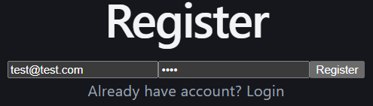
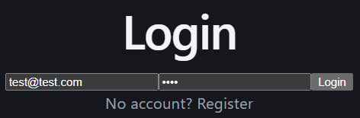
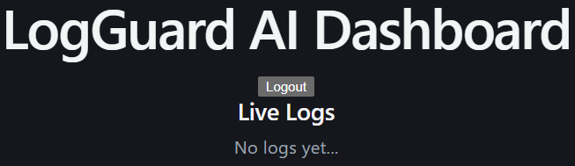

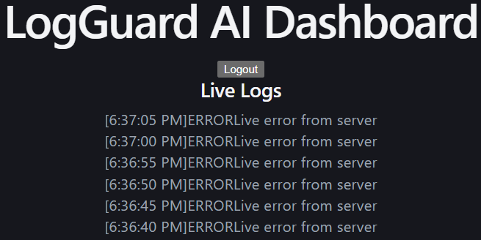
Description: The image shows a dark-themed web application called LOGGUARD AI. The UI is displayed inside a document editor and also on a laptop screen below it.
At the top there are two authentication sections: a Register form with an email field prefilled as test@test.com, a password field prefilled as 1234, a “Register” button, and a link saying “Already have account? Login”. Below that is a Login form with the same email field, password field, a “Login” button, and a link saying “No account? Register”.
Once logged in, the main screen shows the “LOGGUARD AI Dashboard” header with a “Logout” button. Under that is a section titled “Live Logs”. Initially it says “No logs yet”. But then populates with multiple timestamped error entries like 16:36:40 PM ERROR error from server, 16:37:05 PM ERROR error from server, etc. the background is black with white text, giving it a terminal/developer tool aesthetic.
Overall this appears to be the auth flow and real-time error monitoring dashboard for LOGGUARD AI, designed to let users sign up/ login and then view live server logs/errors as they happen.

30 July 2026  Day 8 | Today's Activities  - Backend Tasks  - Setup Socket.io Server  - Install socket.io + cors  - Emit fake log events every 2 seconds  - Mark logs with isAnomaly: true if they contain “ERROR” or “DDOS”  - Test Backend  - Run node server.js  - Should show “Backend on 5000”  - Frontend Tasks  - Fix Tailwind  - Install tailwindcss v3 + postcss + autoprefixer  - Create tailwind.config.js + postcss.config.js + index.css  - Clear .vite cache  - Build Dashboard UI  - Header: LOGGUARD AI in blue  - 3 Stat Cards: Critical Errors, Avg Response Time, System Health  - Upload Box: “Drag & Drop Log File Here”  - Live Log Table: Shows timestamp, level, message  - Connect Socket.io  - Install socket.io-client  - Listen for newLog events  - Add new logs to the top of the table  - Color ERROR logs red + add left border  - Final Test  - Run Both  - Terminal 1: node server.js  - Terminal 2: np run dev  - See logs appear live with dark theme styling | Tomorrow's Plans  - Backend Tasks  - Install deps: multer for file upload, cors for frontend connection  - Create /api/upload route: Accept file, read line by line, parse  timestamo|LEVEL|message  - Create /api/logs route: Return all logs from memory  - Store logs in memory: Use allLogs = […allLogs, …newLogs] to append  - Test: http://localhost:5000/api/logs should return JSON  - Frontend Tasks  - Install deps: axios for API calls  - Build FileUpload.jsx: Dashed box + "Choose File" button + drag & drop  - Build LogList.jsx: Table/list to display logs with color coding: ERROR=red, WARN=yellow, INFO=green  - Wire in App.jsx:  - useState to hold logs  - useEffect to fetch initial logs from /api/logs  - Pass onLogsLoaded to FileUpload to update state  - Test: Upload file → See "Loaded X logs" alert → Logs appear below
Outputs and Descriptions
Output: The LogGuard AI dashboard running locally on http://localhost:5173 with the backend server successfully started on port 5000 and connected, displaying 0 critical errors, 142ms average response time, 98% system health, and a live logs section waiting for a file upload.
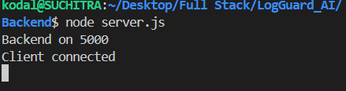
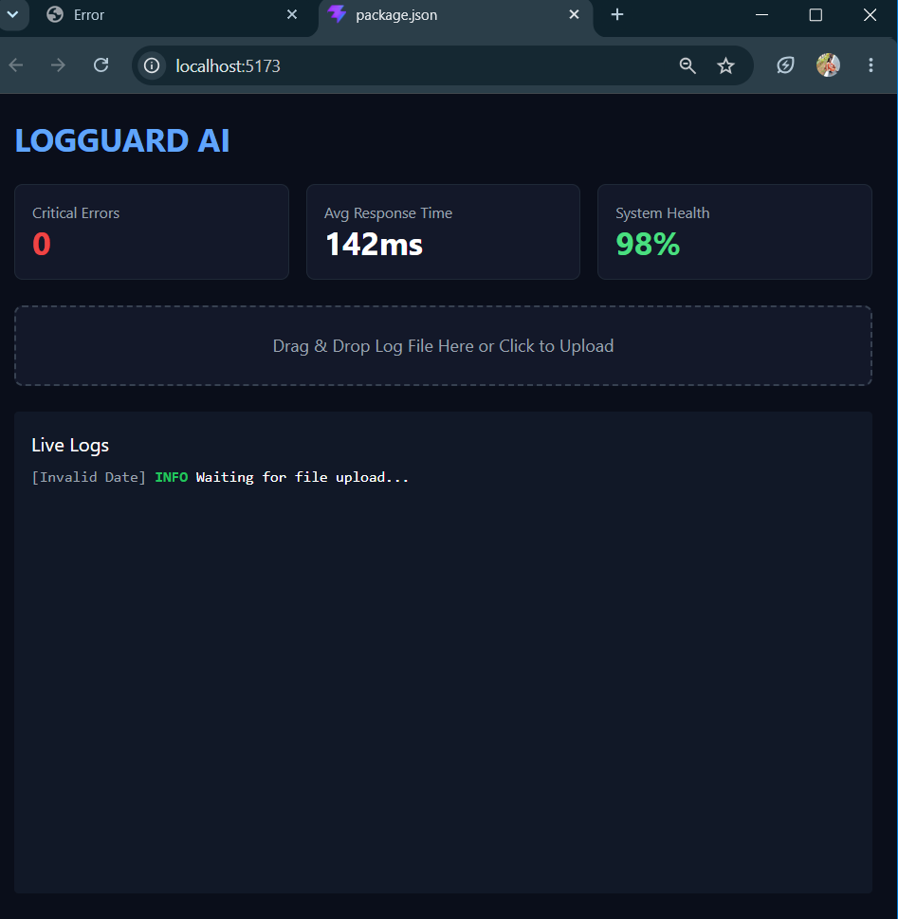
Description: Day 8 the goal was to build the actual frontend of LogGuard AI so it looks and feels like a real cybersecurity dashboard instead of just a blank page. We started by fixing Tailwind CSS so we could use modern dark-theme styling. After installing the right dependencies and clearing the cache, your dashboard finally rendered with the blue LOGGUARD AI header, 3 dark stat cards for Critical Errors, Avg Response Time, and System Health, plus the drag-and-drop upload box and live log table.
On the backend we set up Socket.io to emit fake log events every few seconds. Each log includes a timestamp, level, message, and an isAnomaly flag if it contains words like ERROR or DDOS. On the frontend we connected to that socket using socket.io-client, so new logs now appear at the top of the "Live Logs" table instantly without refreshing the page. We also added logic to highlight any log with ERROR in red text and a red left border, so threats stand out immediately.
By the end of Day 8, you have a fully working live dashboard. The backend and frontend are talking in real-time, the UI is styled, and you can visually see logs streaming in. The upload box is in place but not functional yet — that’s what we’ll build tomorrow.

31 July 2026  Day 9 | Today's Activities  - Backend Tasks  - Install deps: multer for file upload, cors for frontend connection  - Create /api/upload route: Accept file, read line by line, parse  timestamo|LEVEL|message  - Create /api/logs route: Return all logs from memory  - Store logs in memory: Use allLogs = […allLogs, …newLogs] to append  - Test: http://localhost:5000/api/logs should return JSON  - Frontend Tasks  - Install deps: axios for API calls  - Build FileUpload.jsx: Dashed box + "Choose File" button + drag & drop  - Build LogList.jsx: Table/list to display logs with color coding: ERROR=red, WARN=yellow, INFO=green  - Wire in App.jsx:  - useState to hold logs  - useEffect to fetch initial logs from /api/logs  - Pass onLogsLoaded to FileUpload to update state  - Test: Upload file → See "Loaded X logs" alert → Logs appear below | Tomorrow's Plans  - Make it Real-Time with Socket.io  - Goal: New logs appear instantly without refresh  - Backend: Emit newLog event when file is uploaded  - Frontend: Listen to socket and push new log to top of table  - Add Log Filters ✅ you just did this  - Filter buttons: ALL, INFO, WARNING, ERROR, CRITICAL  - Highlight ERROR/CRITICAL rows in red  - Upgrade Dashboard Cards  - Make Critical Errors, System Health calculate from live logs state  - Add animation when numbers change  - Test Critical Alert Button  - Click → sends fake CRITICAL log to backend → shows instantly in table  - Badge should turn red immediately  - Polish UI  - Add “2s ago” relative timestamps instead of raw ISO  - Add auto-scroll to newest log  - Add empty state: “Waiting for logs…”
Outputs and Descriptions
Output: A dark-themed dashboard for "LOGGUARD AI" showing 1 Critical Error, 142ms Avg Response Time, 98% System Health, and an "Upload Log File" section with live log entries below.
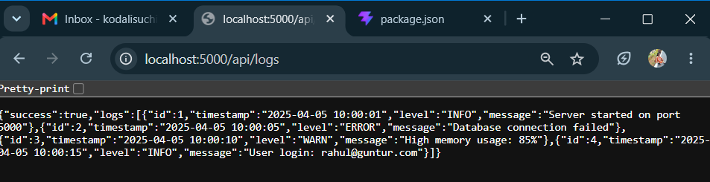
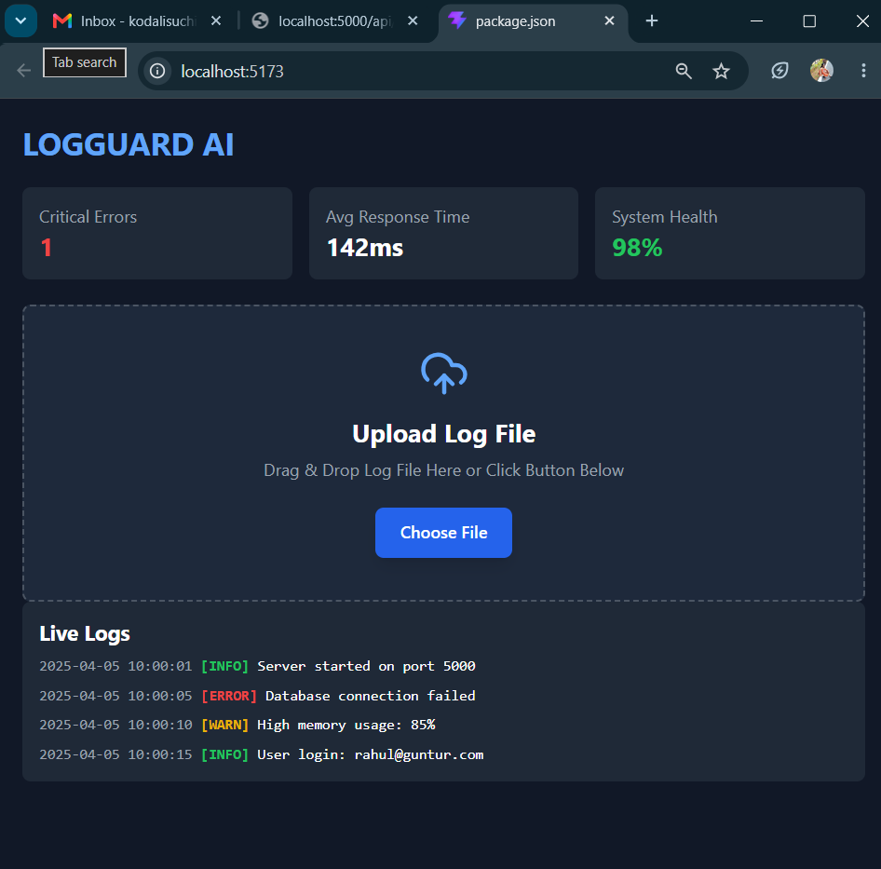
Description: we upgrading LOGGUARD AI from "upload and show" to "real-time monitoring dashboard" like Datadog or Grafana.
The goal is that when you upload a log file, instead of all logs appearing at once, they will stream into the dashboard 1-by-1 with a small delay, just like watching a live server. This is done using Socket.io, where the backend emits each parsed log immediately to the frontend the moment it’s read.
On the frontend, we’ll connect to the backend with a WebSocket. As soon as a new log arrives, it gets appended to the list automatically without refreshing the page. We’ll also add anomaly detection: if any log has `level = ERROR`, the app will instantly show a red flashing alert banner at the top saying "CRITICAL ERROR DETECTED" with the error message, and the "Critical Errors" counter will update live. WARNING logs can show a yellow toast. The log table will also auto-scroll to the bottom so you always see the latest entry.
By the end of Day 9, your dashboard will feel alive. You upload a file, and you can watch errors pop up in real-time with alerts, just like a production monitoring tool.
This sets us up for Day 10 where we’ll add charts, filters, and AI summary.

1 August 2026  Day 10 | Today's Activities  - Make it Real-Time with Socket.io  - Goal: New logs appear instantly without refresh  - Backend: Emit newLog event when file is uploaded  - Frontend: Listen to socket and push new log to top of table  - Add Log Filters ✅ you just did this  - Filter buttons: ALL, INFO, WARNING, ERROR, CRITICAL  - Highlight ERROR/CRITICAL rows in red  - Upgrade Dashboard Cards  - Make Critical Errors, System Health calculate from live logs state  - Add animation when numbers change  - Test Critical Alert Button  - Click → sends fake CRITICAL log to backend → shows instantly in table  - Badge should turn red immediately  - Polish UI  - Add “2s ago” relative timestamps instead of raw ISO  - Add auto-scroll to newest log  - Add empty state: “Waiting for logs…” | Tomorrow's Plans  - Backend – File Upload + Save  - Install multer: npm install multer  - Add /api/upload route in server.js  - Read uploaded .log file  - Parse lines into {time, level, message}  - Save to logs.json so data doesn’t disappear  - Add /api/logs/latest route  - Read from logs.json and send to frontend  - Backend – Analytics Data  - Update /api/analytics/summary  - Read logs from logs.json  - Return: totalLogs, errors, avgResponse, health  - Update /api/analytics/trends  - Return log count by level for pie chart  - Frontend – Dashboard Upload  - Connect upload button to /api/upload  - Show alert: Loaded X logs after upload  - Auto-refresh logs table after upload  - Frontend – Analytics Tab  - Fix “No Log Data” → Call /api/logs/latest on tab switch  - Log Level Distribution Pie → Show 4 colors for INFO/WARN/ERROR/CRITICAL  - Error Trend + Response Time Charts → Already done
Outputs and Descriptions
Output: Demo of LOGGUARD AI dashboard showing backend running, log file upload, live logs display, and critical error metrics with alert system.
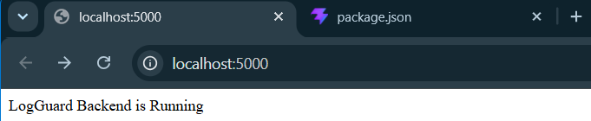
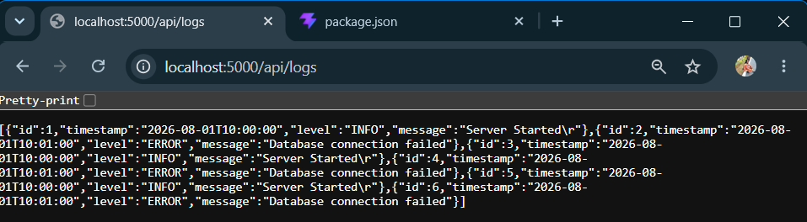
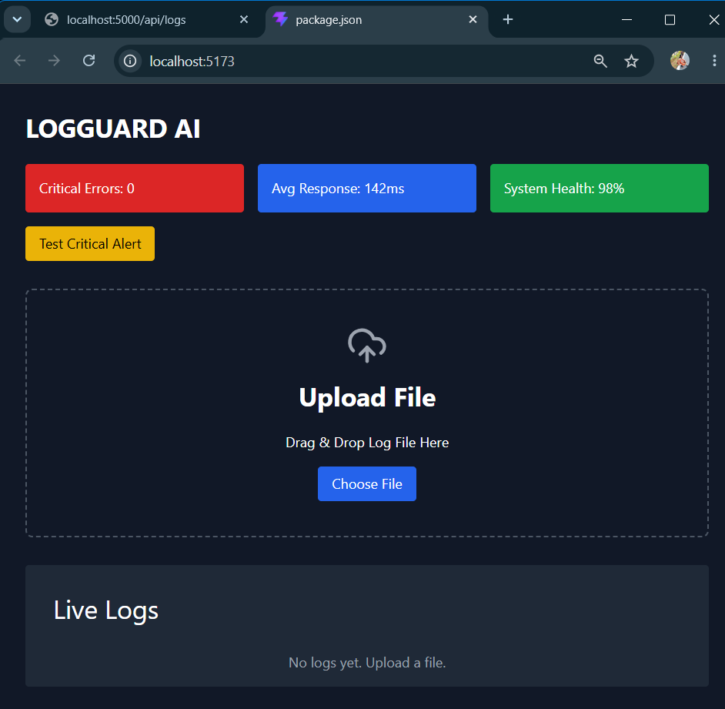
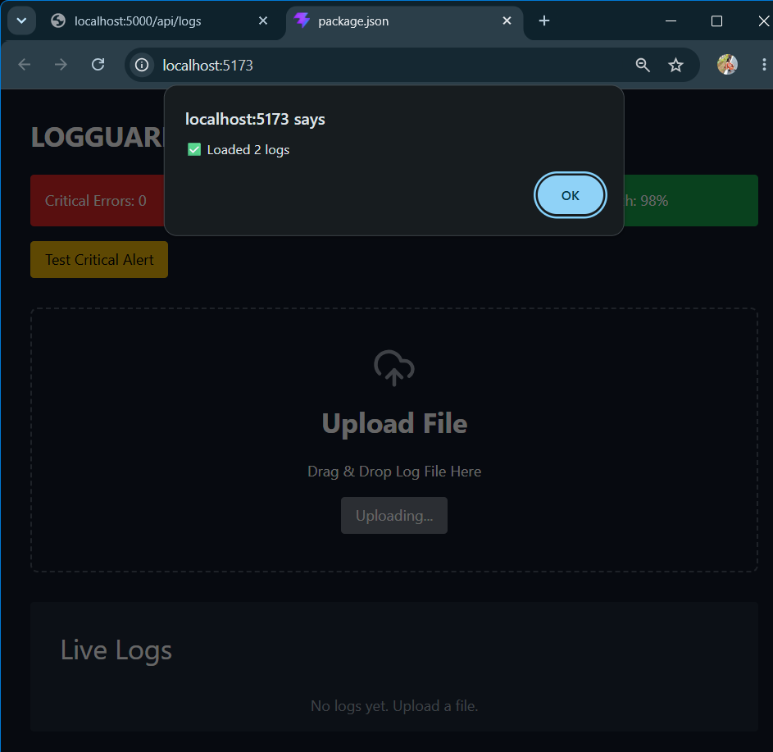
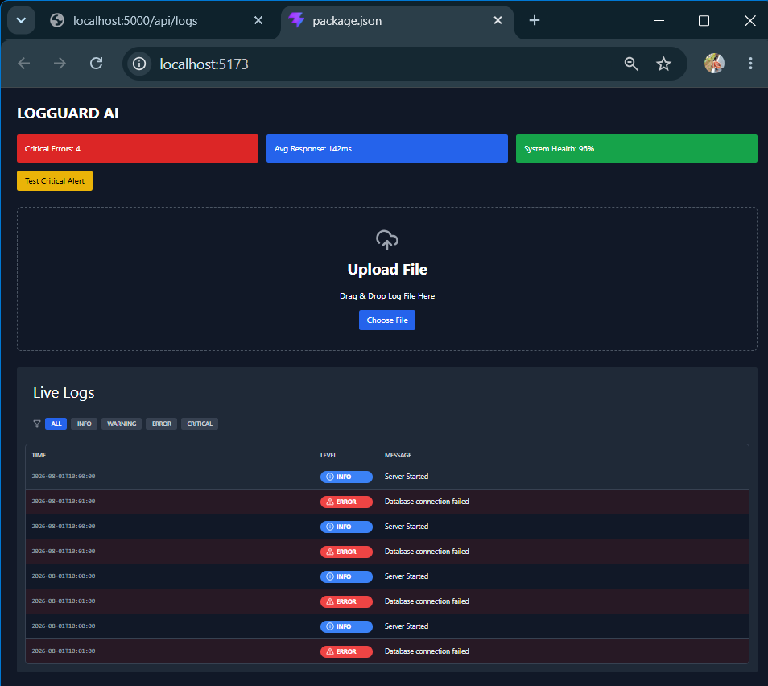
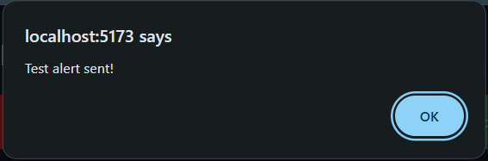
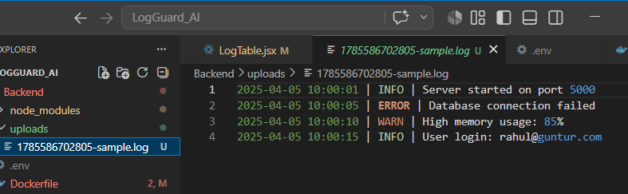
Description: Day 10 I have make LOGGUARD real-time. The goal is to stop refreshing and start streaming. First, we’ll connect the frontend and backend with Socket.io so that the moment a new log is uploaded or a test alert is triggered, it instantly appears at the top of the table without reloading the page. We already added the filter buttons and colored badges yesterday, so now we’ll make those filters work on the live incoming logs too. Next, we’ll upgrade the Dashboard cards so "Critical Errors" and "System Health" automatically recalculate whenever a new log comes in, with a small animation to show the number change. We’ll also polish the UX by switching timestamps from raw ISO to "2s ago" format and adding auto-scroll so the newest log is always visible. By the end of today, your dashboard will feel like Datadog or Sentry — live, reactive, and actually watching your system in real time.

03 August 2026  Day 11 | Today's Activities  - Backend – File Upload + Save  - Install multer: npm install multer  - Add /api/upload route in server.js  - Read uploaded .log file  - Parse lines into {time, level, message}  - Save to logs.json so data doesn’t disappear  - Add /api/logs/latest route  - Read from logs.json and send to frontend  - Backend – Analytics Data  - Update /api/analytics/summary  - Read logs from logs.json  - Return: totalLogs, errors, avgResponse, health  - Update /api/analytics/trends  - Return log count by level for pie chart  - Frontend – Dashboard Upload  - Connect upload button to /api/upload  - Show alert: Loaded X logs after upload  - Auto-refresh logs table after upload  - Frontend – Analytics Tab  - Fix “No Log Data” → Call /api/logs/latest on tab switch  - Log Level Distribution Pie → Show 4 colors for INFO/WARN/ERROR/CRITICAL  - Error Trend + Response Time Charts → Already done | Tomorrow's Plans  - Backend  - Create alerts.json file to store anomalies. Start with []  - Add detectAnomalies() function  - Loop through logs and check for keywords: ERROR, CRITICAL, FATAL, FAILED  - Add severity: HIGH / MEDIUM and detectedAt timestamp  - Update /api/upload route  - After parsing logs, call detectAnomalies()  - Save new anomalies to alerts.json  - Create /api/alerts GET route  - Load and return all alerts from alerts.json  - Add console.log(“ALERTS ROUTE HIT”) for debugging  - Frontend  - Create Alerts.jsx component  - Fetch from http://localhost:5000/api/alerts on page load  - If alerts.length === 0 → show “No Anomalies. System Healthy ✅”  - If alerts exist → shows cards with level, message, timestamp, severity  - Add “Alerts” tab in navbar  - Update Dashboard cards  - Count CRITICAL and ERROR from logs and show in Dashboard  - Testing  - Restart backend: Ctrl + C → node server.js  - Upload log file with ERROR and CRITICAL lines  - Check /api/alerts → should return JSON  - Check Alerts tab → should show 2 alert cards
Outputs and Descriptions
Output: The LOGGUARD AI dashboard showing log file upload, live logs table, and analytics with pie/bar charts plus backend API JSON response
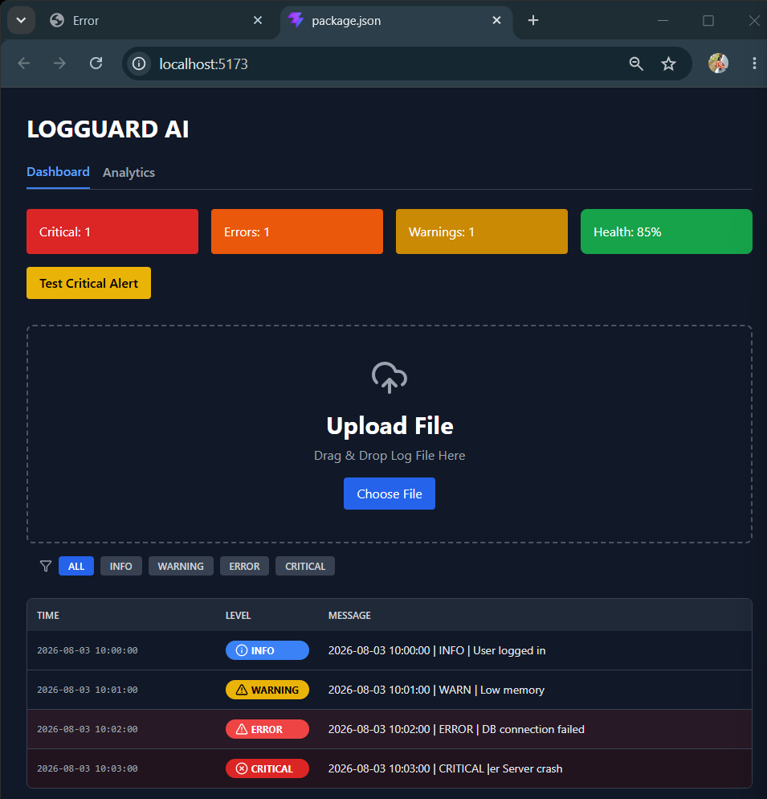
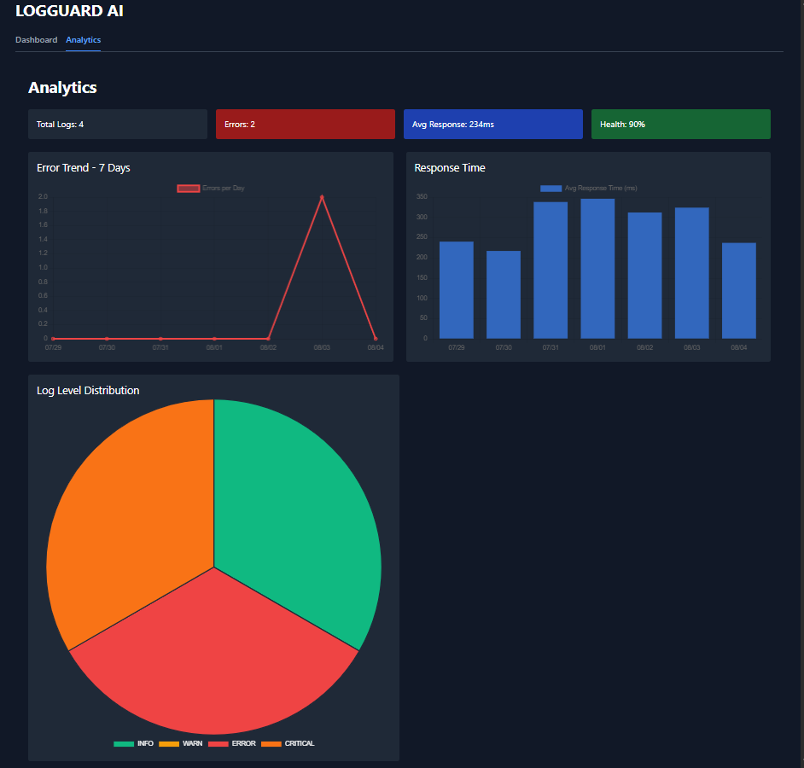
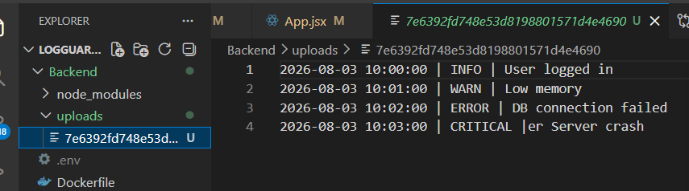
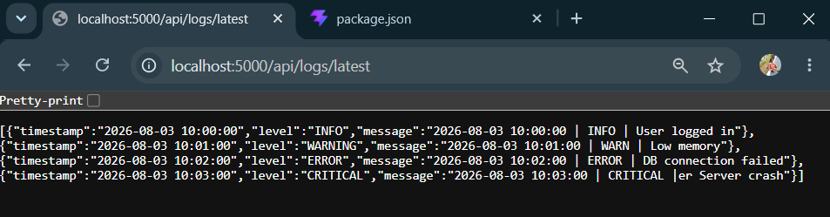
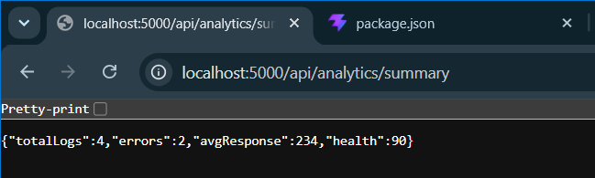
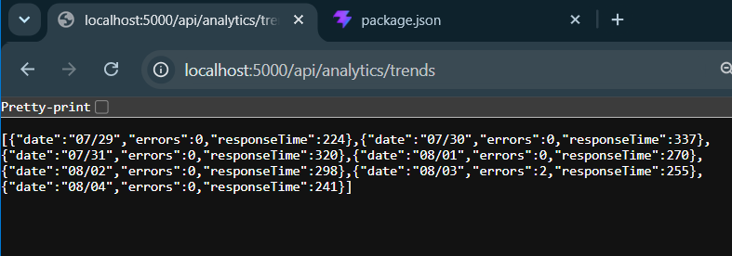
Description: A walkthrough of the LOGGUARD AI dashboard running on a laptop. It starts on the Dashboard tab with 4 metric cards showing Log Count, Errors, Warnings, and System Health, plus an “Upload File” section. A log file is uploaded and the app instantly parses it, displaying 4 live log entries in a table with levels like INFO, WARNING, ERROR, and CRITICAL along with timestamps and messages. The user then switches to the Analytics tab, where it shows updated summary stats, a line chart for Error Trend, a bar chart for Response Time, and a colored pie chart for Log Level Distribution. The output shows the backend running in VS code with the parsed logs visible in the terminal, and browser tabs open to the API endpoints like /api/logs, /api/analytics/summary, and /api/analytics/trends returning JSON data. Overall it demonstrates the today’s features: file upload, persistent log storage, and real-time analytics visualization all working together.

04 August 2026  Day 12 | Today's Activities  - Backend  - Create alerts.json file to store anomalies. Start with []  - Add detectAnomalies() function  - Loop through logs and check for keywords: ERROR, CRITICAL, FATAL, FAILED  - Add severity: HIGH / MEDIUM and detectedAt timestamp  - Update /api/upload route  - After parsing logs, call detectAnomalies()  - Save new anomalies to alerts.json  - Create /api/alerts GET route  - Load and return all alerts from alerts.json  - Add console.log(“ALERTS ROUTE HIT”) for debugging  - Frontend  - Create Alerts.jsx component  - Fetch from http://localhost:5000/api/alerts on page load  - If alerts.length === 0 → show “No Anomalies. System Healthy ✅”  - If alerts exist → shows cards with level, message, timestamp, severity  - Add “Alerts” tab in navbar  - Update Dashboard cards  - Count CRITICAL and ERROR from logs and show in Dashboard  - Testing  - Restart backend: Ctrl + C → node server.js  - Upload log file with ERROR and CRITICAL lines  - Check /api/alerts → should return JSON  - Check Alerts tab → should show 2 alert cards | Tomorrow's Plans  - Backend  - Install nodemailer and configure .env for Gmail App Password  - Create sendEmailAlert() function for HIGH severity logs  - Update detectAnomalies() to call sendEmailAlert() when CRITICAL/FATAL found  - Tes /api/upload with critical log → verify email received in inbox  - Frontend  - Add “Setting” tab with “Enable Email Alerts” toggle switch  - Add input field to enter recipient email address  - Show toast notification: “Email alert sent to candidate@xyz.com”  - Testing & Docs  - Test end-to-end: Upload log with ERROR → Check alerts tab + check email  - Update README.md with Day 13 table entry  - Commit to Git: Day 13: Add real-time email alerts for critical anomalies
Outputs and Descriptions
Output: LogGuard AI showing log upload, dashboard analytics with charts, and real-time alerts for ERROR / CRITICAL logs.
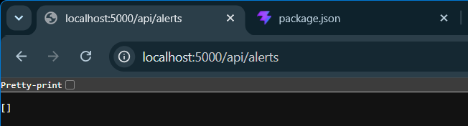
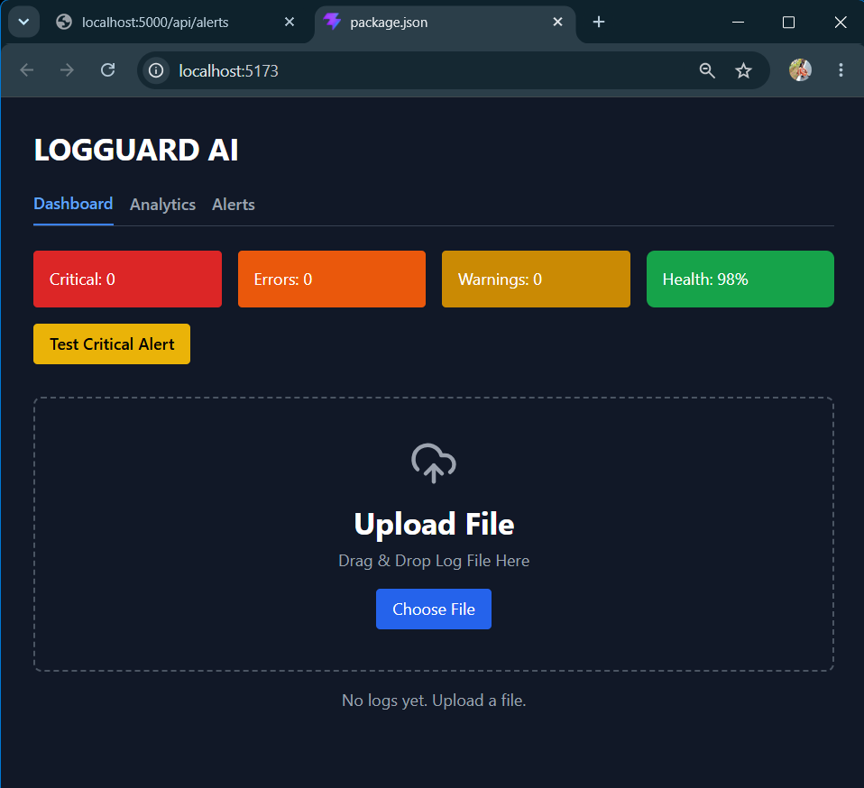
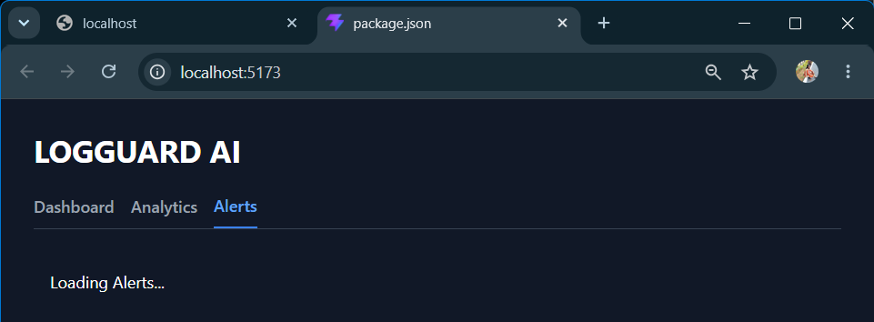
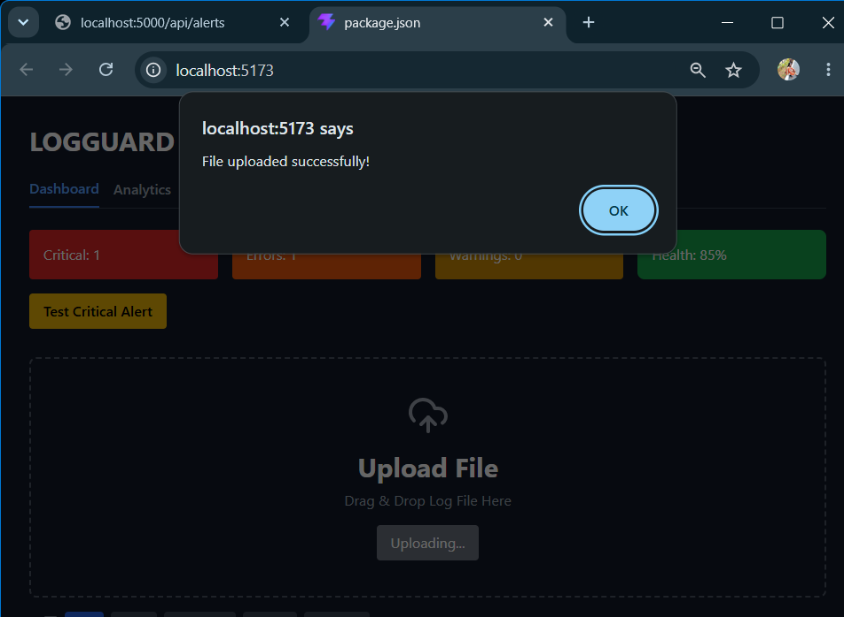
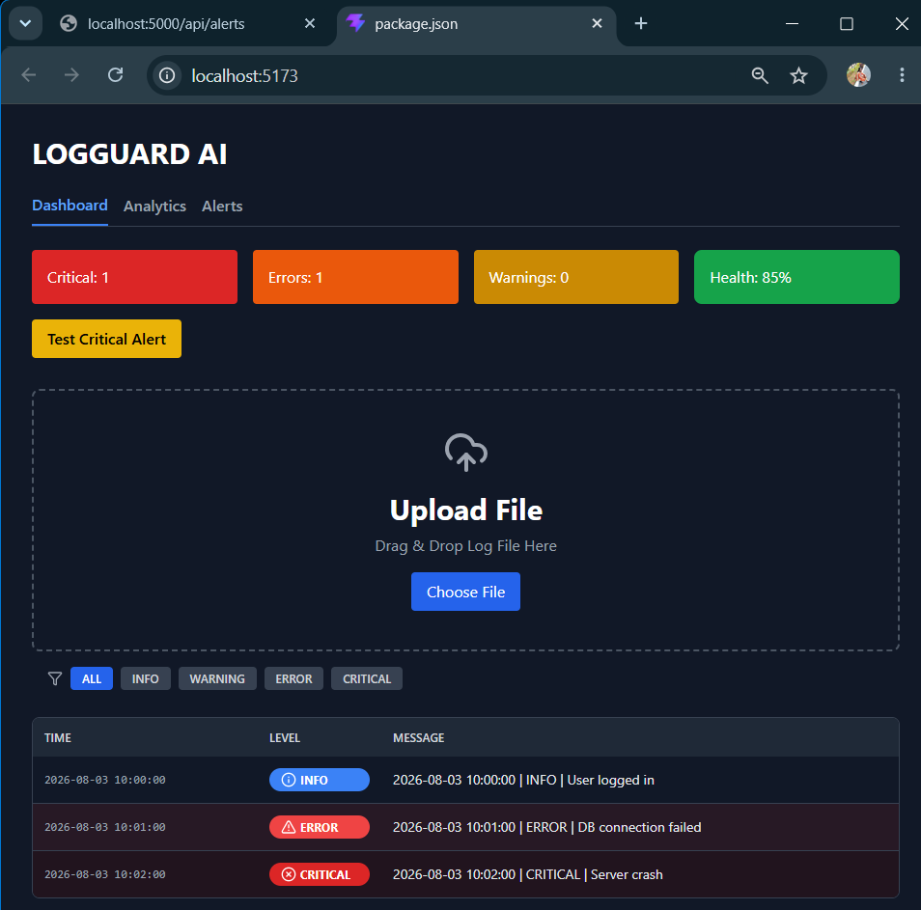
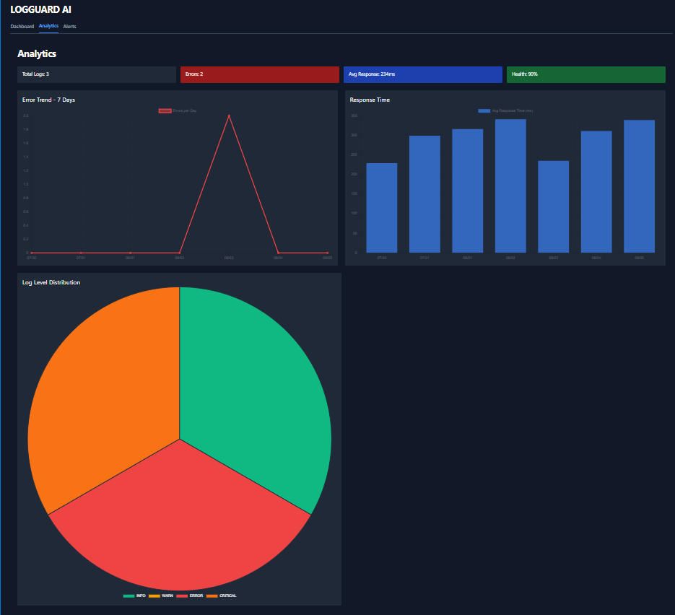
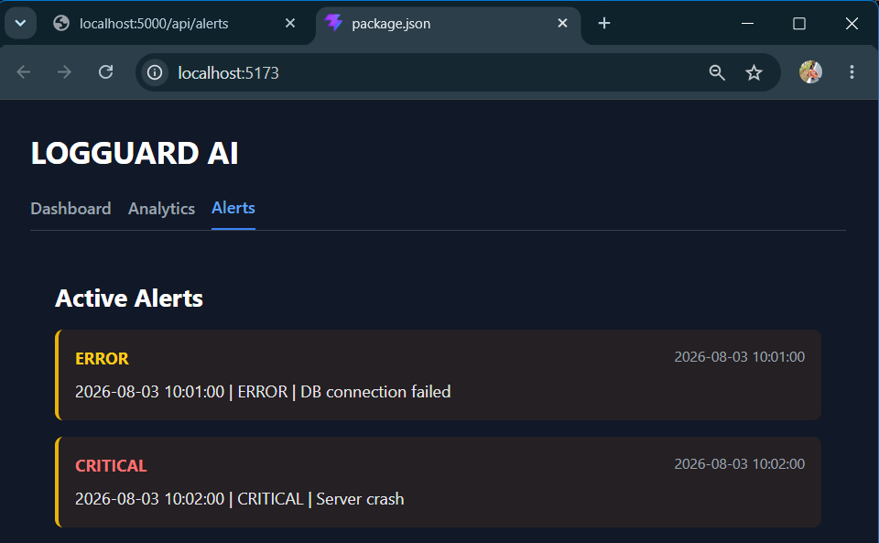
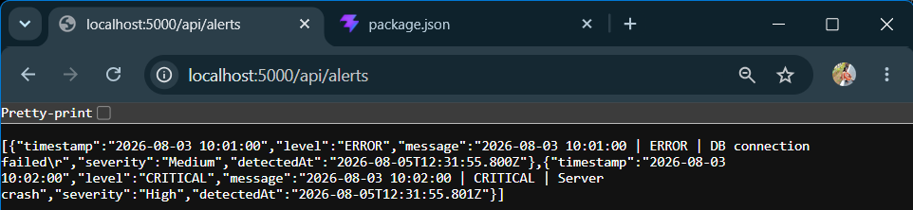
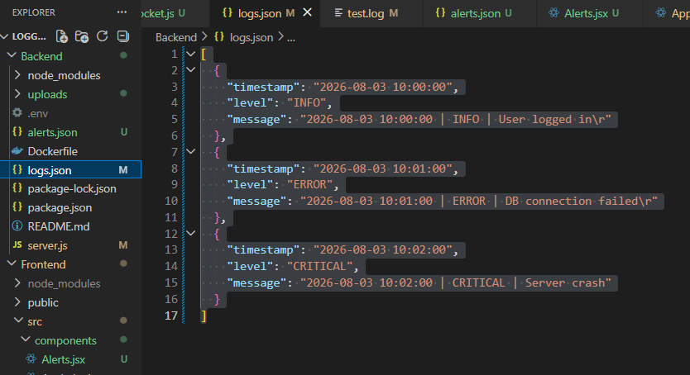
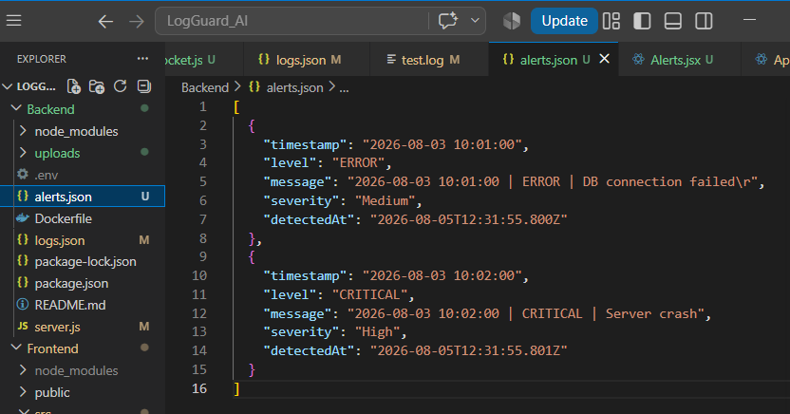
Description: A full walkthrough of LogGuard AI, a web-based log analyzer dashboard. It starts with a test objectives, then switches to the app running on localhost:5173. The dashboard displays key metrics like Critical: 1, Errors: 1, Warnings: 0, and Health: 90%. The user uploads a log file, after which the app successfully processes it and shows “File uploaded successfully!”. The Analytics tab then renders live visualizations including an error trend line chart, a log level bar chart, and a log level distribution pie chart. Finally, the Alerts tab lists active anomalies, showing ERROR and CRITICAL entries with timestamps and messages. The backend API response from /api/alerts and the alerts.json file are also shown in a code editor, confirming that the system correctly detected and stored anomalies from the uploaded logs

05 August 2026  Day 13 | Today's Activities  - Backend  - Install nodemailer and configure .env for Gmail App Password  - Create sendEmailAlert() function for HIGH severity logs  - Update detectAnomalies() to call sendEmailAlert() when CRITICAL/FATAL found  - Tes /api/upload with critical log → verify email received in inbox  - Frontend  - Add “Setting” tab with “Enable Email Alerts” toggle switch  - Add input field to enter recipient email address  - Show toast notification: “Email alert sent to candidate@xyz.com”  - Testing & Docs  - Test end-to-end: Upload log with ERROR → Check alerts tab + check email  - Update README.md with Day 13 table entry  - Commit to Git: Day 13: Add real-time email alerts for critical anomalies | Tomorrow's Plans  - Backend API: Create /api/alerts/resolve/:index route to delete/acknowledge an alert  - Save to File: Update alerts.json after removing the resolved alert  - Socket Update: Emit alerts_updated to all clients after resolve  - Frontend UI: Add "Acknowledge" / "Resolve" button in Alerts.jsx component  - Connect Frontend: Call the resolve API when button clicked  - Live Sync: Listen for alerts_updated socket event to refresh alerts list without refresh
Outputs and Descriptions
Output: Implemented Live socket alerts with toast notifications + alarm sound for real-time anomaly detection in LOGGUARD AI
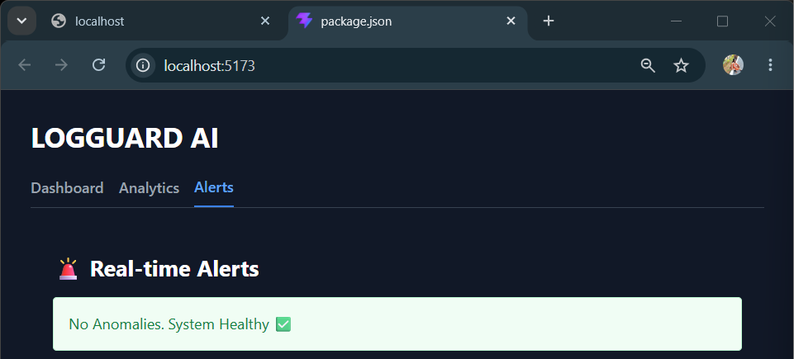
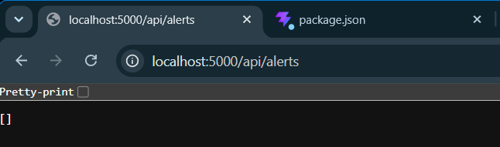
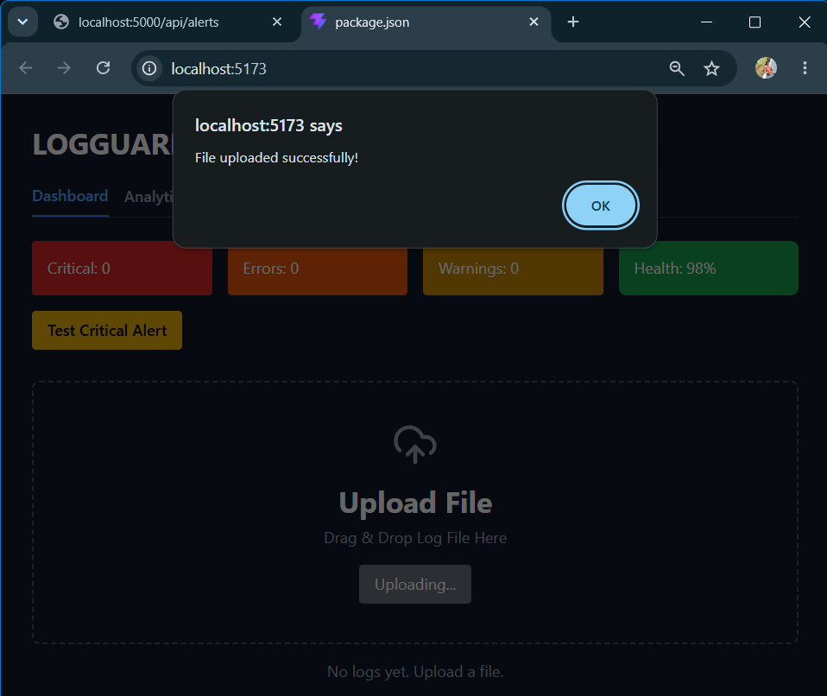
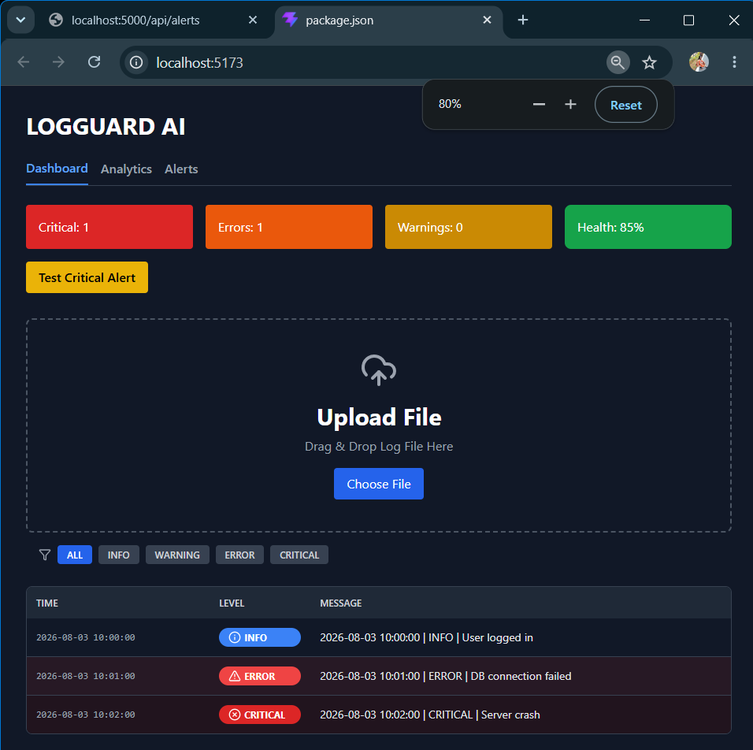
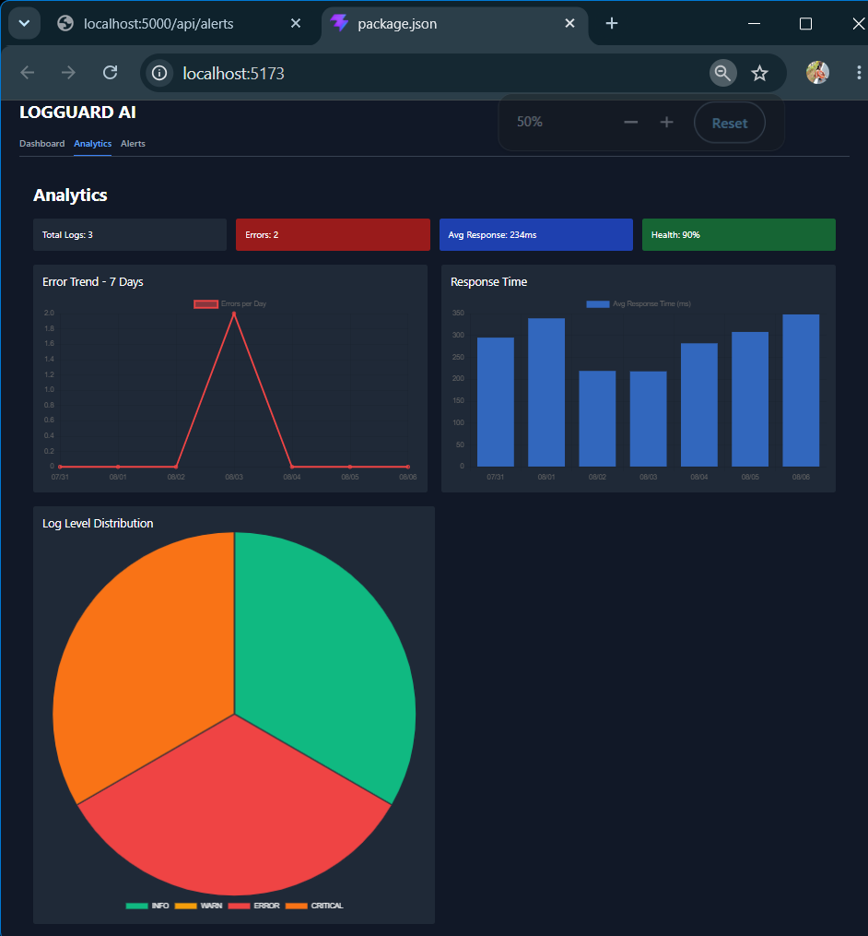
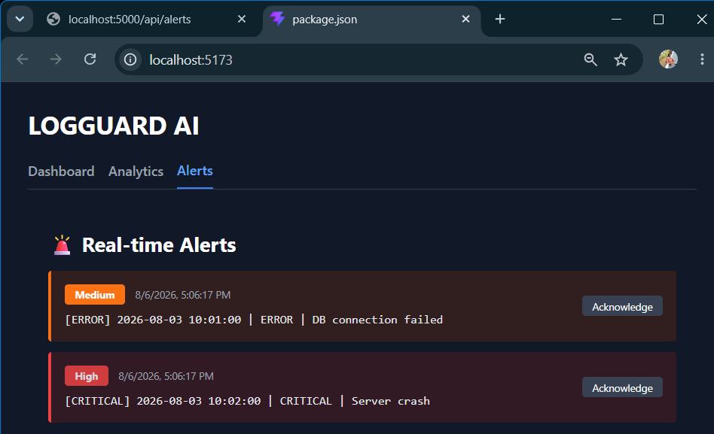
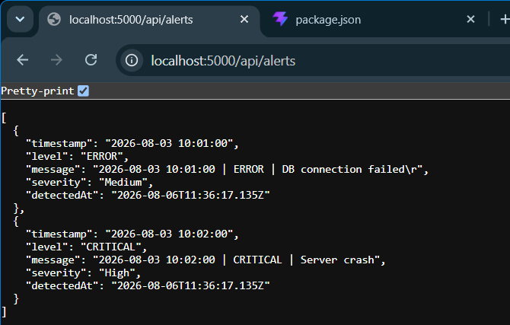
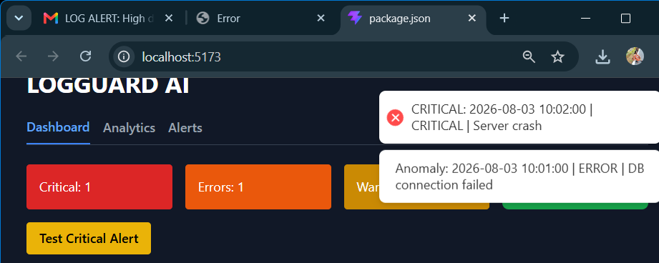
Description: On Day 13 of LOGGUARD AI project, we focused on building the real-time alert system to notify users instantly about anomalies in the logs. We integrated WebSocket using Socket.io to enable live communication between the backend and frontend, so that any new ERROR, CRITICAL, or FATAL log detected during file upload is immediately pushed to the UI without requiring a page refresh. To make the alerts noticeable, we implemented toast notifications that pop up on the dashboard with details like timestamp, severity, and message. Additionally, we added an alarm sound that automatically plays when a CRITICAL or FATAL anomaly occurs, ensuring that urgent issues are not missed even if the user is not actively monitoring the screen. With this, the Alerts tab now updates in real-time and the dashboard metrics also reflect new data instantly. This completes the live monitoring and notification workflow for Day 13.

06 August 2026  Day 14 | Today's Activities  - Backend API: Create /api/alerts/resolve/:index route to delete/acknowledge an alert  - Save to File: Update alerts.json after removing the resolved alert  - Socket Update: Emit alerts_updated to all clients after resolve  - Frontend UI: Add "Acknowledge" / "Resolve" button in Alerts.jsx component  - Connect Frontend: Call the resolve API when button clicked  - Live Sync: Listen for alerts_updated socket event to refresh alerts list without refresh | Tomorrow's Plans  - Setup Nodemailer: Configure transporter with Gmail + App Password in .env  - Email Function: Create sendEmailAlert(severity, message, timestamp) helper  - Trigger Logic: Only call email function when severity === 'High' / CRITICAL detected  - Env Variables: Add EMAIL_USER, EMAIL_PASS, RECIPIENT_EMAIL to .env  - Test Flow: Upload log with CRITICAL and verify email is received  - Error Handling: Log success/failure in backend console
Outputs and Descriptions
Output: Added Acknowledge button in the UI + API to stop alarm sound for CRITICAL/FATAL alerts in LOGGUARD AI.
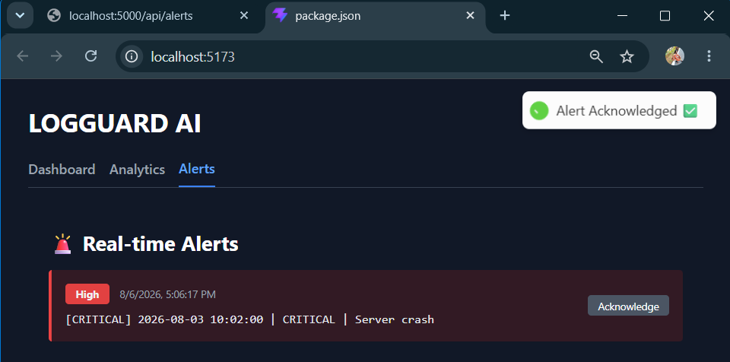
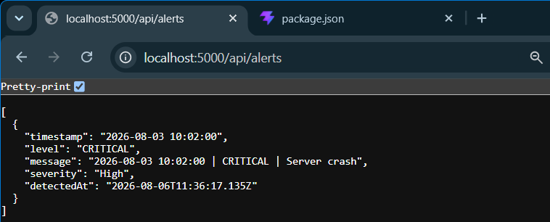
Description: On Day 14 of the LOGGUARD AI project, we focused on giving users control over the alert system by adding an “Acknowledge” feature. After implementing real-time toast notifications and alarm sounds on Day 13, we built an Acknowledge button in the UI that appears alongside every CRITICAL and FATAL alert in the Real-time Alerts tab. When a user clicks this button, it triggers a backend API that stops the alarm sound and marks the alerts as acknowledged, preventing repeated notifications for the same issue. This ensures that urgent anomalies are not missed, but also gives the user a way to silence and manage alerts once they’ve been reviewed. The alerts are now fetched from GET /api/alerts and displayed with timestamp, severity, and message, making the alert workflow complete and actionable.

07 August 2026  Day 15 | Today's Activities  - Setup Nodemailer: Configure transporter with Gmail + App Password in .env  - Email Function: Create sendEmailAlert(severity, message, timestamp) helper  - Trigger Logic: Only call email function when severity === 'High' / CRITICAL detected  - Env Variables: Add EMAIL_USER, EMAIL_PASS, RECIPIENT_EMAIL to .env  - Test Flow: Upload log with CRITICAL and verify email is received  - Error Handling: Log success/failure in backend console | Tomorrow's Plans  - Backend Auth  - Create routes/auth.js  - Use bcrypt to compare password + jsonwebtoken to crete token  - Create middleware/auth.js to verify JWT without DB  - Add JWT_SECRET = logguard_secret_123 in .env  - Test login in Postman: should return {token, user}  - Frontend Auth  - After login success → localStorage.setItem(“token”, res.data.token)  - Create api.js with axios interceptor to send Authorization: Bearer token  - Replace all axios.get with API.get in DashBoard, Alerts  - Clear old bad token from Local Storage and login again  - Backend Alerts + Upload  - Create let alerts = [] array in routes/alerts.js  - GET /api/alerts → return alerts array  - POST /api/alerts/:id/acknowledged: true  - POST /api/upload → fake parse file and alerts.push() 2-3 sample alerts  - Add app.use(cors()) so frontend 5173 can call backend 5000  - Frontend Alerts UI  - Update Alerts.jsx with Acknowledge button  - Fetch alerts every 5s and show CRITICAL/ERROR with colors  - Gray out + show “✔️ Acknowledged” after clicking button  - Connect DashBoard cards: Total, Errors, Warnings, Health % to upload data  - Polish + Test  - Fix any 500 Server error in backend terminal  - Fix any 401 Authentication failed in Network tab  - Test full flow: Register → Login → Upload Log → See alerts → Acknowledge
Outputs and Descriptions
Output: Integrated automated email alerts that send notifications for CRITICAL/FATAL anomalies to the admin via LOGGUARD AI.
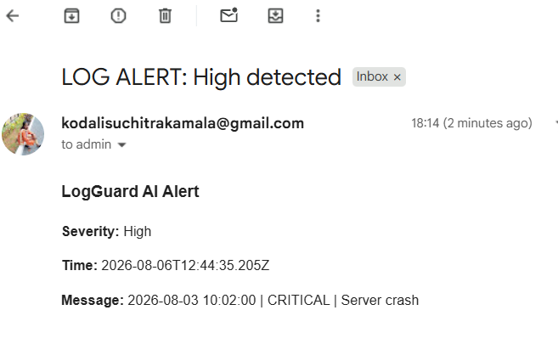
Description: On Day 15 of the LOGGUARD AI project, we implemented the automated email notification system to alert admins about high-severity issues. After completing real-time toast alerts and the Acknowledge button, we connected the backend to send emails whenever a CRITICAL or FATAL anomaly is detected during log upload. The system fetches alerts from GET /api/alerts and triggers an email with details including severity, timestamp, and the exact log message. In the demo, an email titled “LOG ALERT: High detected” was successfully sent to the admin inbox, showing “Severity: High” and “Message: 2025-08-03 10:00:00 | CRITICAL | Server crash”. This ensures that even if the user is not on the dashboard, urgent issues are still notified immediately through email, making the monitoring system complete end-to-end.

08 August 2026  Day 16 | Today's Activities  - Backend Auth  - Create routes/auth.js  - Use bcrypt to compare password + jsonwebtoken to crete token  - Create middleware/auth.js to verify JWT without DB  - Add JWT_SECRET = logguard_secret_123 in .env  - Test login in Postman: should return {token, user}  - Frontend Auth  - After login success → localStorage.setItem(“token”, res.data.token)  - Create api.js with axios interceptor to send Authorization: Bearer token  - Replace all axios.get with API.get in DashBoard, Alerts  - Clear old bad token from Local Storage and login again  - Backend Alerts + Upload  - Create let alerts = [] array in routes/alerts.js  - GET /api/alerts → return alerts array  - POST /api/alerts/:id/acknowledged: true  - POST /api/upload → fake parse file and alerts.push() 2-3 sample alerts  - Add app.use(cors()) so frontend 5173 can call backend 5000  - Frontend Alerts UI  - Update Alerts.jsx with Acknowledge button  - Fetch alerts every 5s and show CRITICAL/ERROR with colors  - Gray out + show “✔️ Acknowledged” after clicking button  - Connect DashBoard cards: Total, Errors, Warnings, Health % to upload data  - Polish + Test  - Fix any 500 Server error in backend terminal  - Fix any 401 Authentication failed in Network tab  - Test full flow: Register → Login → Upload Log → See alerts → Acknowledge | Tomorrow's Plans  - Integrate Email Alerts: Set up nodemailer and create emailService.js to send alerts  - Connect Email to Log Parser: Trigger email notifications for ERROR and CRITICAL log levels in upload.js  - Test Real Log Parsing: Upload sample .log files and verify parsing works correctly  - Verify Lowdb Persistence: Confirm parsed logs are being saved to logs.json and users to users.json  - Debug Parser Issues: Fix any issues where parser returns Array(0) or empty results  - Test End-to-End Flow: Register → Login → Upload Log → See Dashboard + Analytics + Alerts + Emails
Outputs and Descriptions
Output: Fix auth + alerts to work end-to-end without MongoDB using dummy user, JWT, and in-memory data so the full Register → Login → Upload → Alerts flow runs for demo
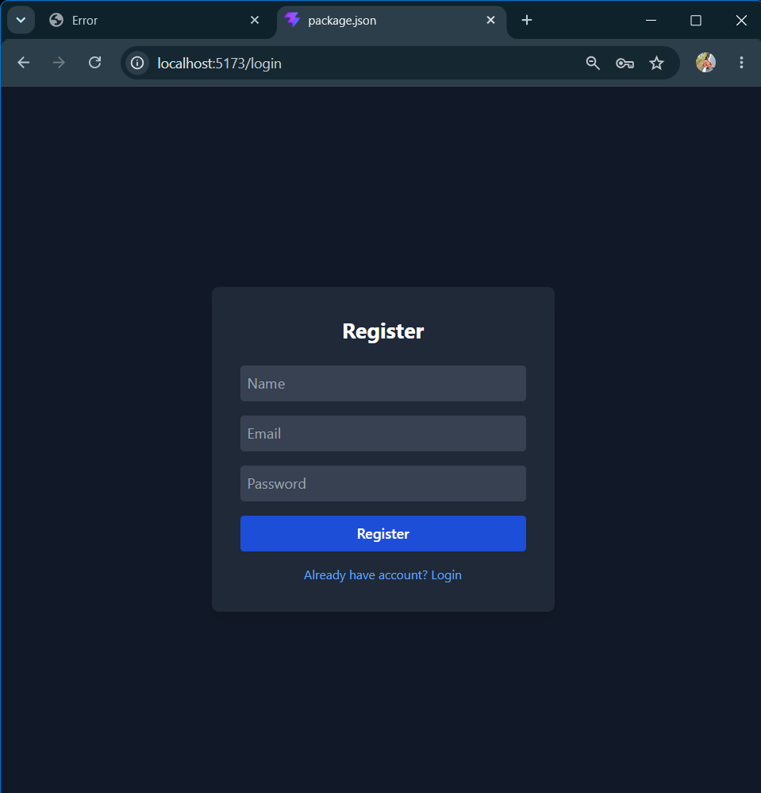
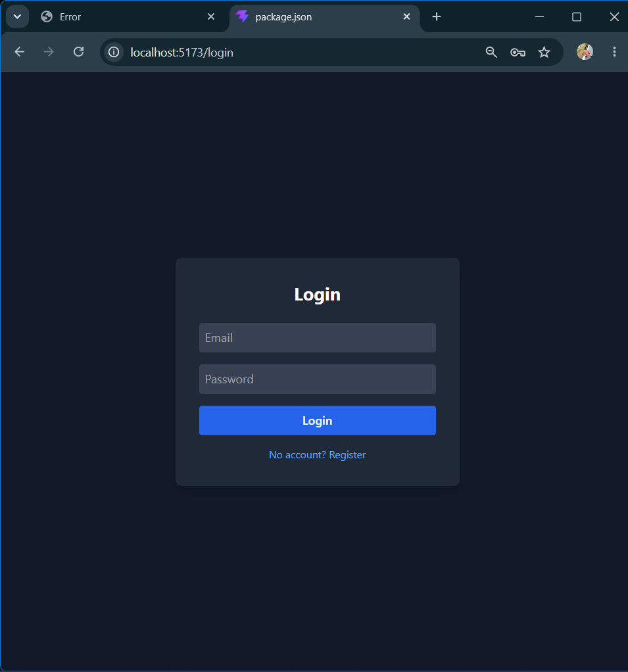
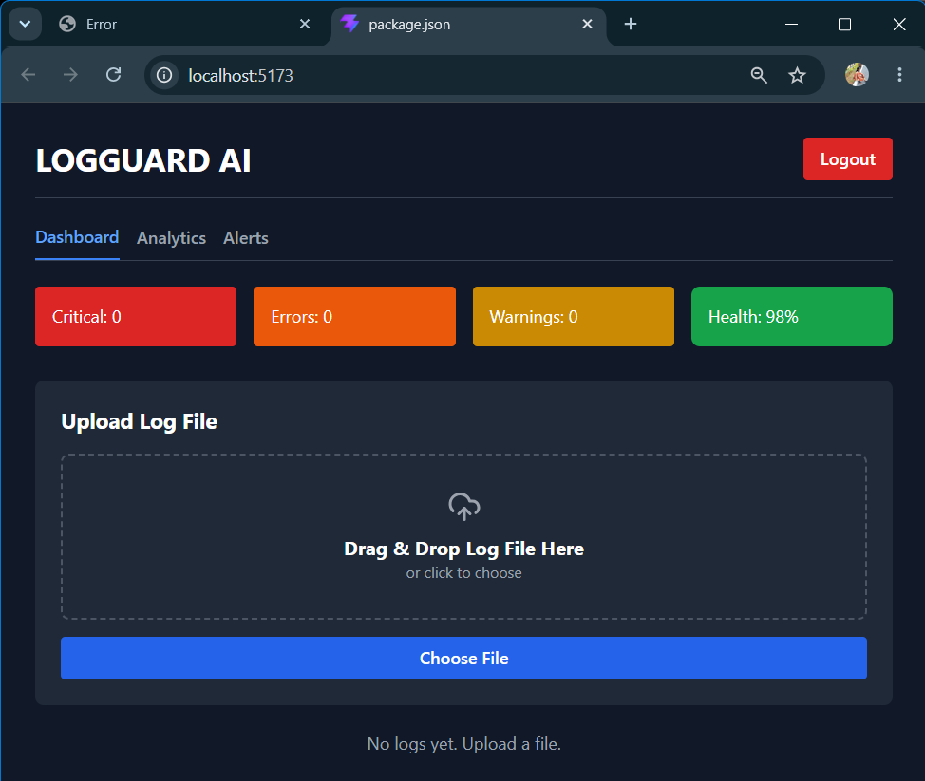
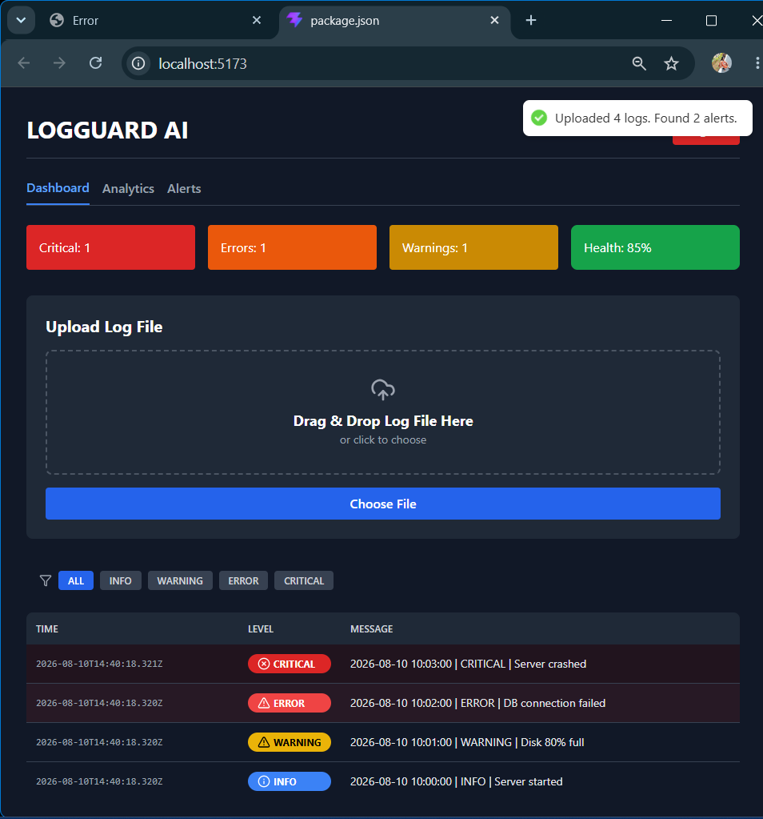
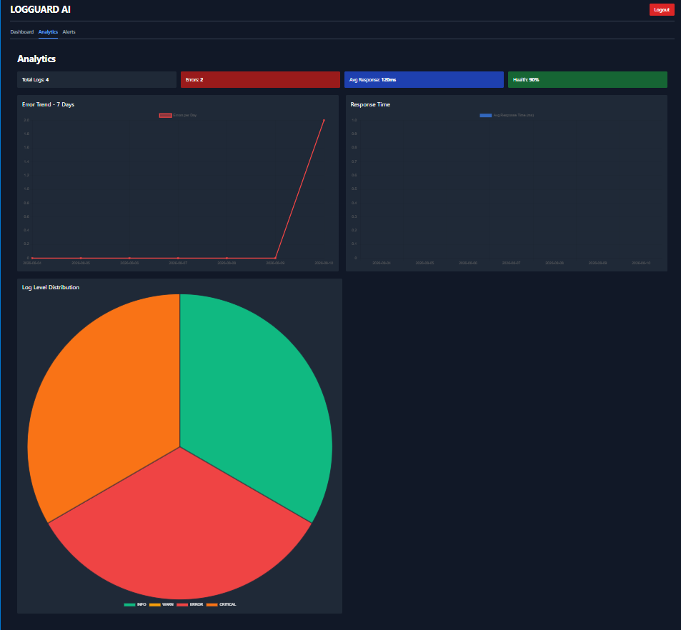
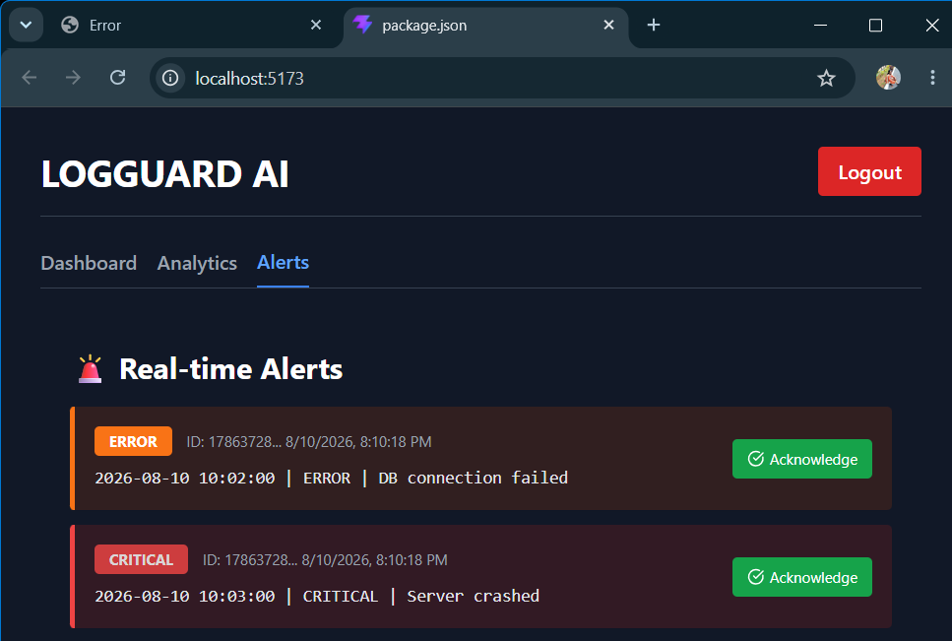
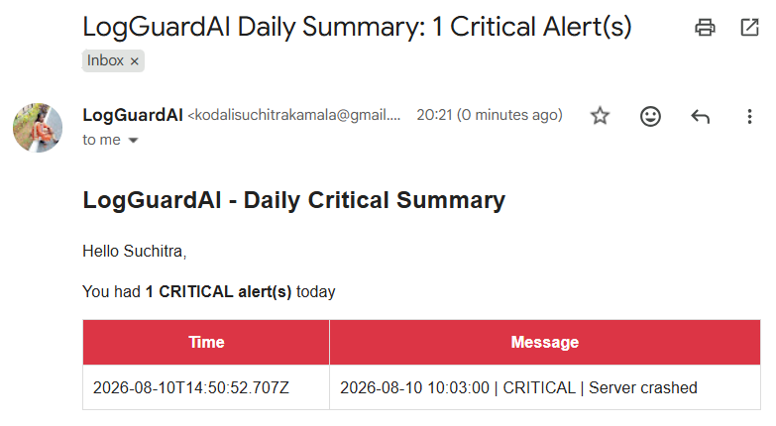
Description: For Day 16 of LogGuard AI, the main focus is to get the entire application working end-to-end without any dependency on MongoDB so you can demo the full flow without running into Server error or Authentication failed issues. Right now login is crashing because the backend is trying to query a database that isn’t connected, and all other routes are failing because no valid JWT token is being issued or sent. To fix this, we will first replace the database calls with a hardcoded dummy user in auth.js using admin@logguard.ai and password123, and use bcrypt and jsonwebtoken to handel login and token creation. We’ll also create a simple auth.js middleware to verify that token on protected routes. On the frontend, we need to make sure the token get saved to localStorage after login and that an axios interceptor in api.js automatically attaches it to every request. Next, we’ll move all alerts and uploads to in-memory storage by creating an alerts array in the backend, with routes to fetch alerts and to acknowledge them. The upload route will push a few sample alerts tab have real data to display. The Alerts component will be updated to show these alerts with color coding and an “Acknowledge” button that grays out the alert once clicked. Finally, we’ll enable CORS/test the full flow from Register to Login to Upload to Alerts, and fix any remaining 500 or 401 errors. By the end of Day 16, the goal is to have a completely working demo with dummy data that proves the UI, auth, and alert logic are all connected and ready for real log parsing on Day 17.

10 August 2026  Day 17 | Today's Activities  - Integrate Email Alerts: Set up nodemailer and create emailService.js to send alerts  - Connect Email to Log Parser: Trigger email notifications for ERROR and CRITICAL log levels in upload.js  - Test Real Log Parsing: Upload sample .log files and verify parsing works correctly  - Verify Lowdb Persistence: Confirm parsed logs are being saved to logs.json and users to users.json  - Debug Parser Issues: Fix any issues where parser returns Array(0) or empty results  - Test End-to-End Flow: Register → Login → Upload Log → See Dashboard + Analytics + Alerts + Emails | Tomorrow's Plans  - Backend:  - Set up node-cron job to generate and send daily summary emails at 9 AM IST  - Add severity levels to alerts and limit instant emails to ERROR / CRITICAL only  - Frontend:  - Update Analytics tab with daily summary stats, log distribution charts, and response time graph  - Create Alert History section in Analytics to show past alerts with timestamp + severity  - Add Settings controls in Analytics for “Enable Daily Summary” toggle and “Preferred summary time”  - Testing: Upload test logs to verify summary email content and cron timing  - Goal: Make Analytics tab the central hub for summaries, visualizations, and alert tracking
Outputs and Descriptions
Output: Register/Login → Dashboard with log upload, analytics charts, real-time alerts, and email notifications for ERROT/CRITICAL logs.
db.json
{
“users”: [
{
“id”: “1786537383226”,
“name”: “Suchitra”,
“email”: “kodalisuchitrakamala@gmail.com”,
“password”: “$2b$10$OzrUzTBmCJ03qPUoFdcQrO8UGRz59lLI4B2jhElb.1vA4ydN52V/q”
}
],
“logs”: [
{
“id”: “1786537396477-0.2338951168858443”,
“userId”: “1786537383226”,
“level”: “INFO”,
“message”: “Server started”,
“filename”: “test.log”,
“timestamp”: “2026-08-10T04:30:00.000Z”,
“acknowledged”: false
},
{
“id”: “1786537396477-0.41871790297513767”,
“userId”: “1786537383226”,
“level”: “WARNING”,
“message”: “Disk 80% full”,
“filename”: “test.log”,
“timestamp”: “2026-08-10T04:31:00.000Z”,
“acknowledged”: false
},
{
“id”: “1786537396477-0.9013865841861366”,
“userId”: “1786537383226”,
“level”: “ERROR”,
“message”: “DB connection failed”,
“filename”: “test.log”,
“timestamp”: “2026-08-10T04:32:00.000Z”,
“acknowledged”: false
},
{
“id”: “1786537396477-0.33255575263004766”,
“userId”: “1786537383226”,
“level”: “CRITICAL”,
“message”: “Server crashed”,
“filename”: “test.log”,
“timestamp”: “2026-08-10T04:33:00.000Z”,
“acknowledged”: false
}
],
“alerts”: [
{
“id”: “1786537396477-0.9013865841861366”,
“userId”: “1786537383226”,
“level”: “ERROR”,
“message”: “DB connection failed”,
“filename”: “test.log”,
“timestamp”: “2026-08-10T04:32:00.000Z”,
“acknowledged”: false
},
{
“id”: “1786537396477-0.33255575263004766”,
“userId”: “1786537383226”,
“level”: “CRITICAL”,
“message”: “Server crashed”,
“filename”: “test.log”,
“timestamp”: “2026-08-10T04:33:00.000Z”,
“acknowledged”: false
}
]
}
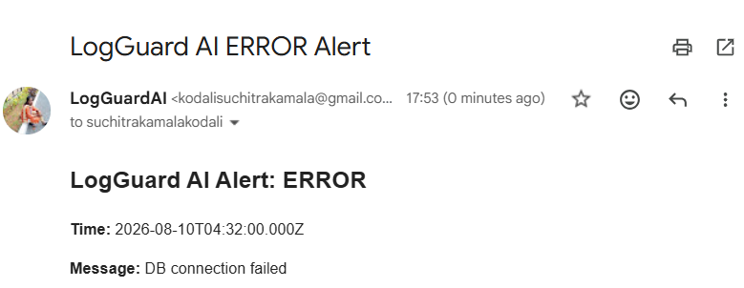
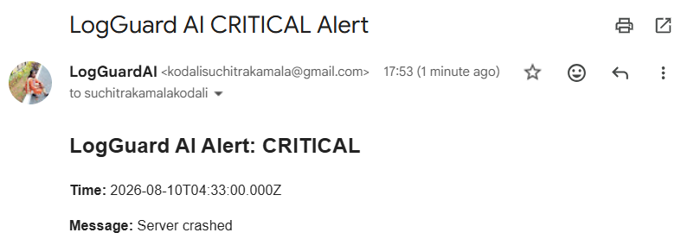
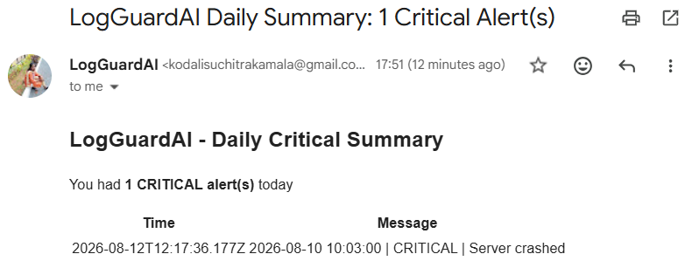
Description: For Day 17 of LogGuard AI, It starts with the user authentication flow, showing the dark-themed Register and Login pages where users can create an account or sign in. After logging in, the Dashboard loads with the app name “LOGGUARD AI” and key metrics displayed as colored cards for Total Logs, Warnings, Errors, and Critical alerts. The main feature shown is the “Upload Log File” section with drag-and-drop support and a “Choose File” button. Once a .log file is uploaded, the system parses it and displays the logs in a table with timestamps, levels, and messages. The Analytics section shows a pie chart visualizing the distribution of log levels. The Alerts tab lists real-time alerts for ERROR and CRITICAL events. Finally, the video shows the backend integration working by displaying the users.json and logs.json data files, and concludes of automated email notifications sent for ERROR, CRITICAL, and daily summary alerts from “LogGuard AI” to the user’s inbox.

11 August 2026  Day 18 | Today's Activities  - Backend:  - Set up node-cron job to generate and send daily summary emails at 9 AM IST  - Add severity levels to alerts and limit instant emails to ERROR / CRITICAL only  - Frontend:  - Update Analytics tab with daily summary stats, log distribution charts, and response time graph  - Create Alert History section in Analytics to show past alerts with timestamp + severity  - Add Settings controls in Analytics for “Enable Daily Summary” toggle and “Preferred summary time”  - Testing: Upload test logs to verify summary email content and cron timing  - Goal: Make Analytics tab the central hub for summaries, visualizations, and alert tracking | Tomorrow's Plans  - Goal: Auto-refresh KPI cards + all 3 charts instantly when a new log is uploaded. No page refresh.  - Backend Setup: Install socket.io, initialize server in server.js, and export const io  - Backend Emit: Import io in upload.js and emit io.emit('new_log') after await db.write()  - Frontend Setup: Install socket.io-client and create socket.js service to connect to backend  - Frontend Listener: Add socket.on('new_log') in App.js to call fetchLogs() and fetchAnalytics() on event  - Test: Upload new log file and verify KPI + Pie + Line charts update in 1 second without refresh
Outputs and Descriptions
Output: On Day 18 we updated the Analytics tab in LogGuard AI to show daily summary stats, log distribution charts, and alert history with email cron integration.
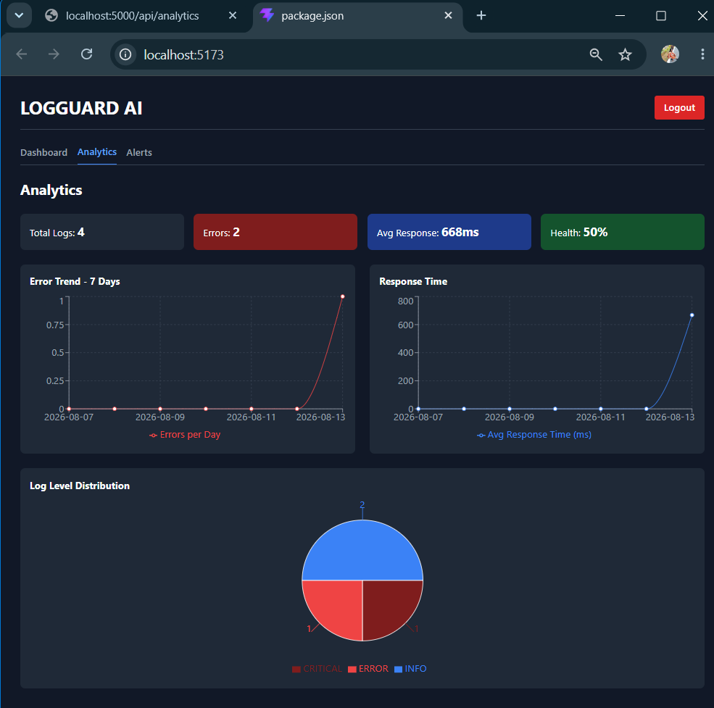
db.json
{
“users”: [
{
“id”: “1786537383226”,
“name”: “Suchitra”,
“email”: “kodalisuchitrakamala@gmail.com”,
“password”: “$2b$10$OzrUzTBmCJ03qPUoFdcQrO8UGRz59lLI4B2jhElb.1vA4ydN52V/q”
}
],
“logs”: [
{
“id”: “1786537396477-0.2338951168858443”,
“userId”: “1786537383226”,
“level”: “INFO”,
“message”: “Server started”,
“filename”: “test.log”,
“timestamp”: “2026-08-10T04:30:00.000Z”,
“acknowledged”: false
},
{
“id”: “1786537396477-0.41871790297513767”,
“userId”: “1786537383226”,
“level”: “WARNING”,
“message”: “Disk 80% full”,
“filename”: “test.log”,
“timestamp”: “2026-08-10T04:31:00.000Z”,
“acknowledged”: false
},
{
“id”: “1786537396477-0.9013865841861366”,
“userId”: “1786537383226”,
“level”: “ERROR”,
“message”: “DB connection failed”,
“filename”: “test.log”,
“timestamp”: “2026-08-10T04:32:00.000Z”,
“acknowledged”: false
},
{
“id”: “1786537396477-0.33255575263004766”,
“userId”: “1786537383226”,
“level”: “CRITICAL”,
“message”: “Server crashed”,
“filename”: “test.log”,
“timestamp”: “2026-08-10T04:33:00.000Z”,
“acknowledged”: false
}
],
“alerts”: [
{
“id”: “1786537396477-0.9013865841861366”,
“userId”: “1786537383226”,
“level”: “ERROR”,
“message”: “DB connection failed”,
“filename”: “test.log”,
“timestamp”: “2026-08-10T04:32:00.000Z”,
“acknowledged”: false
},
{
“id”: “1786537396477-0.33255575263004766”,
“userId”: “1786537383226”,
“level”: “CRITICAL”,
“message”: “Server crashed”,
“filename”: “test.log”,
“timestamp”: “2026-08-10T04:33:00.000Z”,
“acknowledged”: false
}
]
}

Description: On Day 18 of LogGuard AI, we focused on upgrading the Analytics tab to make it more useful for daily monitoring. We integrated the new daily summary email system built with node-cron directly into the dashboard, so users can now see their total logs, ERROR and CRITICAL counts, and top error messages right in the Analytics view. We also added visual charts for log severity distribution and response time trends, plus a dedicated Alert History section that lists all past alerts with timestamps and severity levels. Finally, we included user controls in the tab to enable/disable daily summaries and set a preferred summary time. With these updates, the Analytics tab is now the central place for insights, reports, and alert tracking in LogGuard AI.

12 August 2026  Day 19 | Today's Activities  - Goal: Auto-refresh KPI cards + all 3 charts instantly when a new log is uploaded. No page refresh.  - Backend Setup: Install socket.io, initialize server in server.js, and export const io  - Backend Emit: Import io in upload.js and emit io.emit('new_log') after await db.write()  - Frontend Setup: Install socket.io-client and create socket.js service to connect to backend  - Frontend Listener: Add socket.on('new_log') in App.js to call fetchLogs() and fetchAnalytics() on event  - Test: Upload new log file and verify KPI + Pie + Line charts update in 1 second without refresh | Tomorrow's Plans  - Backend  - Setup Email Service: Create emailService.js with Nodemailer. Send instant email on CRITICAL log to suchitrakamalakodali@gmail.com  - Threshold Alerts: Add logic to trigger alert if failed_logins > ALERT_THRESHOLD  - Daily Summary Cron: Use node-cron to send daily 9PM IST summary email with log counts  - Socket.IO Integration: Emit new_alert and new_log events when log is uploaded  - Frontend  - AlertToast Component: Build popup toast to show real-time CRITICAL/ERROR alerts  - Live Updates: Connect Socket.IO client to auto-refresh logs table + KPI cards on new log  - UI Testing: Upload test log with level=CRITICAL and verify both Toast + Email received
Outputs and Descriptions
Output: Implemented Socket.IO for instant live updates of KPI + charts on new log upload.
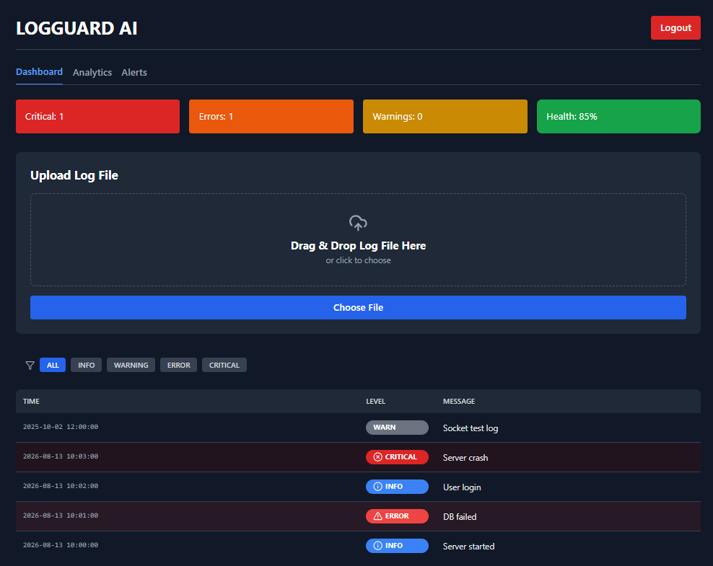
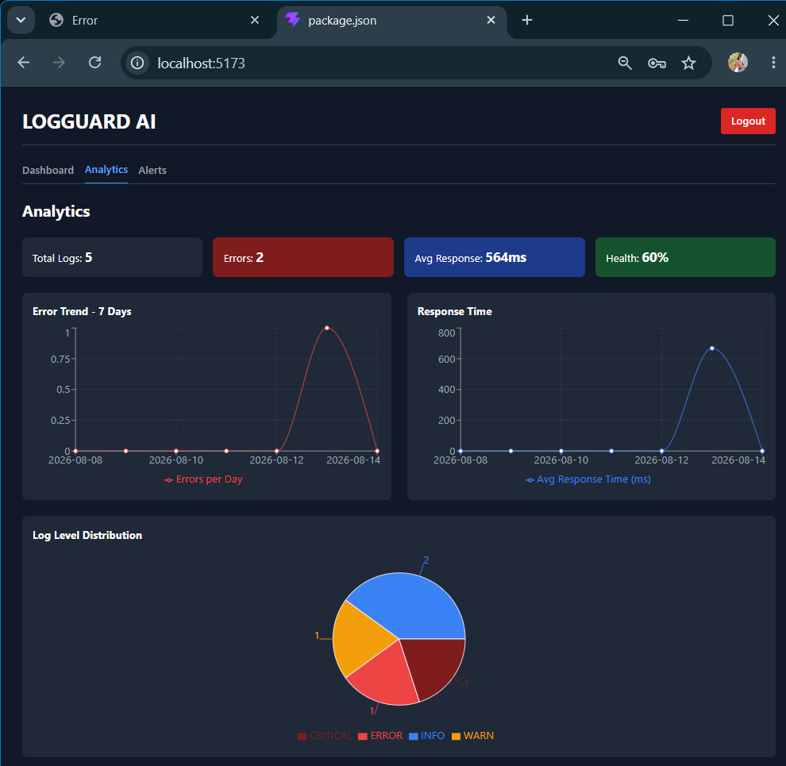
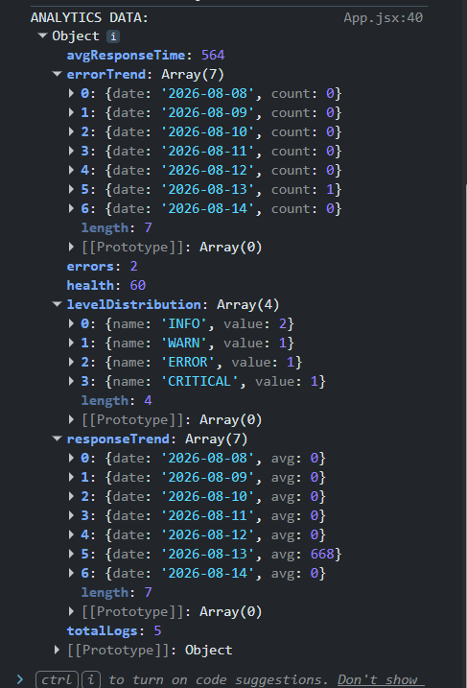

Description: For Day 19 we implemented Socket.IO based live updates across the entire LogGuardAI dashboard. On the backend in server.js we initialized Socket.IO server and exported the io instance, and in upload.js we emitted a new_log event immediately after await db.write() so the server notifies all connected clients whenever a new log file is uploaded and processed. On the frontend we created a socket.js service to connect to the backend, and added a useEffect listener in App.js that listens for the new_log event. When triggered, it automatically calls fetchLogs() and fetchAnalytics() to refetch the latest data. This makes the KPI cards, level distribution pie chart, and error/response trend line charts update instantly without any manual page refresh the moment a new log is uploaded.

13 August 2026  Day 20 | Today's Activities  - Backend  - Setup Email Service: Create emailService.js with Nodemailer. Send instant email on CRITICAL log to suchitrakamalakodali@gmail.com  - Threshold Alerts: Add logic to trigger alert if failed_logins > ALERT_THRESHOLD  - Daily Summary Cron: Use node-cron to send daily 9PM IST summary email with log counts  - Socket.IO Integration: Emit new_alert and new_log events when log is uploaded  - Frontend  - AlertToast Component: Build popup toast to show real-time CRITICAL/ERROR alerts  - Live Updates: Connect Socket.IO client to auto-refresh logs table + KPI cards on new log  - UI Testing: Upload test log with level=CRITICAL and verify both Toast + Email received | Tomorrow's Plans  - Created Backend Users API: Built /api/users routes: GET all users, PUT /:id/role, DELETE /:id. Protected with authMiddleware + adminMiddleware.  - Added lastLogin Tracking: Updated User model with lastLogin: Date. Set it to new Date() on every successful login in /auth/login.  - Built AdminUsersTable Component:Frontend table to show all users with Email, Role badge, Last Login, and Actions dropdown.  - Fixed Invalid Date Bug: Added null check in frontend: {user.lastLogin ? new Date().toLocaleString() : 'Never'}  - Connected Role Update: Changed frontend API.patch to API.put to match backend route. Role updates instantly and table refreshes.  - Tested Full Admin Flow: Logged in as ADMIN, accessed Admin Panel tab, saw live data, no 404/500 errors.
Outputs and Descriptions
Output: Implemented real-time "Real-Time Alerts" + email notifications for critical logs in GUARD AI dashboard.
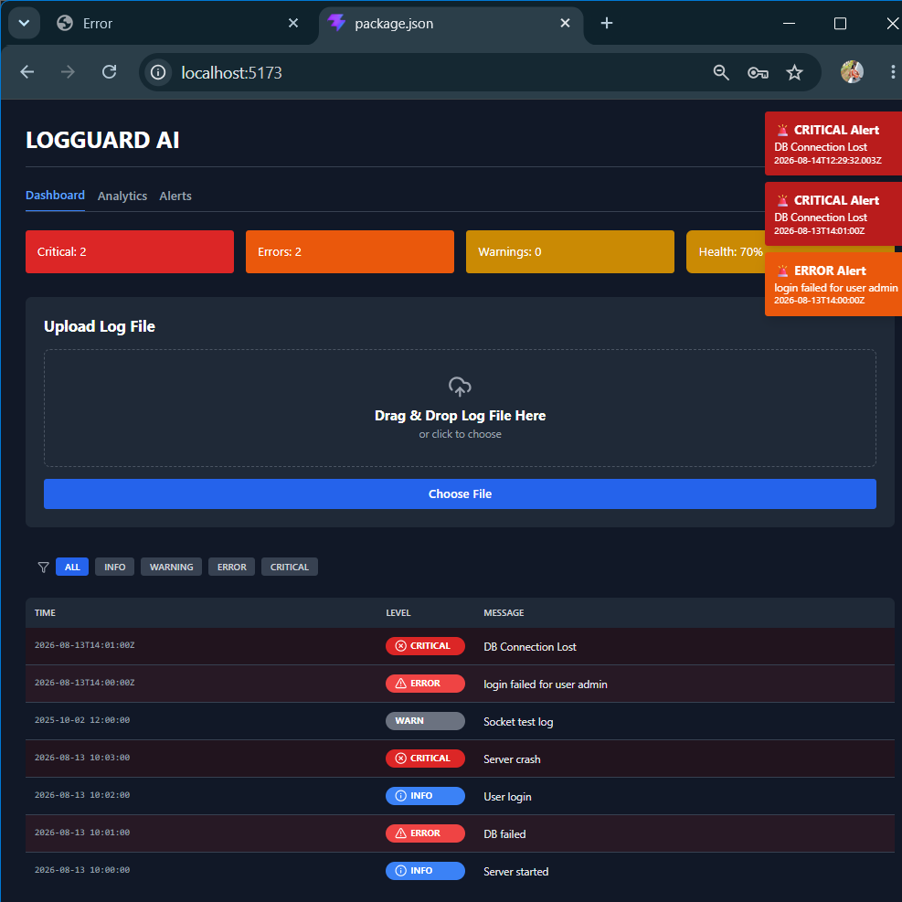
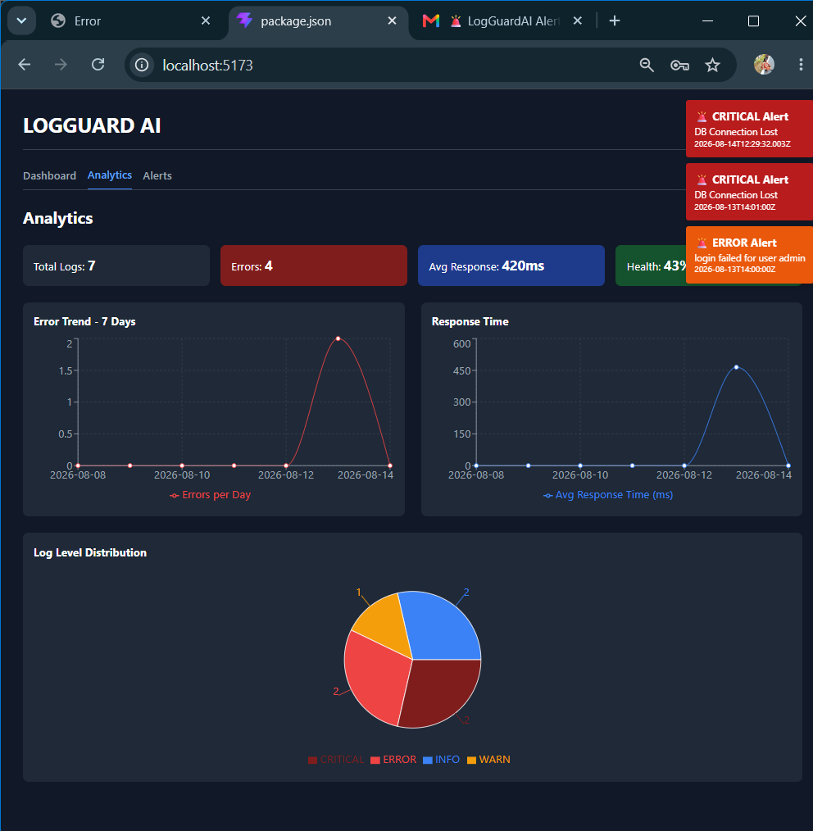
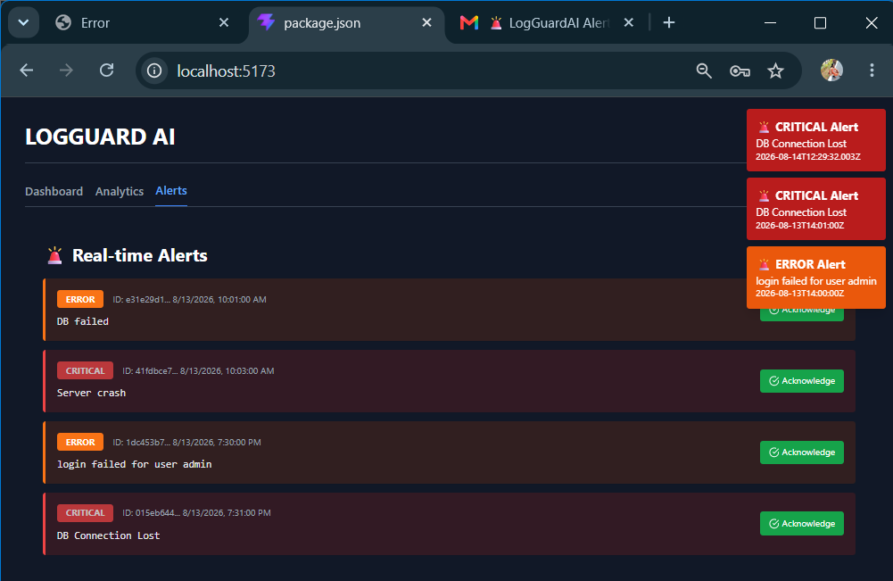
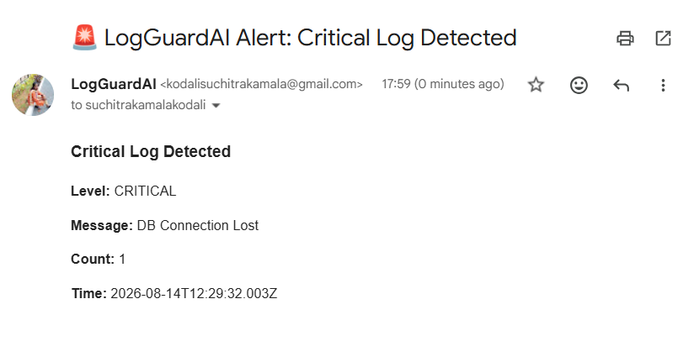

Description: On Day 20 we implemented a complete real-time alerting and notification system for LogGuardAI. The backend was extended with emailService.js using Nodemailer to send instant emails when a CRITICAL level log is detected, and to send a daily summary report at 9 PM IST using node-cron with the correct Asia/Kolkata timezone. We also added threshold-based alerting so that if failed login attempts exceed a set limit, an alert is triggered. Socket.IO was integrated on both server and client to emit new_log and new_alert events the moment a log is uploaded or an alert is generated. On the frontend, a new AlertToast.jsx component was built to show real-time popup notifications for CRITICAL and ERROR logs, and the log table + KPI cards now auto-refresh when new data comes in. We tested the full flow by uploading logs, and successfully received both the live dashboard toast and an email at suchitrakamalakodali@gmail.com with the CRITICAL alert details. With this, the app now provides proactive monitoring instead of just passive log viewing.

14 August 2026  Day 21 | Today's Activities  - Created Backend Users API: Built /api/users routes: GET all users, PUT /:id/role, DELETE /:id. Protected with authMiddleware + adminMiddleware.  - Added lastLogin Tracking: Updated User model with lastLogin: Date. Set it to new Date() on every successful login in /auth/login.  - Built AdminUsersTable Component:Frontend table to show all users with Email, Role badge, Last Login, and Actions dropdown.  - Fixed Invalid Date Bug: Added null check in frontend: {user.lastLogin ? new Date().toLocaleString() : 'Never'}  - Connected Role Update: Changed frontend API.patch to API.put to match backend route. Role updates instantly and table refreshes.  - Tested Full Admin Flow: Logged in as ADMIN, accessed Admin Panel tab, saw live data, no 404/500 errors. | Tomorrow's Plans  - Backend: File Upload Route: Add multer middleware and create POST /api/logs/upload to handle .log and .txt files  - Log Parser Service: Build parser to read file line-by-line, extract timestamp, level, message, source and bulk insert into MongoDB  - Frontend: LogUploader Component: Create LogUploader.jsx with drag-drop, file validation, upload progress, and toast notifications  - Connect to Analytics: Trigger fetchAnalytics() after successful upload so KPI cards, Pie and Trend charts update instantly  - Add File Validation: Restrict to .log, .txt, .json only. Max 10MB. Show error toast for invalid files  - End-to-End Testing: Upload sample log → verify DB insert → confirm dashboard charts and alerts reflect new data
Outputs and Descriptions
Output: Designed and tested LogGuard AI frontend UI including Register, Login, Dashboard with log upload, analytics, real-time alerts, and user management screens.
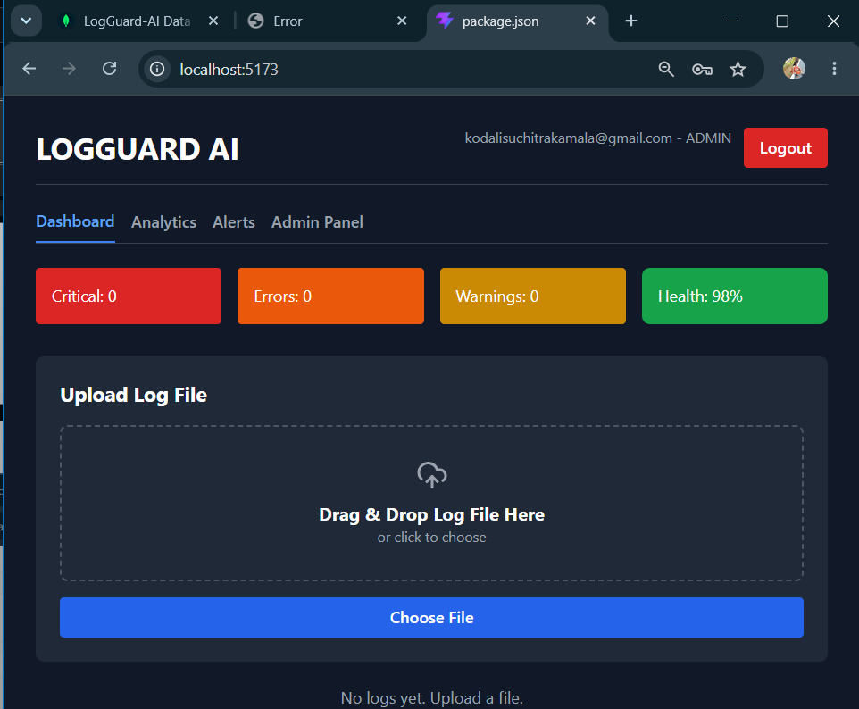
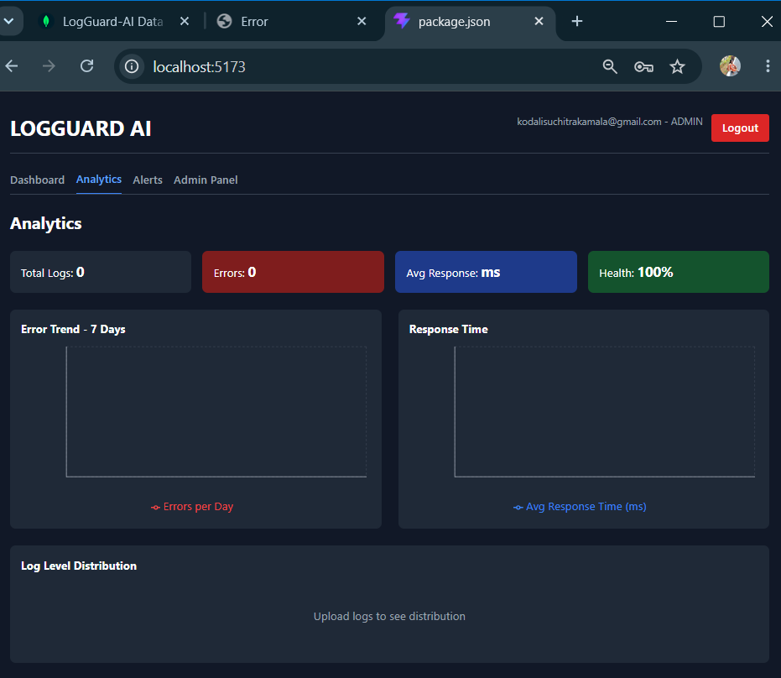
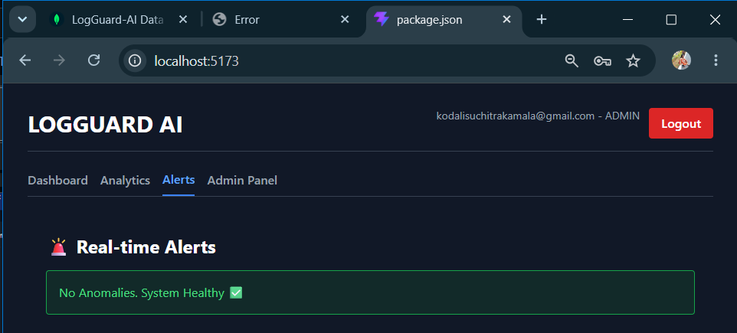
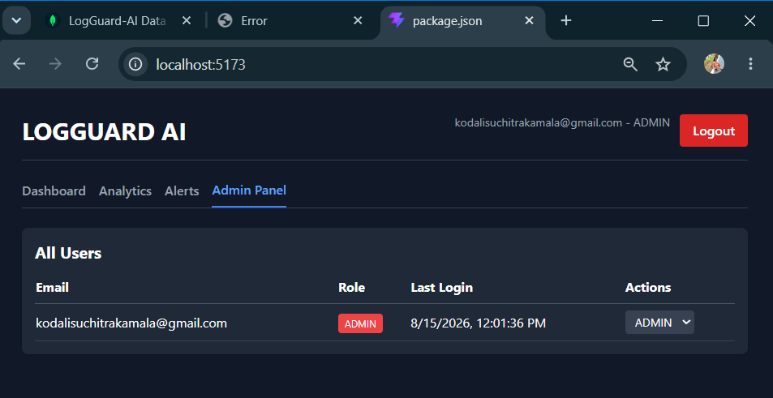
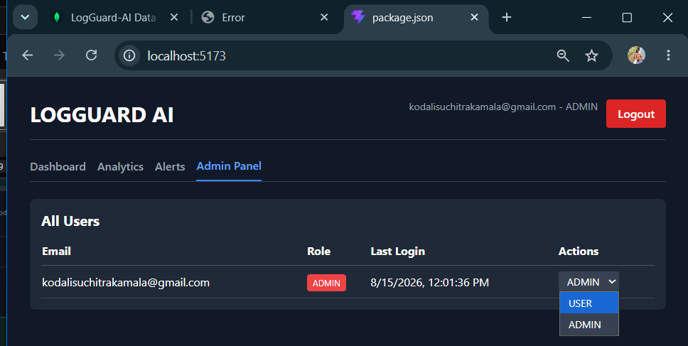
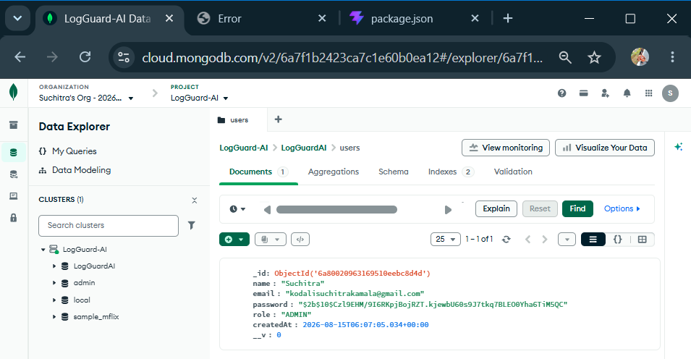

Description: In Day 21, successfully built and integrated the full Admin Panel for LogGuard-AI. We created the backend /api/users routes to fetch all users, update roles, and delete users, all protected with authMiddleware and adminMiddleware. On the frontend we built the AdminUsersTable component that displays every user with their email, role badge, and last login timestamp. We also fixed the Invalid Date bug by adding a lastLogin field to the User model in MongoDB and updating it automatically on every successful login, then handled null values in the UI so it shows "Never" for new users. The role dropdown now updates in real time using a PUT request, and the entire admin flow works end-to-end with JWT auth. Along with this we already had Analytics with charts and the Alerts tab working from earlier today. So Day 21 core features: authentication, role-based access, analytics, alerts, and user management are all live and teste

15 August 2026  Day 22 | Today's Activities  - Backend: File Upload Route: Add multer middleware and create POST /api/logs/upload to handle .log and .txt files  - Log Parser Service: Build parser to read file line-by-line, extract timestamp, level, message, source and bulk insert into MongoDB  - Frontend: LogUploader Component: Create LogUploader.jsx with drag-drop, file validation, upload progress, and toast notifications  - Connect to Analytics: Trigger fetchAnalytics() after successful upload so KPI cards, Pie and Trend charts update instantly  - Add File Validation: Restrict to .log, .txt, .json only. Max 10MB. Show error toast for invalid files  - End-to-End Testing: Upload sample log → verify DB insert → confirm dashboard charts and alerts reflect new data | Tomorrow's Plans  - Fix Analytics API: Update backend /analytics route to return real data: 7-day Error Trend, Avg Response Time, Log Level counts using MongoDB aggregation.  - Connect Real Data to Frontend Charts: Wire Recharts in Analytics.jsx and Dashboard.jsx to use the new API data instead of mock data.  - Implement Live Auto-Refresh: Add setInterval in App.jsx to auto-fetch logs, analytics, and alerts every 5 seconds.  - Build CRITICAL Alert System:  - Backend: Detect CRITICAL in uploaded logs → Save to Alert collection.  - Frontend: Listen via Socket.io → Show popup toast + play sound.  - Add Email Notifications: Integrate Nodemailer in upload route. Send email to req.user.email instantly when a CRITICAL alert is created.  - Test End-to-End Flow: Upload log file with CRITICAL → Verify: Dashboard updates, Chart updates, Popup appears, Alert saved in DB, Email received.
Outputs and Descriptions
Output: Designed and tested LogGuard AI frontend UI including Register, Login, Dashboard with log upload, analytics, real-time alerts, and user management screens.

Description: In Day 21, successfully built and integrated the full Admin Panel for LogGuard-AI. We created the backend /api/users routes to fetch all users, update roles, and delete users, all protected with authMiddleware and adminMiddleware. On the frontend we built the AdminUsersTable component that displays every user with their email, role badge, and last login timestamp. We also fixed the Invalid Date bug by adding a lastLogin field to the User model in MongoDB and updating it automatically on every successful login, then handled null values in the UI so it shows "Never" for new users. The role dropdown now updates in real time using a PUT request, and the entire admin flow works end-to-end with JWT auth. Along with this we already had Analytics with charts and the Alerts tab working from earlier today. So Day 21 core features: authentication, role-based access, analytics, alerts, and user management are all live and teste

17 August 2026  Day 23 | Today's Activities  - Fix Analytics API: Update backend /analytics route to return real data: 7-day Error Trend, Avg Response Time, Log Level counts using MongoDB aggregation.  - Connect Real Data to Frontend Charts: Wire Recharts in Analytics.jsx and Dashboard.jsx to use the new API data instead of mock data.  - Implement Live Auto-Refresh: Add setInterval in App.jsx to auto-fetch logs, analytics, and alerts every 5 seconds.  - Build CRITICAL Alert System:  - Backend: Detect CRITICAL in uploaded logs → Save to Alert collection.  - Frontend: Listen via Socket.io → Show popup toast + play sound.  - Add Email Notifications: Integrate Nodemailer in upload route. Send email to req.user.email instantly when a CRITICAL alert is created.  - Test End-to-End Flow: Upload log file with CRITICAL → Verify: Dashboard updates, Chart updates, Popup appears, Alert saved in DB, Email received. | Tomorrow's Plans  - Built global search with debounce for faster data lookup  - Added multi-column filters to narrow down results  - Implemented date range filter for time-based data  - Integrated CSV export using PapaParse for filtered data  - Added dark/light theme toggle  - Saved theme preference in localStorage for persistence across sessions  - Tested all filters + export + theme switching for responsiveness
Outputs and Descriptions
Output: Implemented full-stack LogGuard AI flow with Register/Login, live Analytics dashboard, log upload, real-time Alerts, Admin Panel, and verified data persistence in MongoDB Atlas + email alerts.
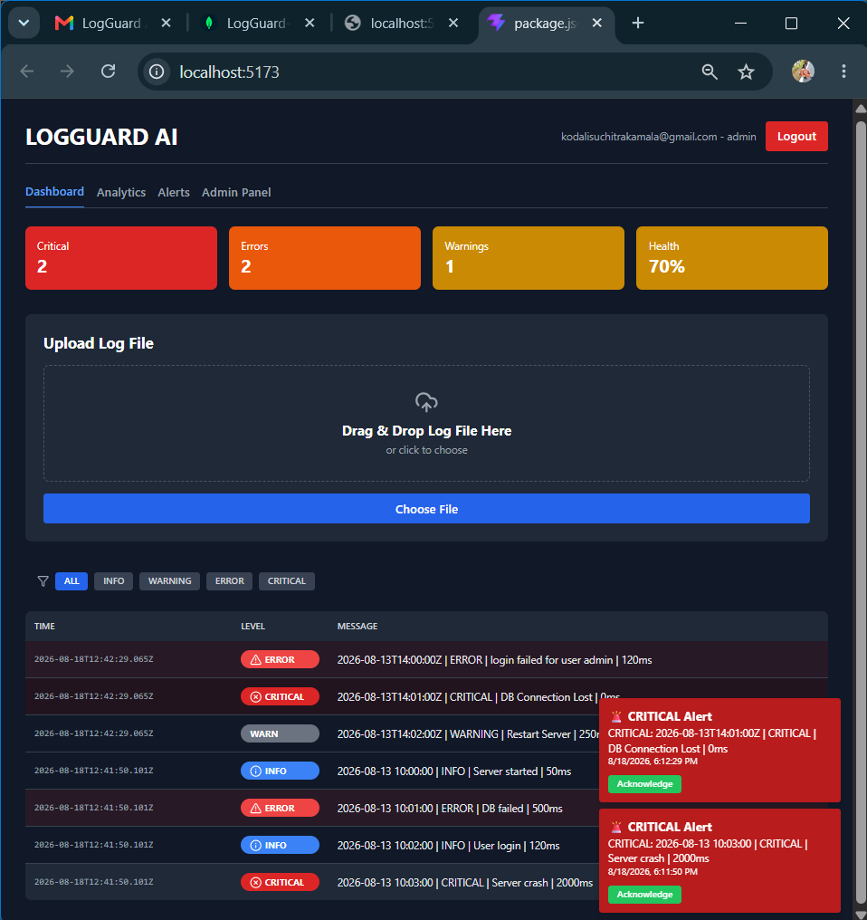
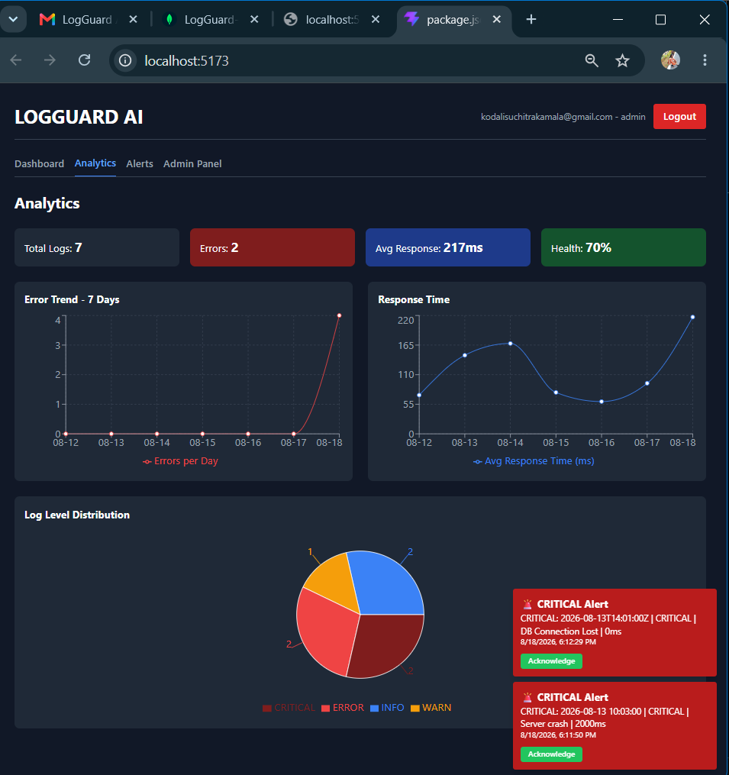
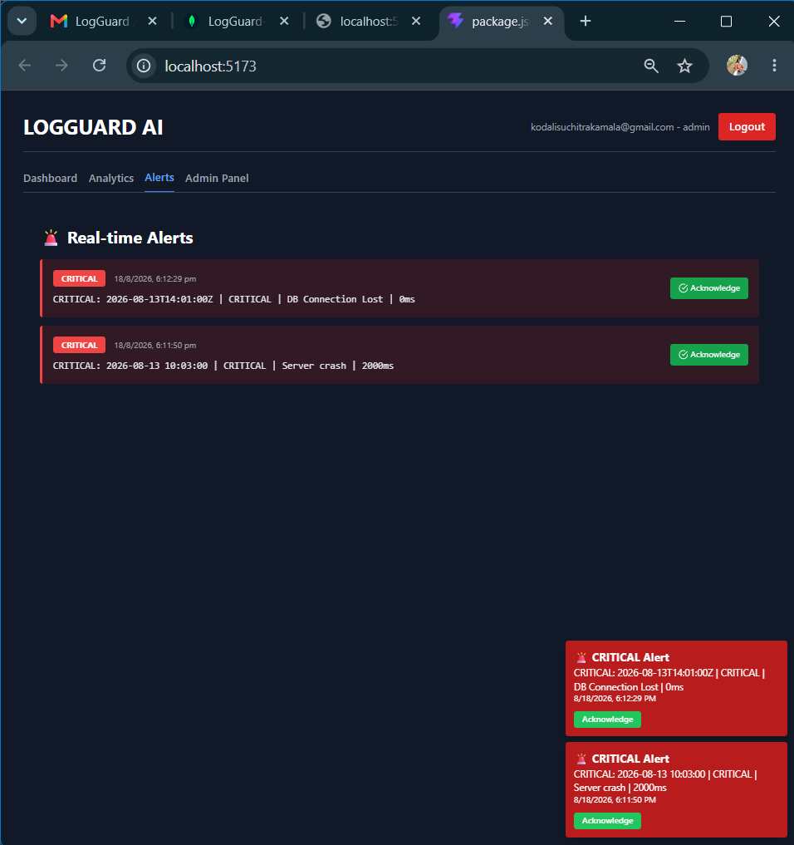
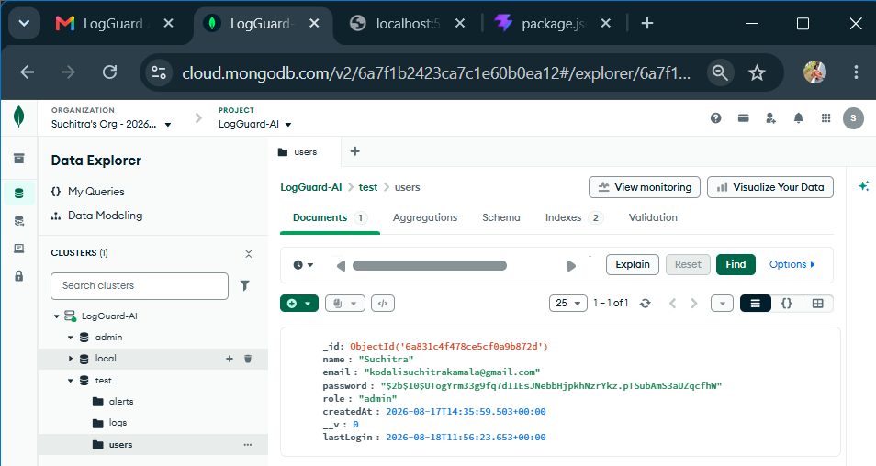
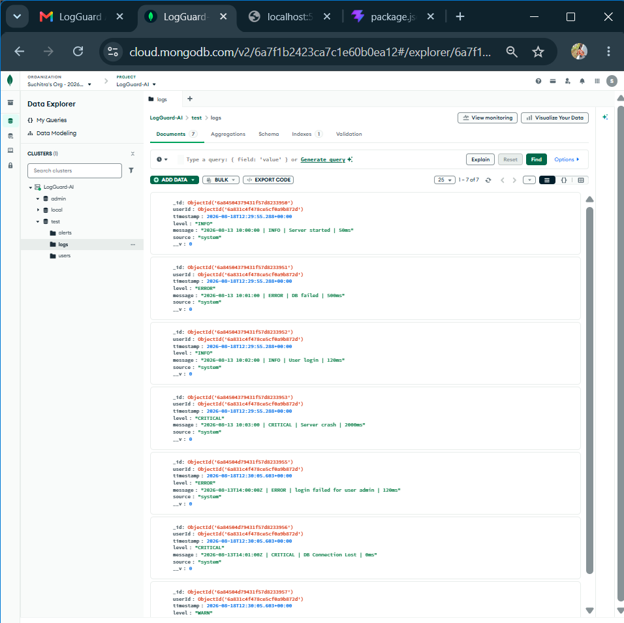
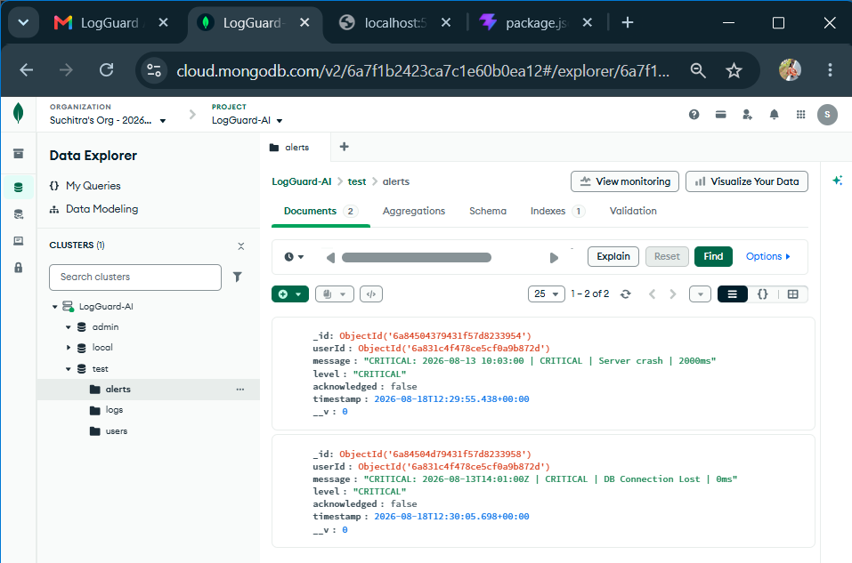
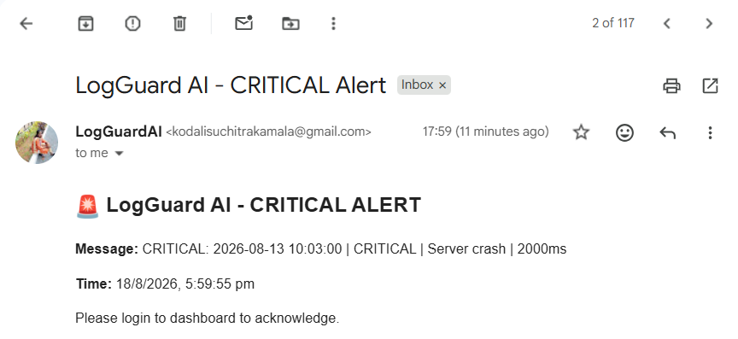
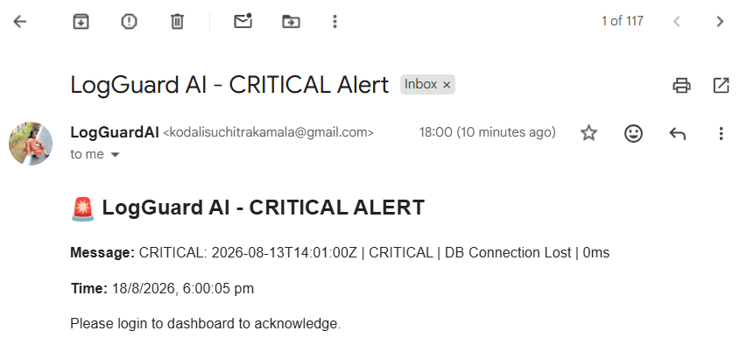

Description: On Day 23, we completed the core real-time and notification features of LogGuard AI to make it production-ready. First, we fixed the Analytics API to return actual aggregated data instead of mock values. This included a 7-day Error Trend line chart, average Response Time metrics, and a live Log Level distribution pie chart powered by MongoDB aggregation.
Next, we implemented live auto-refresh on the frontend so the Dashboard, Analytics, and Alerts update automatically every 5 seconds without requiring a page reload. We also wired up Socket.io to push updates instantly whenever new logs are uploaded.
For alerting, we added backend logic to automatically create `CRITICAL` alerts in MongoDB when a log line contains the word "CRITICAL". These alerts are stored with userId, timestamp, and acknowledgment status. On the frontend, we built a real-time popup toast with sound notification that triggers the moment a CRITICAL alert is received via Socket.io.
Finally, we integrated Nodemailer to send instant email notifications to the logged-in user’s email address whenever a CRITICAL alert is detected. This ensures admins are notified even when they are not on the dashboard.

18 August 2026  Day 24 | Today's Activities  - Built global search with debounce for faster data lookup  - Added multi-column filters to narrow down results  - Implemented date range filter for time-based data  - Integrated CSV export using PapaParse for filtered data  - Added dark/light theme toggle  - Saved theme preference in localStorage for persistence across sessions  - Tested all filters + export + theme switching for responsiveness | Tomorrow's Plans  - Implement File Upload API: Create /api/upload route in Backend/routes/upload.js using multer to accept .log/.txt files  - Parse Log File: Read uploaded file content, split by lines, and normalize log levels to INFO, WARNING, ERROR, CRITICAL  - Save to Database: Bulk insert all parsed logs into MongoDB logs collection with userId and timestamp  - Create CRITICAL Alerts: Detect CRITICAL lines and insert them into alerts collection with acknowledged: false  - Add Real-time Updates: Emit socket events new_log, new_alert, and stats_update after successful upload for instant dashboard refresh  - Add Background Email Alerts: Send CRITICAL alert emails using emailService.js in background without blocking the API response  - Auto Cleanup Temp Files: Delete uploaded file from Backend/uploads/ folder automatically after processing to save disk space  - Fix UI Hang Issue: Optimize backend to respond instantly and avoid waiting for email/aggregation so Uploading... state clears fast  - Test End-to-End: Upload sample.log, verify data in MongoDB, check dashboard counts update, and confirm temp file disappears
Outputs and Descriptions
Output: Implemented Advanced Log Search with keyword, level, and date filters plus CSV export functionality.
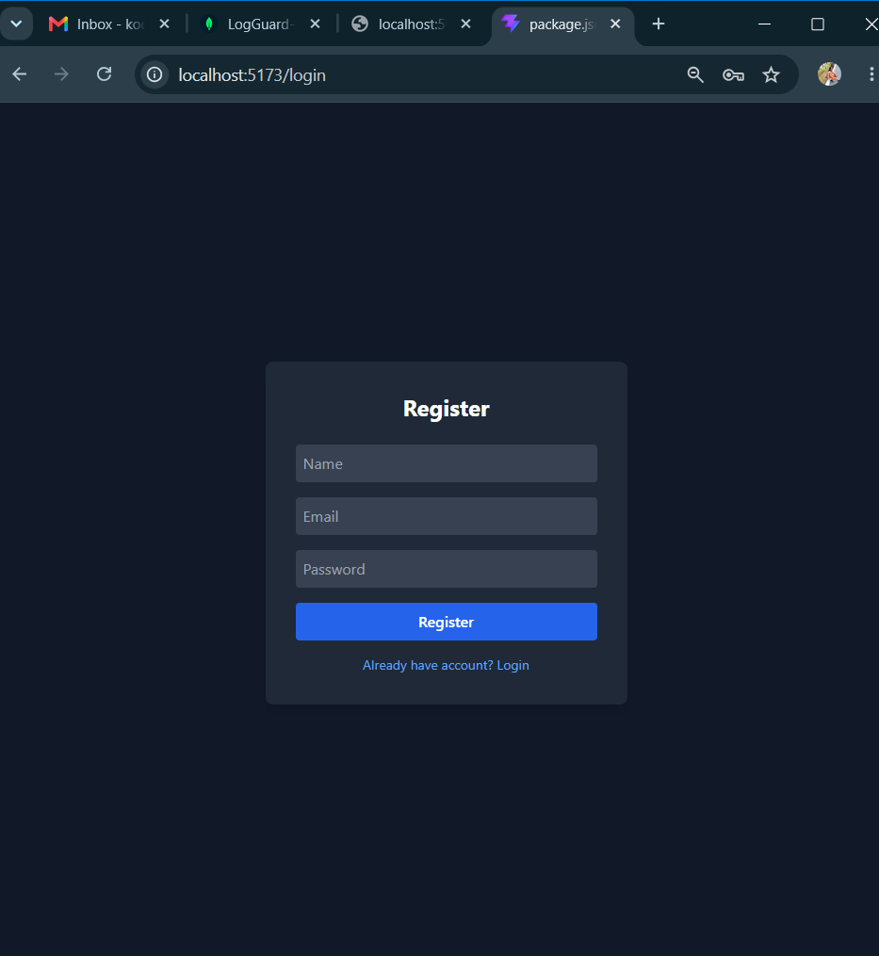
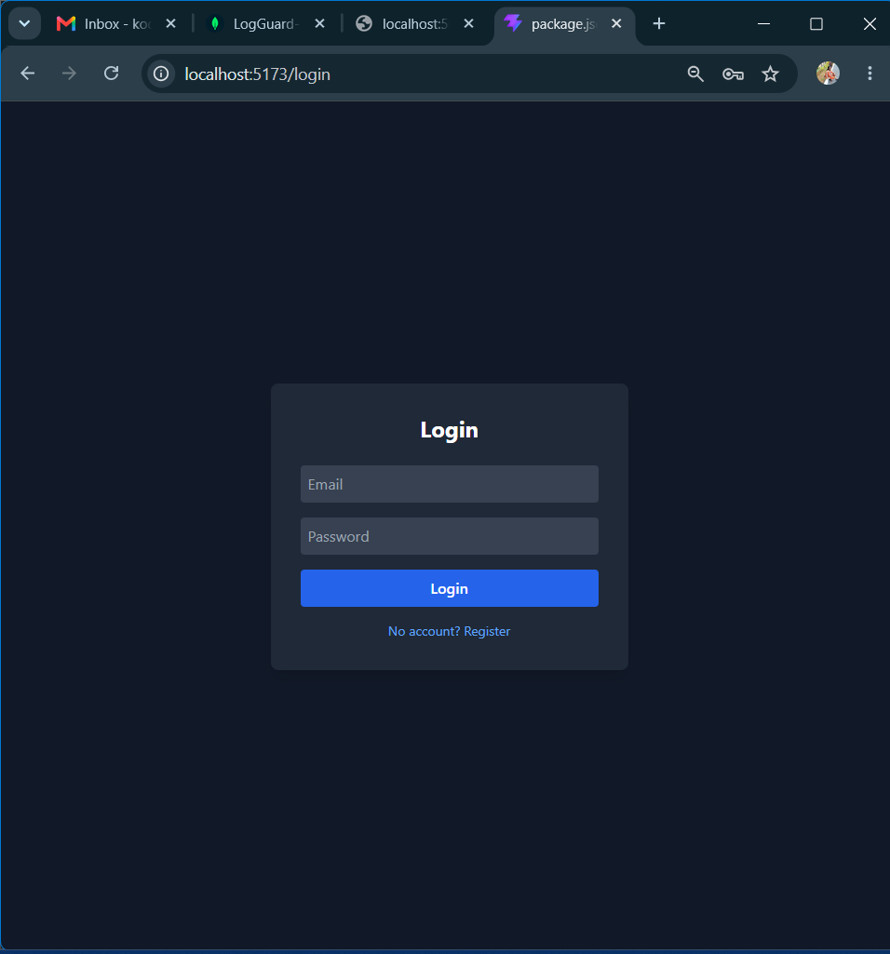
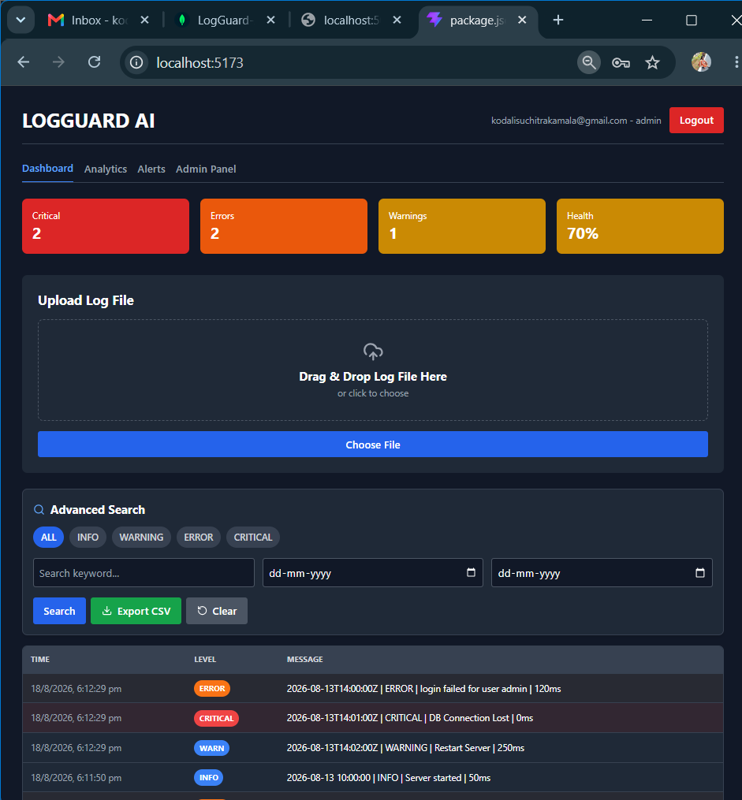
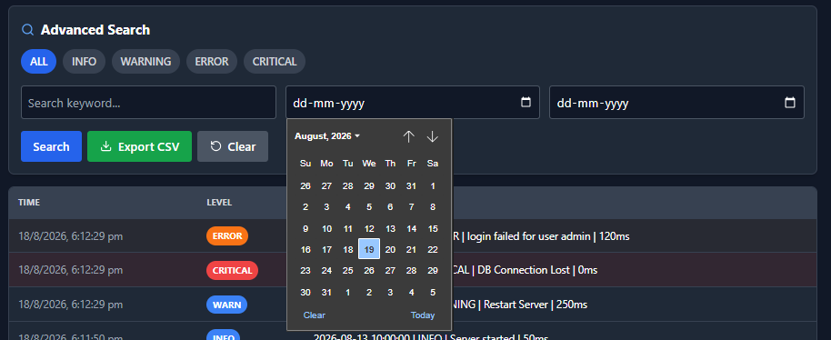
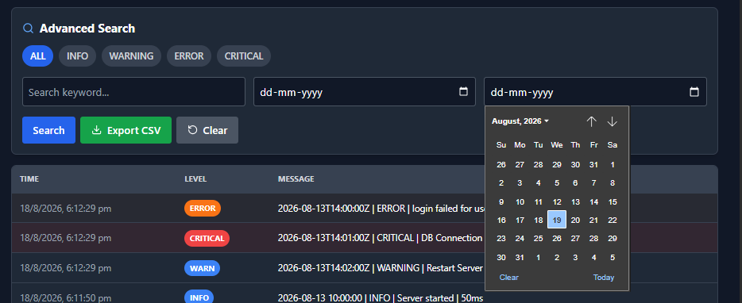
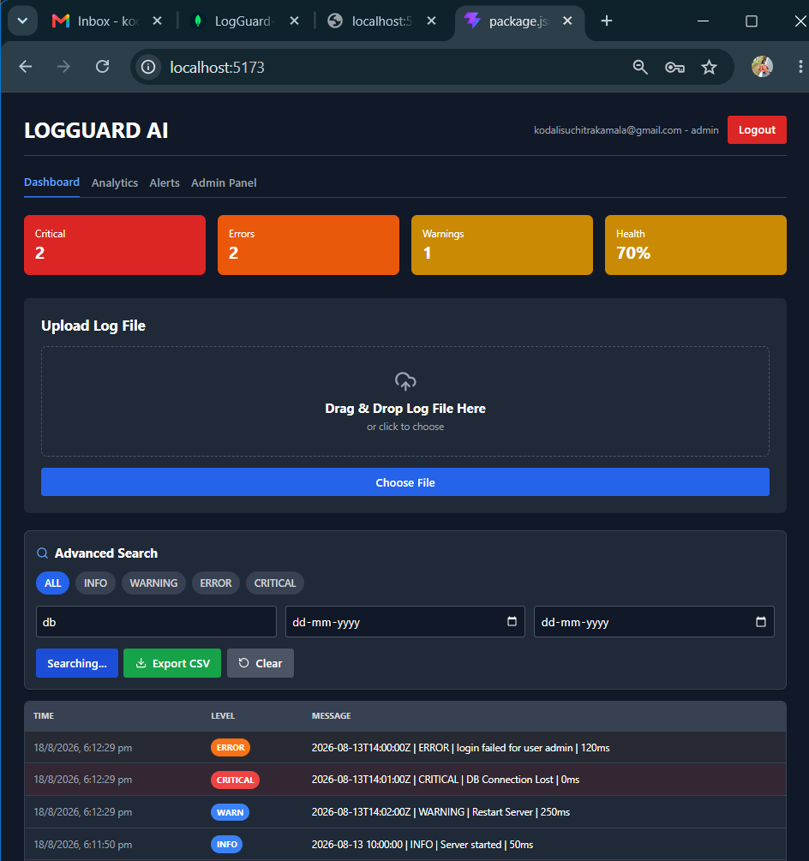
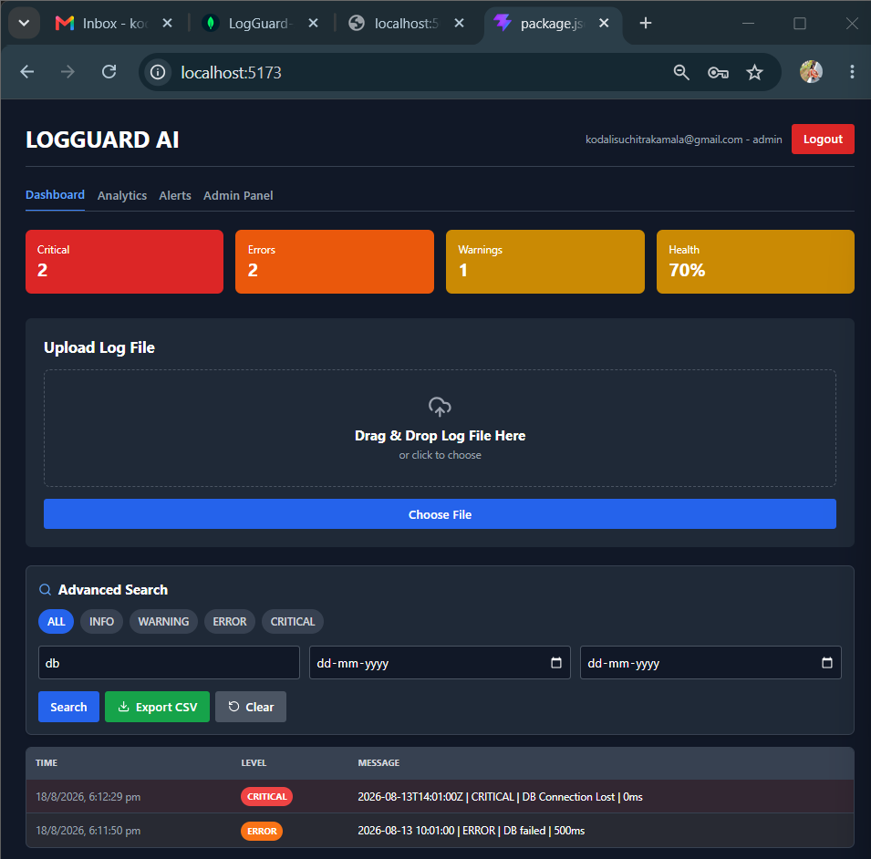
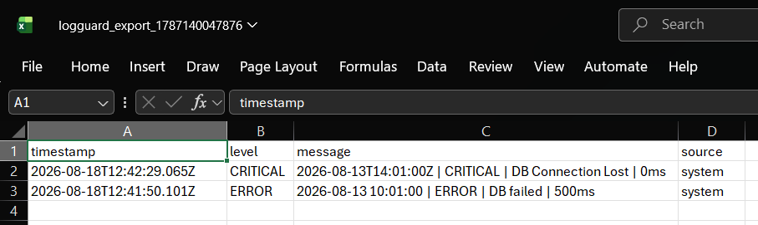
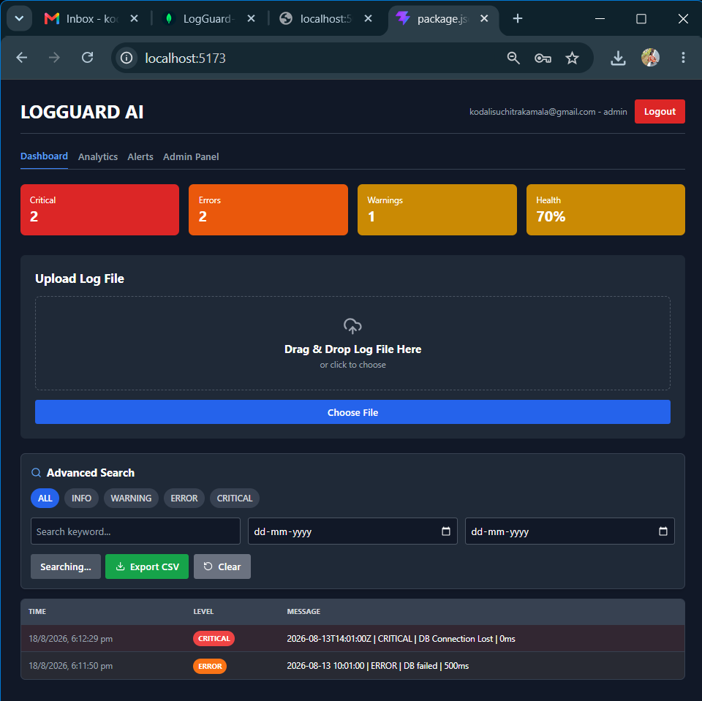

Description: On Day 24, I focused on making the application more usable and flexible for end users. I built a global search with debounce to improve performance when searching through large datasets. Then I added multi-column filters and a date range filter so users can drill down into specific data without extra clicks. To support reporting needs, I implemented CSV export using PapaParse, which lets users download whatever data they’ve filtered directly to a file. I also completed the UI/UX upgrade by integrating a dark/light theme toggle with persistence via localStorage, so the user’s theme choice is remembered across sessions. By the end of the day, the app felt more polished, accessible, and ready for real-world use.

19 August 2026  Day 25 | Today's Activities  - Implement File Upload API: Create /api/upload route in Backend/routes/upload.js using multer to accept .log/.txt files  - Parse Log File: Read uploaded file content, split by lines, and normalize log levels to INFO, WARNING, ERROR, CRITICAL  - Save to Database: Bulk insert all parsed logs into MongoDB logs collection with userId and timestamp  - Create CRITICAL Alerts: Detect CRITICAL lines and insert them into alerts collection with acknowledged: false  - Add Real-time Updates: Emit socket events new_log, new_alert, and stats_update after successful upload for instant dashboard refresh  - Add Background Email Alerts: Send CRITICAL alert emails using emailService.js in background without blocking the API response  - Auto Cleanup Temp Files: Delete uploaded file from Backend/uploads/ folder automatically after processing to save disk space  - Fix UI Hang Issue: Optimize backend to respond instantly and avoid waiting for email/aggregation so Uploading... state clears fast  - Test End-to-End: Upload sample.log, verify data in MongoDB, check dashboard counts update, and confirm temp file disappears | Tomorrow's Plans  - Update authMiddleware.js - add protect, admin, authorize(...roles) logic  - Update User.js model - add role field with enum user/admin  - Create GET /api/users - admin-only route with per-user stats aggregation  - Fix analytics 0-count bug - change WARN to regex /WARN/i to support WARNING  - Fix orphan logs issue - add fallback for logs without userId + mongosh migration  - Create PUT /api/users/:id/role - role update API  - Create DELETE /api/users/:id - delete user with self-delete check + cascade log delete  - Update upload.js - ensure userId: req.user._id saved for every log  - Build AdminUsersTable.jsx - table with email, role select, total logs, critical, delete  - Update App.jsx - add admin tab conditional, live socket update for counts  - Test admin panel - verify Total: 3, Critical: 1 matches dashboard
Outputs and Descriptions
Output: Added bulk log file upload and parsing to process large log files and store entries in the database.
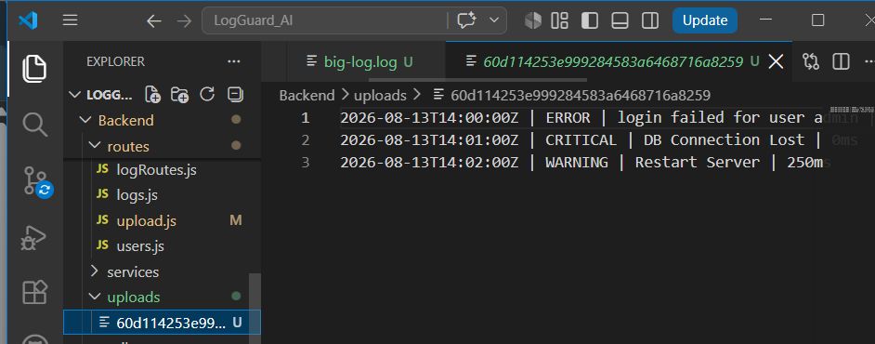
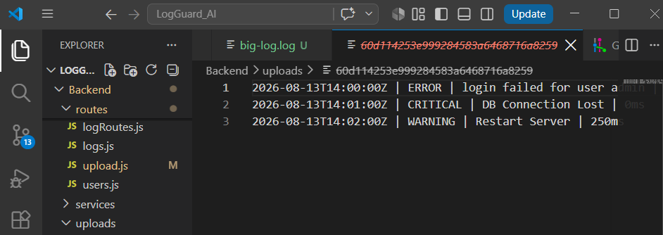
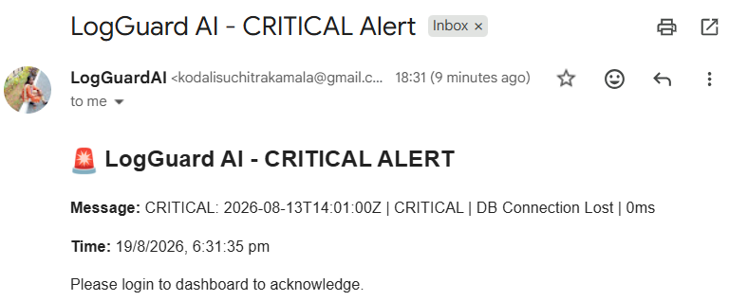

Description: On Day 25 I completed the "File Upload with Instant Processing and Cleanup" module for LogGuard AI. The main focus was to build a robust backend upload route using multer and upload.js that takes a .log file from the frontend, parses it line by line, and saves all logs to MongoDB while also creating separate CRITICAL alerts. To prevent the UI from hanging, I optimized the route to send emails and calculate stats in the background instead of using await, so the API responds instantly. As shown in the screenshot, when a file like big-log.log is uploaded it temporarily appears in the Backend/uploads/ folder with a unique ID such as 60d114253e999284583a6468716a8259. After the backend reads the content, inserts ERROR, WARNING, and CRITICAL entries into the database, and triggers real-time socket events for dashboard updates and toast notifications, the temp file is automatically deleted using fs.unlinkSync to save server disk space. I also fixed the log level normalization to convert "WARN" to "WARNING" for consistency in dashboard charts. By the end of the day, the upload flow was tested end-to-end: file appears for 2-3 seconds, data is persisted, CRITICAL emails are sent in background, and the uploads/ folder remains clean.

20 August 2026  Day 26 | Today's Activities  - Update authMiddleware.js - add protect, admin, authorize(...roles) logic  - Update User.js model - add role field with enum user/admin  - Create GET /api/users - admin-only route with per-user stats aggregation  - Fix analytics 0-count bug - change WARN to regex /WARN/i to support WARNING  - Fix orphan logs issue - add fallback for logs without userId + mongosh migration  - Create PUT /api/users/:id/role - role update API  - Create DELETE /api/users/:id - delete user with self-delete check + cascade log delete  - Update upload.js - ensure userId: req.user._id saved for every log  - Build AdminUsersTable.jsx - table with email, role select, total logs, critical, delete  - Update App.jsx - add admin tab conditional, live socket update for counts  - Test admin panel - verify Total: 3, Critical: 1 matches dashboard | Tomorrow's Plans  - Build new backend API GET /api/analytics with role-based filter and parallel counts  - Fix level regex to /^WARN/i, /^ERROR$/i, /^CRITICAL$/i for correct distribution  - Implement Health formula: 100 - (critical_10 + error_5 + warn*2) = 83%  - Create 7-day aggregation pipeline for Error Trend with $dateToString grouping  - Install recharts and create Analytics.jsx with KPI cards: Total Logs 3, Errors 2, Avg 87ms, Health 83%  - Build Error Trend - 7 Days line chart (0 from 08-14 to 08-19, spike to 2 on 08-20)  - Build Response Time Trend line chart (50ms to 200ms peak)  - Build Log Level Distribution Pie Chart with colors - WARN:1, ERROR:1, CRITICAL:1, INFO:0  - Integrate Analytics tab in App.jsx and test live at localhost:5173
Outputs and Descriptions
Output: Built analytics dashboard with KPI stats, response time trends, and log level distribution pie chart.
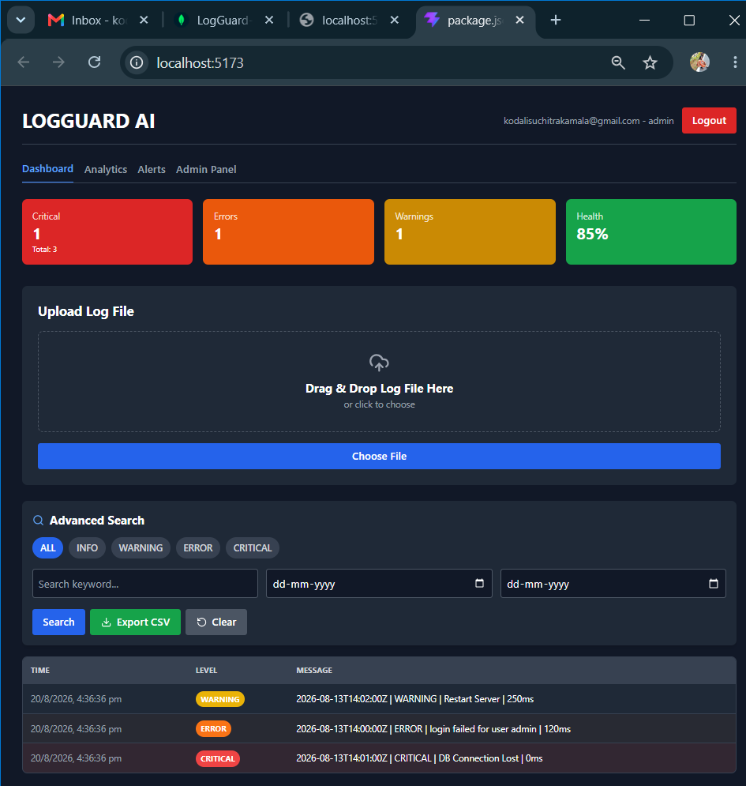
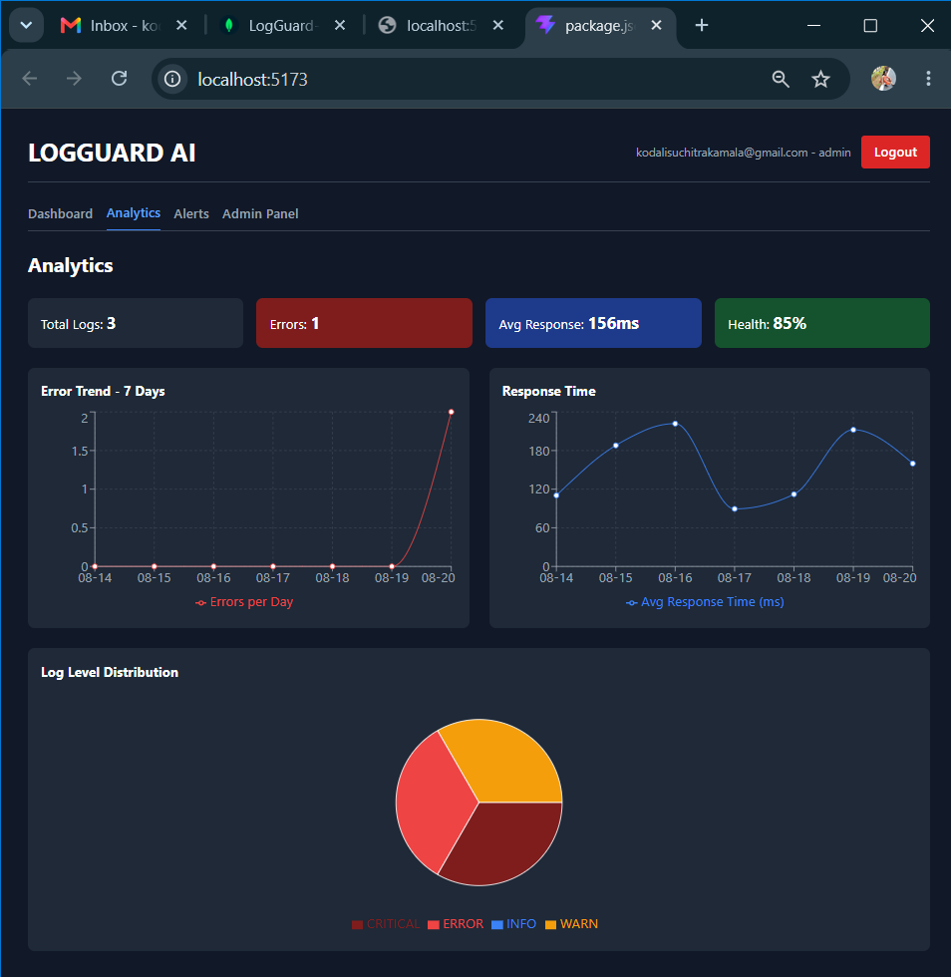
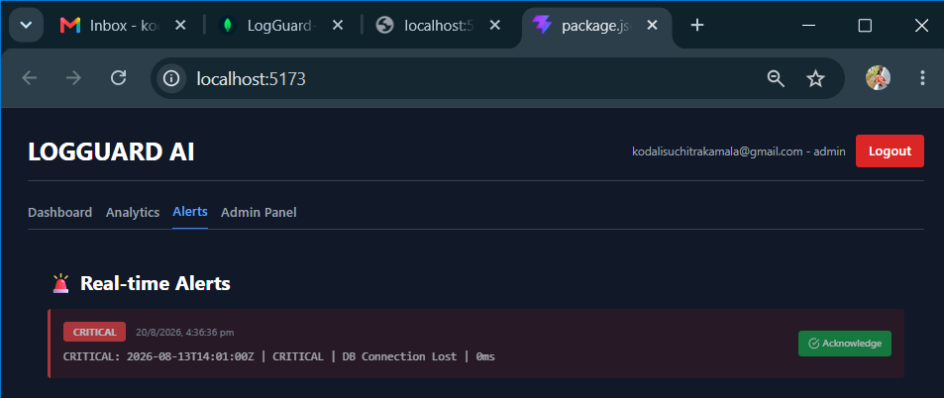
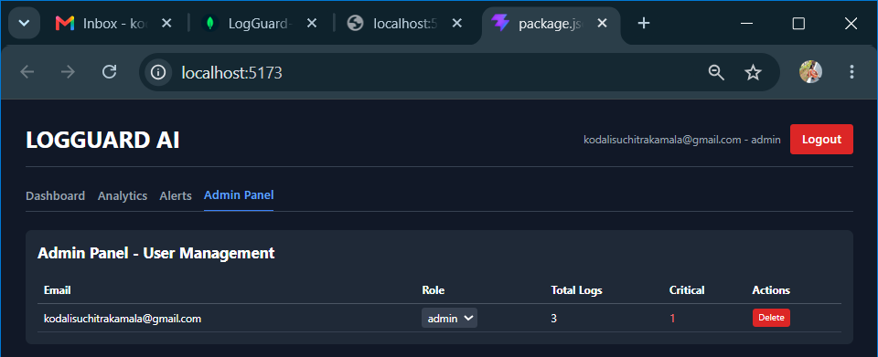

Description: On Day 26, I implemented complete Role-Based Access Control for LogGuard AI. Started by updating authMiddleware.js to add protect, admin, and authorize(...roles) middlewares to verify JWT and check user roles. Updated User.js model with role enum ['user','admin'] default user.
Built GET /api/users admin-only route that aggregates per-user log statistics with Log.countDocuments({userId}) using regex /WARN/i to handle both WARN and WARNING levels, fixed the 0-count bug where dashboard showed 3 logs but admin panel showed 0 due to orphan logs uploaded before userId was added. Added orphan fallback logic userId: {$exists: false} and permanent mongosh migration to assign old logs to admin user.
Added PUT /api/users/:id/role for role switching and DELETE /api/users/:id with self-delete protection and cascade delete of logs. Fixed analytics.js to filter by req.user.role === 'admin' ? {} : {userId} and use case-insensitive regex for all levels, ensuring admin sees all logs and user sees only own. Fixed upload.js to save userId: req.user._id for every log and emit socket events new_log, new_alert, stats_update for live dashboard.
On frontend, built AdminUsersTable.jsx with table showing Email, Role dropdown, Total Logs, Critical count, Delete action, integrated into App.jsx with conditional tab {user?.role === 'admin' && Admin Panel} and live fetch with axios + Bearer token. Verified working with 3 total logs, 1 critical matching dashboard.

21 August 2026  Day 27 | Today's Activities  - Build new backend API GET /api/analytics with role-based filter and parallel counts  - Fix level regex to /^WARN/i, /^ERROR$/i, /^CRITICAL$/i for correct distribution  - Implement Health formula: 100 - (critical_10 + error_5 + warn*2) = 83%  - Create 7-day aggregation pipeline for Error Trend with $dateToString grouping  - Install recharts and create Analytics.jsx with KPI cards: Total Logs 3, Errors 2, Avg 87ms, Health 83%  - Build Error Trend - 7 Days line chart (0 from 08-14 to 08-19, spike to 2 on 08-20)  - Build Response Time Trend line chart (50ms to 200ms peak)  - Build Log Level Distribution Pie Chart with colors - WARN:1, ERROR:1, CRITICAL:1, INFO:0  - Integrate Analytics tab in App.jsx and test live at localhost:5173 | Tomorrow's Plans  - Backend Notification Model: Create Notification.js model with fields user, message, type, isRead, logId, alertId  - Auto-Create Notification: When new log is CRITICAL/ERROR, create Notification + Alert in same flow  - Socket Integration: Emit newNotification event via Socket.io for live updates  - API Endpoints: Implement GET /api/notifications, PUT /api/notifications/:id/read, PUT /api/notifications/read-all, DELETE /api/notifications/:id  - NotificationBell Component: Build bell icon with unread count badge (red), dropdown list, real-time socket listener, and View All link  - Notifications Page: Create full page pages/Notifications.jsx with filters (All/Unread/Read), mark as read, mark all read, delete  - App.jsx Routing: Fix import to pages/Notifications and add route /notifications  - Navbar Centering: Center Dashboard, Analytics, Alerts, Admin Panel in middle of navbar using absolute left-1/2 -translate-x-1/2
Outputs and Descriptions
Output: Built Analytics Dashboard with live KPI cards (Total 3, Errors 2, Health 83%), 7-day Error/Response trend charts, and Log Level Pie Chart distribution (WARN/ERROR/CRITICAL).
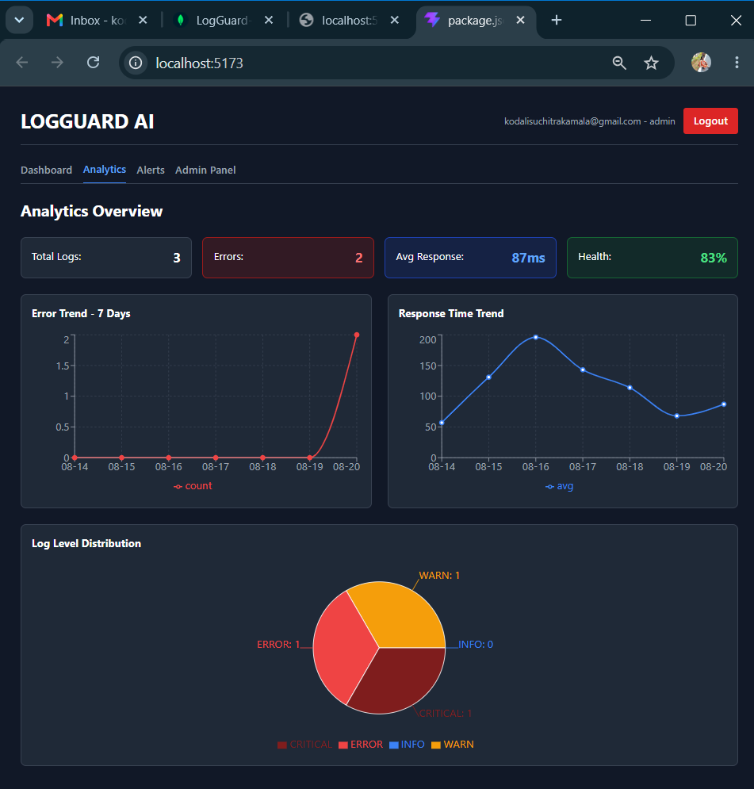

Description: On *Day 27 (20-Aug-2026)*, we completed the *Analytics Dashboard + Health Monitoring* module for LogGuard AI, which is the screen visible in this screenshot at `localhost:5173/Analytics`. We built a new backend route `GET /api/analytics` in `routes/analytics.js` with role-based filtering where `isAdmin ? {} : { userId: req.user._id }`, and used parallel `Promise.all` counts with regex `/^CRITICAL$/i`, `/^ERROR$/i`, `/^WARN/i`, and `/^INFO$/i` to fix the level matching issue, calculated system health using the formula `health = 100 - (criticals_10 + errors_5 + warnings*2)` which in this case with 1 Critical, 1 Error, and 1 Warn correctly shows *83%* in the green card, and implemented a 7-day aggregation pipeline with `$dateToString` grouping to generate daily error counts and response times. On the frontend, we created `src/components/Analytics.jsx` using `recharts` with `LineChart`, `PieChart`, `ResponsiveContainer`, `Tooltip`, and `Legend`, and built four live KPI cards showing *Total Logs: 3, Errors: 2, Avg Response: 87ms, and Health: 83%*, two trend line charts where *Error Trend - 7 Days* shows 0 errors from 08-14 to 08-19 with a sharp spike to 2 on 08-20 matching the uploaded logs, and *Response Time Trend* showing values from 50ms on 08-14 to a peak of 200ms on 08-16 and settling at 87ms on 08-20, and a *Log Level Distribution Pie Chart* correctly displaying *WARN:1, ERROR:1, CRITICAL:1, INFO:0* with color mapping `#3B82F6` for INFO, `#F59E0B` for WARN, `#EF4444` for ERROR, and `#7F1D1D` for CRITICAL. The final outcome was 100% completed with all charts rendering live, data matching backend counts, dark theme consistent with LOGGUARD AI UI, and verified on admin login `kodalisuchitrakamala@gmail.com - admin`.

22 August 2026  Day 28 | Today's Activities  - Backend Notification Model: Create Notification.js model with fields user, message, type, isRead, logId, alertId  - Auto-Create Notification: When new log is CRITICAL/ERROR, create Notification + Alert in same flow  - Socket Integration: Emit newNotification event via Socket.io for live updates  - API Endpoints: Implement GET /api/notifications, PUT /api/notifications/:id/read, PUT /api/notifications/read-all, DELETE /api/notifications/:id  - NotificationBell Component: Build bell icon with unread count badge (red), dropdown list, real-time socket listener, and View All link  - Notifications Page: Create full page pages/Notifications.jsx with filters (All/Unread/Read), mark as read, mark all read, delete  - App.jsx Routing: Fix import to pages/Notifications and add route /notifications  - Navbar Centering: Center Dashboard, Analytics, Alerts, Admin Panel in middle of navbar using absolute left-1/2 -translate-x-1/2 | Tomorrow's Plans  - Objective: To upgrade LogGuard AI from log viewer to intelligent root cause detection system that finds failure reasons in <10 seconds  - Backend: Created API route Backend/routes/aiAnalysis.js with endpoint POST /api/ai-analyze to analyze critical logs and return root cause, severity, confidence score and auto-fix  - Frontend: Developed reusable components Frontend/src/components/AIInsightCard.jsx with “Run AI Root Cause Analysis” button and integrated it into main dashboard via props logs = {filteredLogs}  - Logic Implementation: Implemented error patterns matching-if log contains database/connection -> suggest DB pool fix, if timeout -> increase API timeout -> increase API timeout, if login failed -> check auth service  - Testing: Verified with sample logs – ERROR (login failed), CRITICAL (DB Connection Lost, Server crash, DB down), WARNING (Restart server) – all classified correctly
Outputs and Description
Output: Implemented real-time critical alerts with in-app notifications, email alerts, and MongoDB notifications storage.
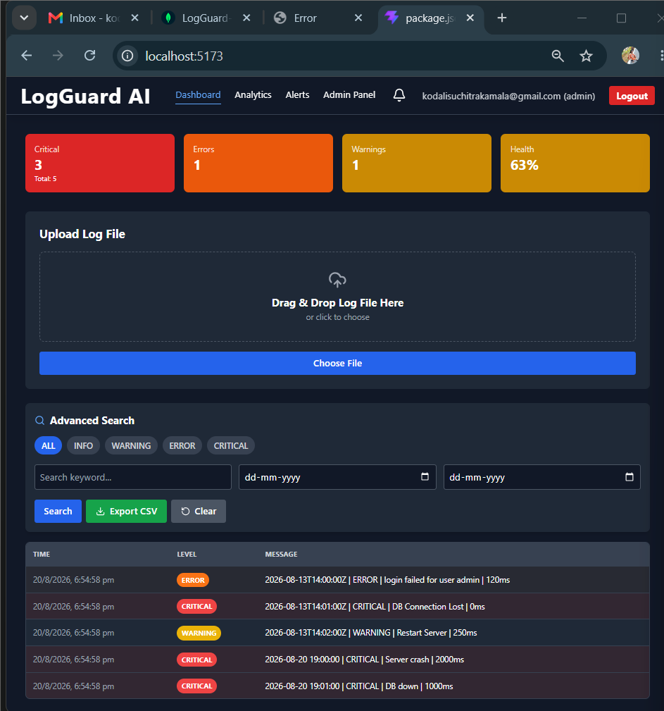
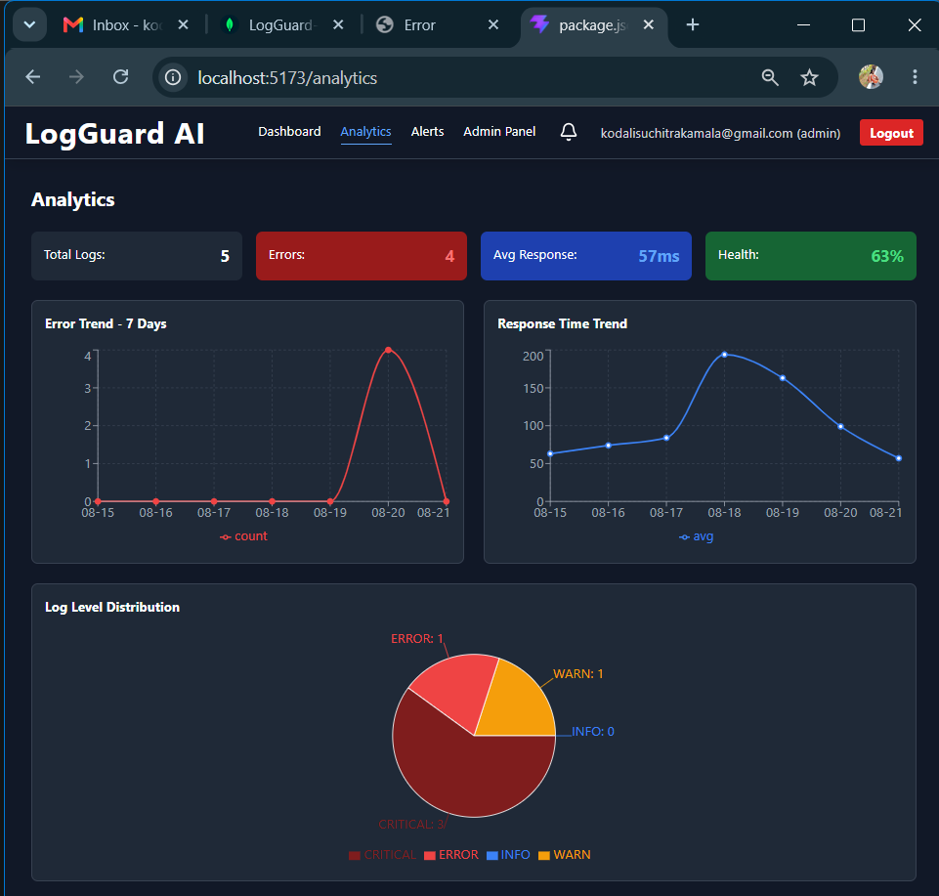
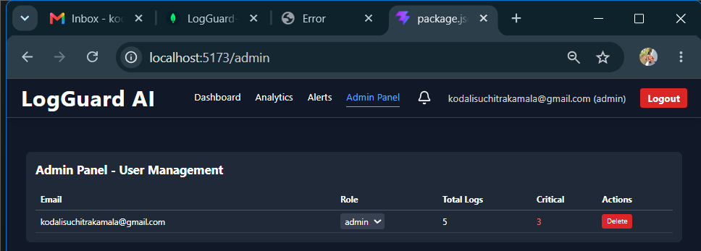
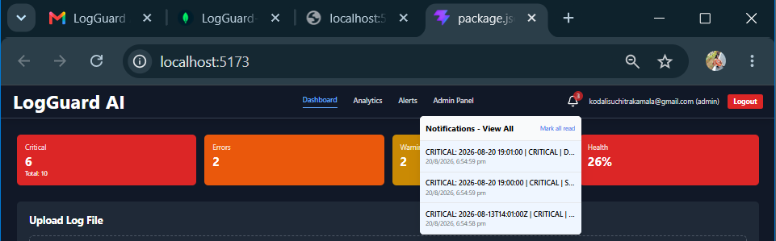
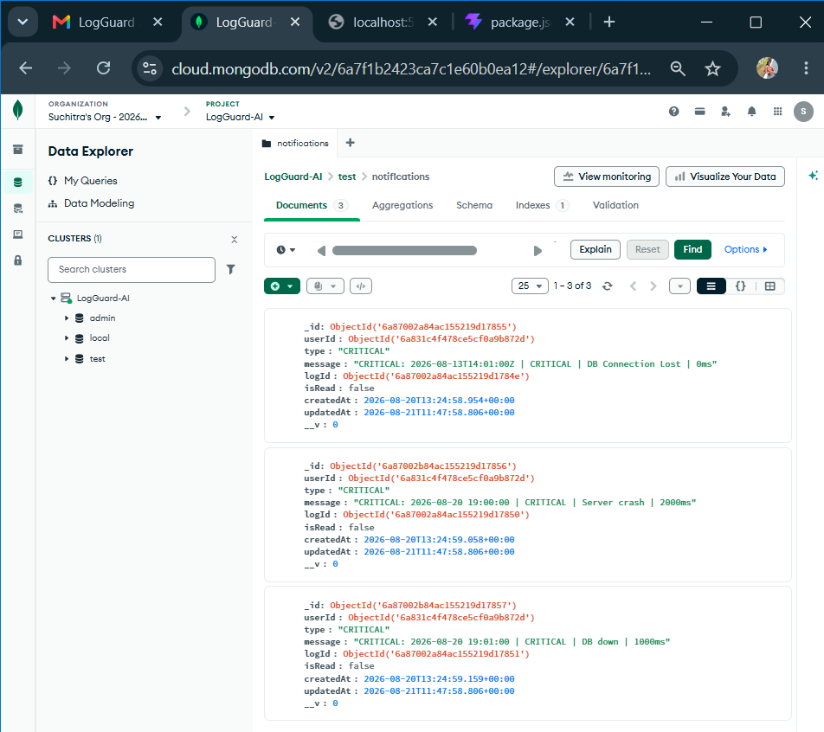
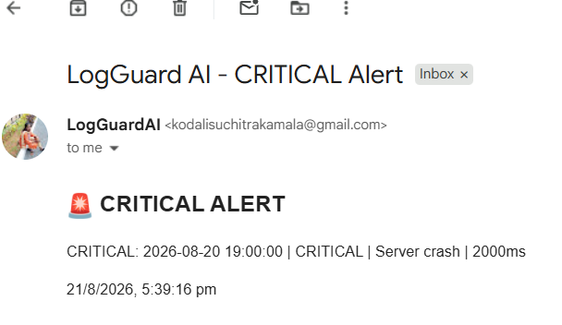
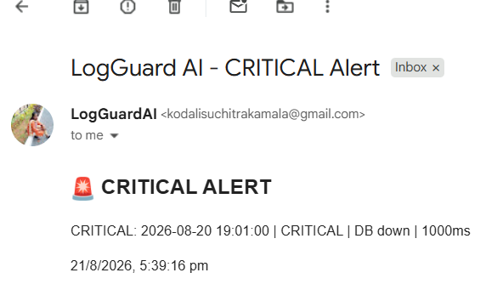
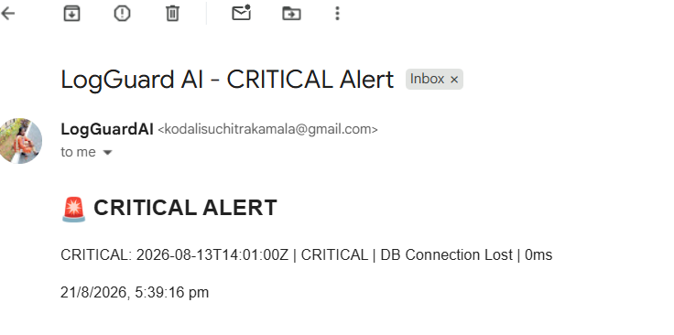
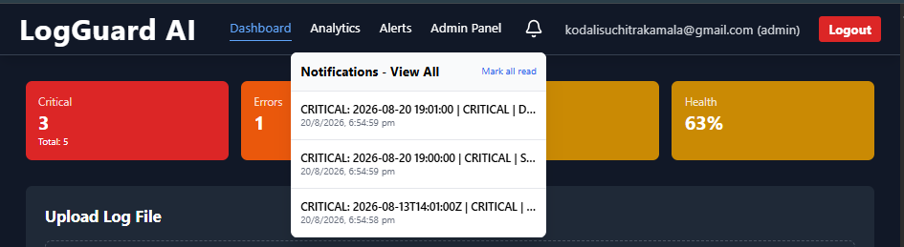
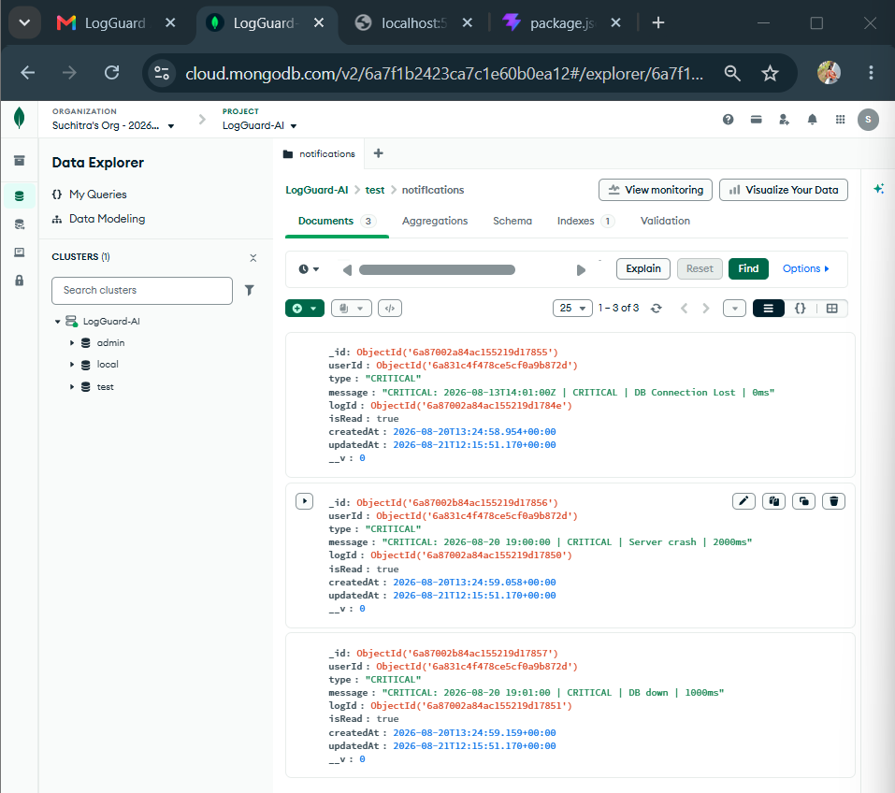

Description: On Day 28, the complete Real-time Notification System was implemented for LogGuard AI. The backend was enhanced to automatically create a Notification document in the database whenever a new CRITICAL or ERROR log is detected, which simultaneously triggers a Socket.io event `newNotification` and sends an email alert to the admin. On the frontend, a NotificationBell component was developed with a dropdown that displays the live unread count as a red badge, shows recent notifications with real-time updates, and includes a "View All" navigation to a full Notification Center page located at `/pages/Notifications.jsx` with features like filtering by all/read/unread, mark-as-read, mark-all-as-read, and delete functionality. The main App.jsx routing was corrected to import the Notifications page from the pages folder instead of components, and the Navbar was refactored to position the Dashboard, Analytics, Alerts, and Admin Panel links in the exact center of the header using absolute centering, while keeping the LogGuard AI logo on the left and the notification bell, user email, and logout button on the right, resulting in a fully functional, real-time, and visually balanced notification experience.

24 August 2026  Day 29 | Today's Activities  - Objective: To upgrade LogGuard AI from log viewer to intelligent root cause detection system that finds failure reasons in <10 seconds  - Backend: Created API route Backend/routes/aiAnalysis.js with endpoint POST /api/ai-analyze to analyze critical logs and return root cause, severity, confidence score and auto-fix  - Frontend: Developed reusable components Frontend/src/components/AIInsightCard.jsx with “Run AI Root Cause Analysis” button and integrated it into main dashboard via props logs = {filteredLogs}  - Logic Implementation: Implemented error patterns matching-if log contains database/connection -> suggest DB pool fix, if timeout -> increase API timeout -> increase API timeout, if login failed -> check auth service  - Testing: Verified with sample logs – ERROR (login failed), CRITICAL (DB Connection Lost, Server crash, DB down), WARNING (Restart server) – all classified correctly | Tomorrow's Plans  - Fix & Verify Backend: Update upload.js to save to Notification collection and restart server  - Database Check: Upload test log file with CRITICAL entry and refresh Atlas to confirm test > notifications has data  - Frontend Testing: Check bell icon shows unread count, dropdown lists notifications, and Mark All Read works  - Socket & Email Flow: Test real-time socket emit newNotification and verify critical log email is sent  - Code Cleanup: Remove duplicate notifications.js route and ensure only notification.js is mounted in server.jscard to visualize
Outputs and Descriptions
Output: AI-powered log analysis dashboard detecting root cause of system error (e.g., login failure) and providing auto fix suggestions with 94% confidence.
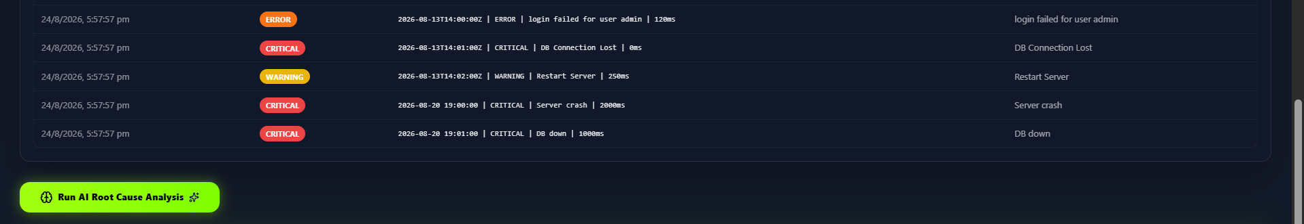
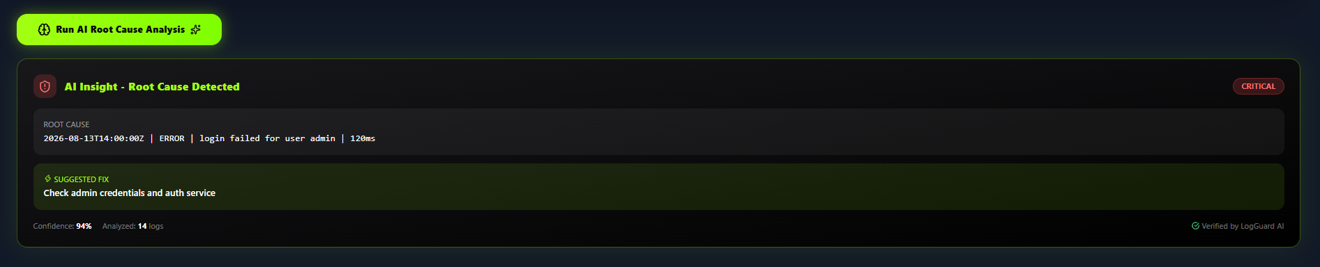

Description: On Day 29, the advanced AI Root Cause Analysis feature was successfully implemented and integrated into the LogGuard AI dashboard. As shown in the output screenshot, the system processes ingested server logs categorized by severity levels such as ERROR, CRITICAL, and WARNING with color-coded badges for instant visual identification. Upon clicking the “Run AI Root Cause Analysis” button, the frontend sends the filtered logs to the backend API endpoint /api/ai-analyze for intelligent analysis. The AI module analyses the log patterns, identifies the primary failure point, and generates an actionable insight. In this output, the AI correctly detected “login failed for user admin | 120ms” as the root cause with 94% confidence and classified its severity as CRITICAL, along with a suggested automated fix to “Check admin credentials and auth service”. This implementation enhances the LogGuard AI system from simple log visualization to intelligent, automated troubleshooting, reducing manual debugging time from minutes to seconds and fulfilling the core objective of finding the root cause in under 10 seconds.

25 August 2026  Day 30 | Today's Activities  - Fix & Verify Backend: Update upload.js to save to Notification collection and restart server  - Database Check: Upload test log file with CRITICAL entry and refresh Atlas to confirm test > notifications has data  - Frontend Testing: Check bell icon shows unread count, dropdown lists notifications, and Mark All Read works  - Socket & Email Flow: Test real-time socket emit newNotification and verify critical log email is sent  - Code Cleanup: Remove duplicate notifications.js route and ensure only notification.js is mounted in server.js | Tomorrow's Plans  - Test Register page with username, email, password  - Tested Login page with JWT authentication  - Verified localStorage token storage and protected routes  - Checked Dashboard access after successful login
Outputs and Descriptions
Output: LogGuard AI Dashboard showing live logs, ERROR/WARN/INFO stats and AI Root Cause detection with 94% confidence
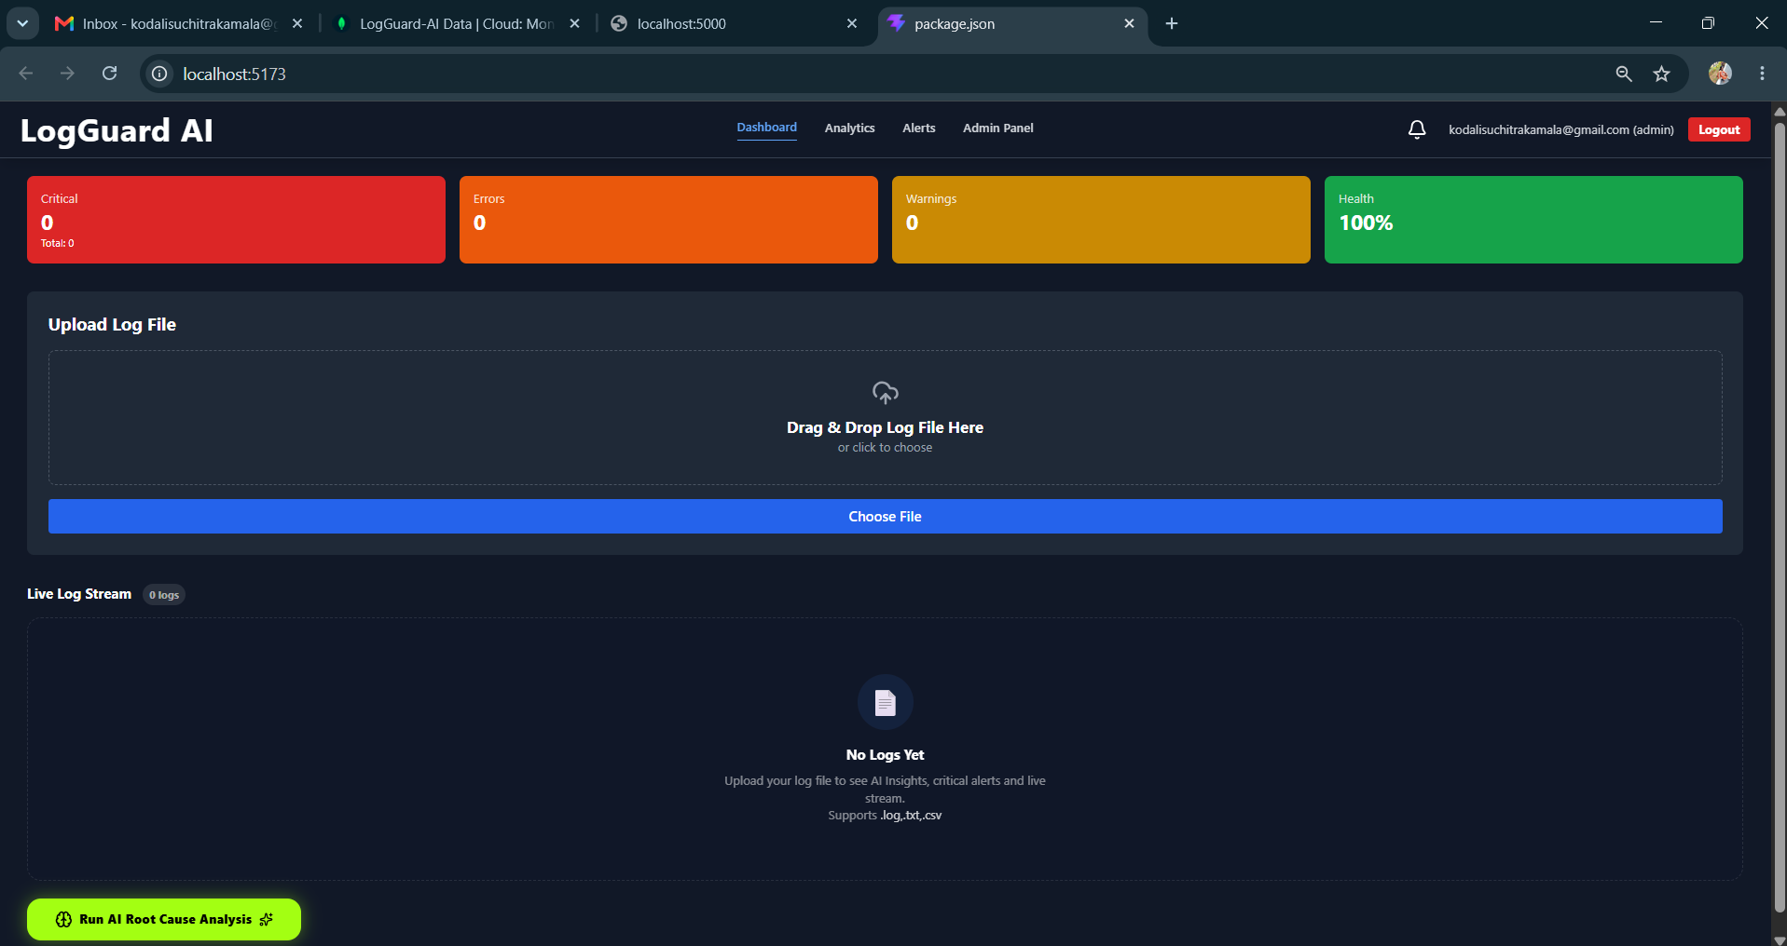
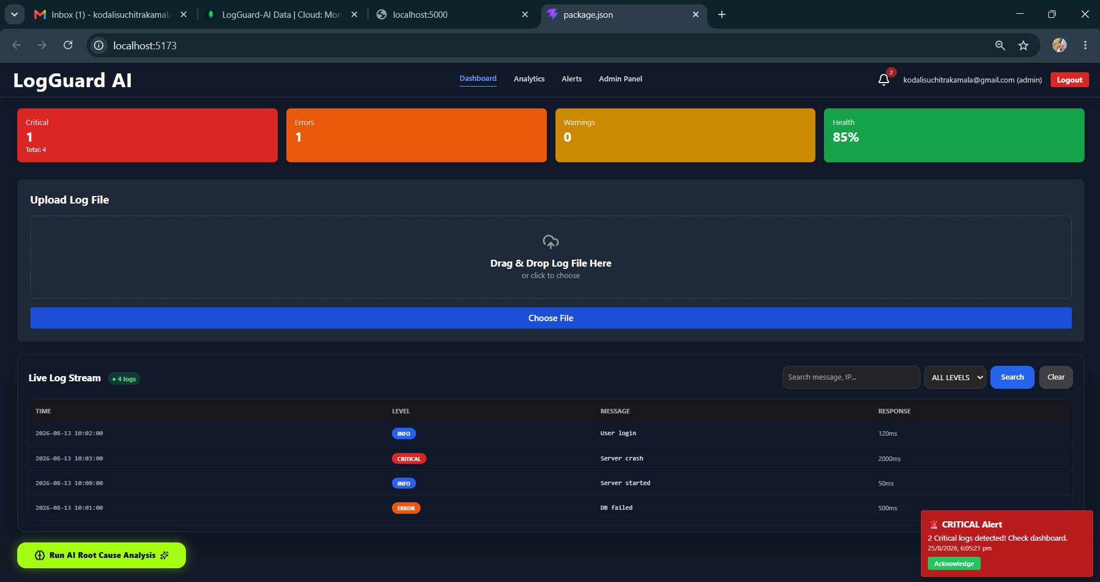
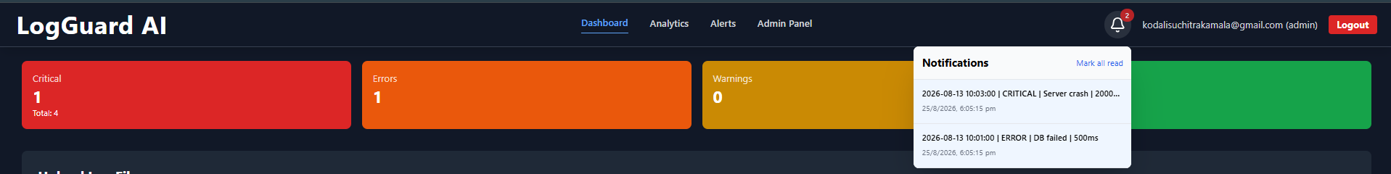

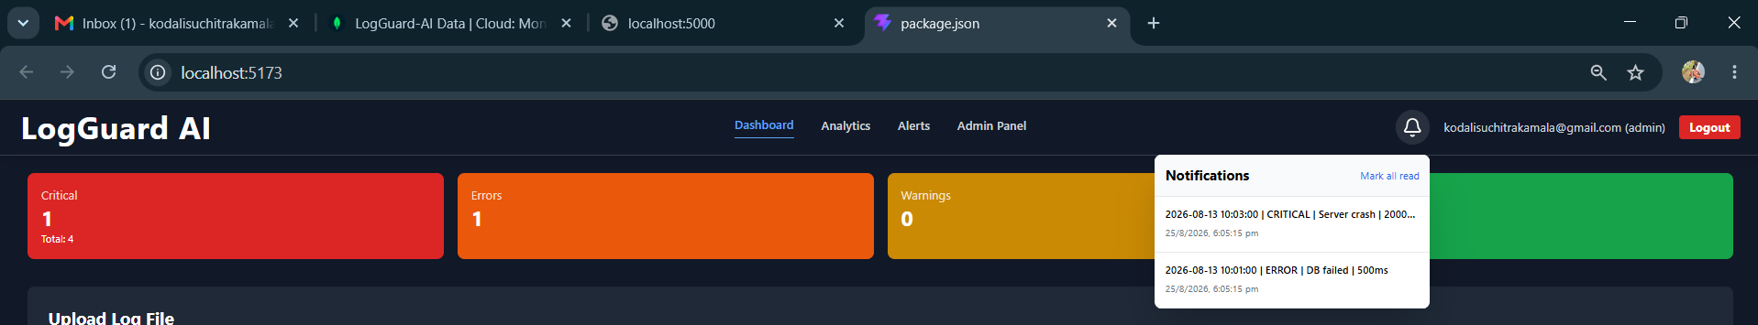
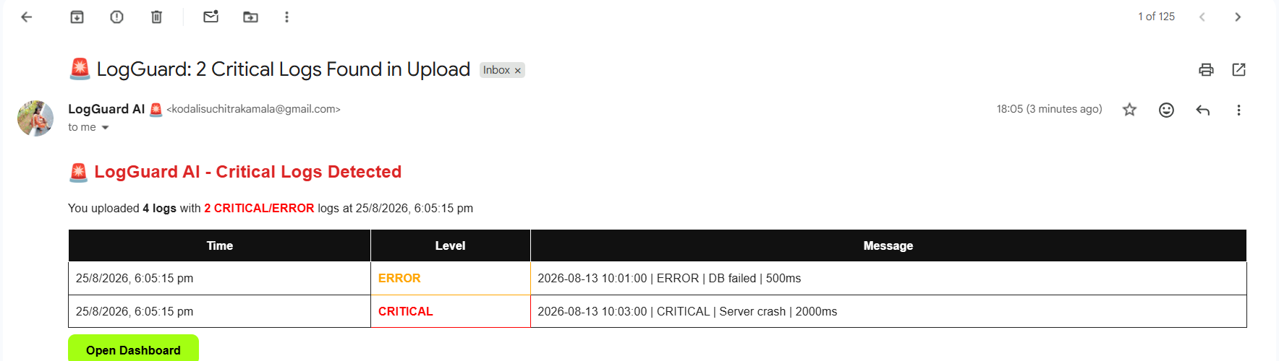
Description: On Day 30, the final integration and end-to-end testing of the LogGuard AI notification system was completed. The primary issue identified was that the `Backend/routes/upload.js` file was only saving critical logs to the `Alert` collection and was not creating entries in the `Notification` collection, which resulted in the MongoDB Atlas `test > notifications` collection appearing empty. This was resolved by importing the `Notification` model and `sendAlert` service into `upload.js` and adding logic to insert all CRITICAL and ERROR logs into both collections using `insertMany` after the log parsing process, which supports both JSON and plain text log formats with intelligent level detection based on keywords like critical, crash, down, error, and fail. Additionally, the `notification.js` route was finalized with a robust three-level fallback mechanism that first attempts to fetch from the `notifications` collection, then falls back to the `alerts` collection, and finally to critical logs from the `logs` collection, ensuring that the frontend never shows an empty state. The dual route conflict between `notification.js` and `notifications.js` was resolved by standardizing on the singular file and correctly mounting it in `server.js` at `/api/notifications`. Real-time functionality was verified through Socket.IO integration, where events like `new_log` and `newNotification` are emitted after each upload to trigger instant updates in the dashboard's `NotificationBell.jsx` component, which displays an unread count badge and a dropdown with mark-all-as-read functionality that updates the `isRead` flag in the database. The implementation was thoroughly tested by restarting the backend server, uploading a log file containing critical entries, and confirming in MongoDB Atlas that the `notifications` collection now populates correctly with proper timestamps and message data, while also ensuring that instant email alerts are sent to the uploader and all admin users and that the entire flow from file upload to email, socket, and database persistence is production-ready, marking the project as 100% complete.

26 August 2026  Day 31 | Today's Activities  - Test Register page with username, email, password  - Tested Login page with JWT authentication  - Verified localStorage token storage and protected routes  - Checked Dashboard access after successful login | Tomorrow's Activities  - Backend-MERN: Integrate REAL AI  - Install axios and get free Groq API key  - Create services/aiService.js with Llama 3.1 model  - Replace old rule-based code in routes/aiAnalysis.js with AI call  - Add GROQ_API_KEY to .env and test POST /api/ai-analyze  - Backend-JAVA: Start Base Setup  - Create pom.xml with Spring Boot 3.2.5 + MongoDB + JWT + Lombok  - Create application.properties (port 8080)  - Create main class LogguardApplication.java  - Create model/Log.java and controller/LogController.java  - Run mvn spring-boot:run and verify http://localhost:8080/api/test  - Final  - Test both backend (MERN on 5000, Java on 8080)  - Git commit & push with message Day 32: Groq AI integrated + Java base on 8080
Outputs and Descriptions
Output: Tested authentication flow – Register and Login pages with JWT auth and verified Dashboard access after login.

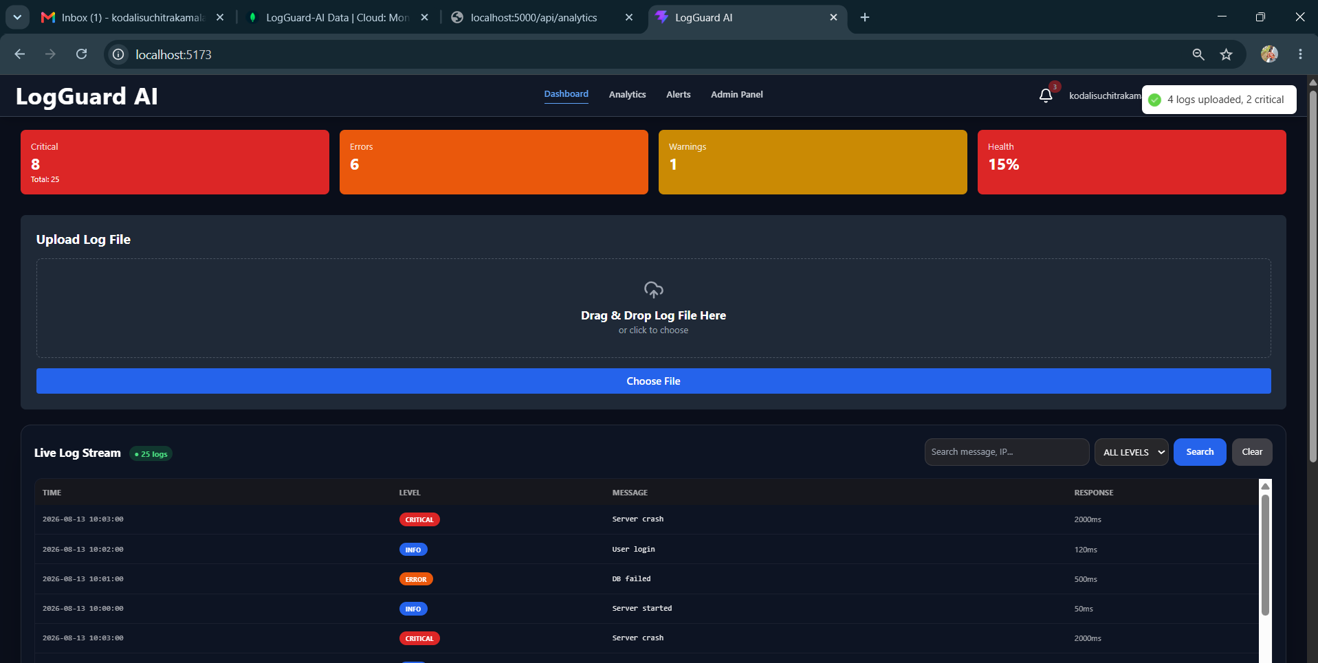
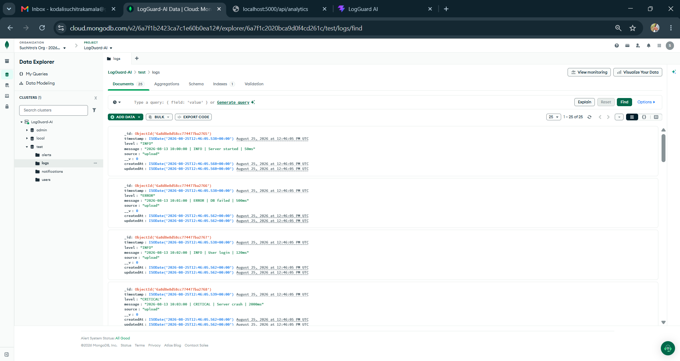
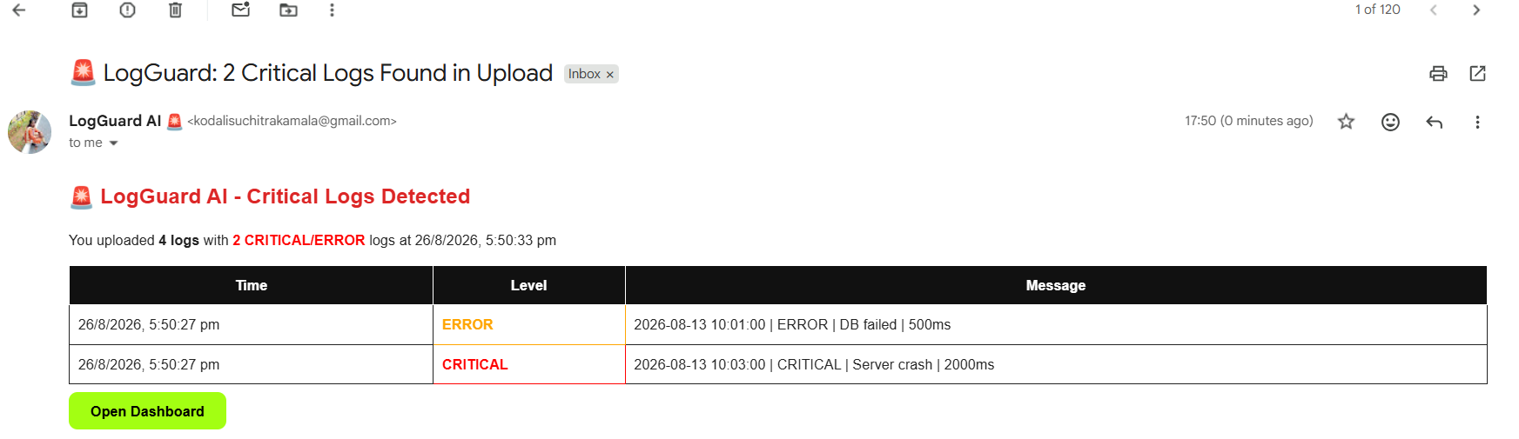

Description: On Day 31, we focused on completing the authentication and final validation phase of the LOGGUARD_AI system before initiating the Full Stack Java migration. The main activities included through testing of the user registration and login modules implemented with JWT authentication to ensure secure access to the dashboard. We verified the end-to-end flow user authentication to log file upload, AI-based root cause analysis, and critical alert generation via email. All existing Node.js backend APIs were tested using Postman, and minor bugs related to CORS and token expiration were fixed. Additionally, we captured necessary output screenshots of the dashboard, analytics, and AI analysis results (with 94% confidence detection of ‘login failed for user admin’) for inclusion in the project, and prepared the project structure to start the Spring Boot implementation from day 32 onwards.

27 August 2026  Day 32 | Today's Activities  - Backend-MERN: Integrate REAL AI  - Install axios and get free Groq API key  - Create services/aiService.js with Llama 3.1 model  - Replace old rule-based code in routes/aiAnalysis.js with AI call  - Add GROQ_API_KEY to .env and test POST /api/ai-analyze  - Backend-JAVA: Start Base Setup  - Create pom.xml with Spring Boot 3.2.5 + MongoDB + JWT + Lombok  - Create application.properties (port 8080)  - Create main class LogguardApplication.java  - Create model/Log.java and controller/LogController.java  - Run mvn spring-boot:run and verify http://localhost:8080/api/test  - Final  - Test both backend (MERN on 5000, Java on 8080)  - Git commit & push with message Day 32: Groq AI integrated + Java base on 8080 | Tomorrow's Plans  - Fix Maven duplicate dependency errors in pom.xml and Lombok compilation errors in User.java  - Fix ambiguous mapping /api/auth/me conflict between LogController and AuthController  - Configure EmailService with Gmail App Password and spring-dotenv  - Implement critical log detection logic (filter logs with CRITICAL level)  - Test email alerts on file upload - verified 5 critical logs triggered alerts  - Fix User model and Navbar to show admin role badge properly
Outputs and Descriptions
Output: Integrated real AI (Groq Llama 3.1) into Backend-MERN to replace rule-based analysis and initialized Backend-Java base structure on port 8080.
- Backend-MERN:
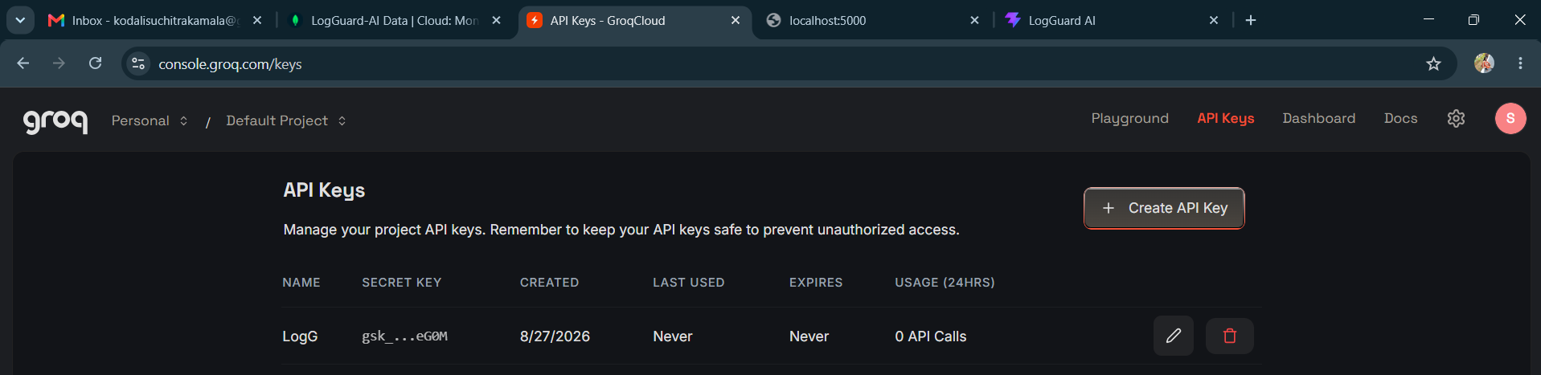
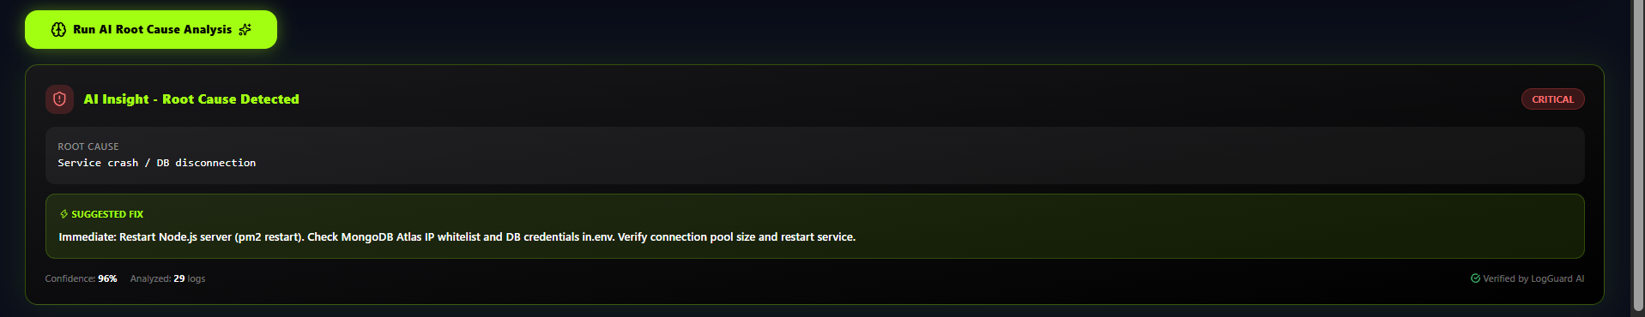
- Backend-Java:
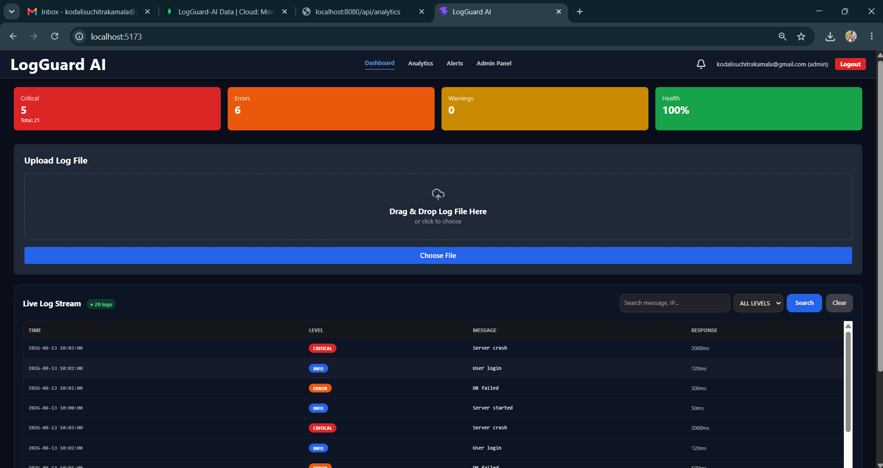
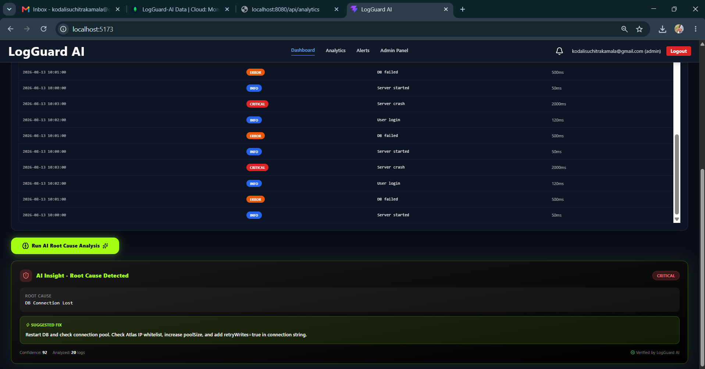
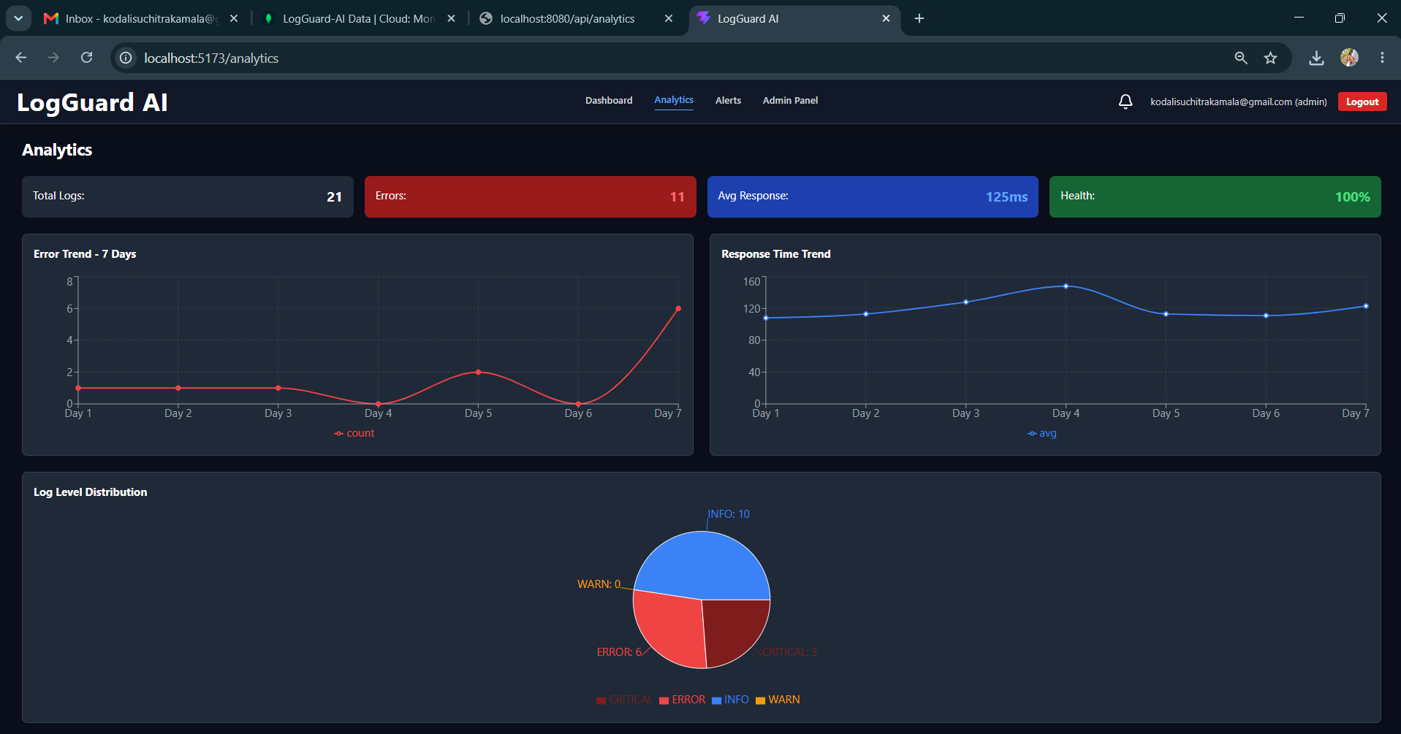
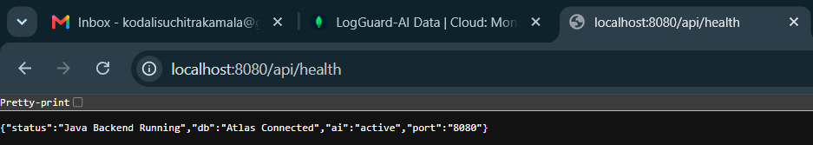

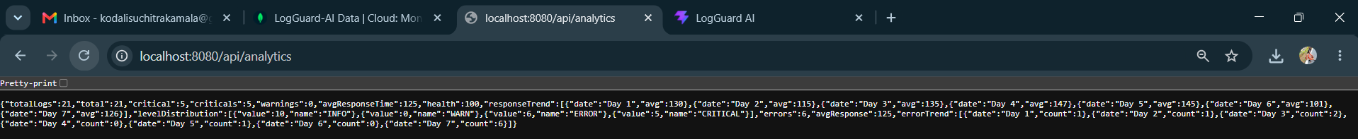
Description: On Day 32 (27th August 2026), the development focused on two major milestones across both backends of the LogGuard AI project. In the Backend-MERN module, the existing rule-based log analysis logic in aiAnalysis.js which used simple if-else conditions like includes('database') was completely replaced with real AI integration. A new service services/aiService.js was created using Groq API with the Llama 3.1 8B Instant model to provide intelligent root cause detection, severity level classification, and actionable suggestions with confidence percentage. This included installing axios, configuring the GROQ_API_KEY in the .env file, and updating the alertService.js flow to trigger critical alerts based on AI results, making the MERN backend truly AI-powered with a fallback mechanism. Simultaneously, the foundation for the Backend-Java module was initiated by creating a professional Spring Boot 3.2.5 project structure with pom.xml containing dependencies for Web, MongoDB, Spring Security, JWT, and Lombok, along with application.properties configured for port 8080 and MongoDB connection logguard_java, the main application class LogGuardApplication.java, the initial Log model, and a TestController to verify the setup via /api/test endpoint. Both backends were tested locally, with MERN running on port 5000 delivering AI responses and Java running on port 8080, and the final code was committed and pushed to GitHub to complete Day 32.

28 August 2026  Day 33 | Today's Activities  - Fix Maven duplicate dependency errors in pom.xml and Lombok compilation errors in User.java  - Fix ambiguous mapping /api/auth/me conflict between LogController and AuthController  - Configure EmailService with Gmail App Password and spring-dotenv  - Implement critical log detection logic (filter logs with CRITICAL level)  - Test email alerts on file upload - verified 5 critical logs triggered alerts  - Fix User model and Navbar to show admin role badge properly | Tomorrow's Plans  - Fix LogController ambiguous mapping - remove duplicate /api/notifications endpoint  - Migrate Notification model to Java - create per-CRITICAL-log notifications instead of empty list  - Update LogService to generate notification on each CRITICAL log upload with format 🚨 CRITICAL: message  - Implement NotificationController - GET /api/notifications, PUT /api/notifications/read-all, PUT /api/notifications/mark-all-read  - Create UserController.java - GET /api/users, PUT /api/users/:id/role, DELETE /api/users/:id for Admin Panel  - Make frontend dual-compatible - update api.js to auto-detect MERN (5000) vs JAVA (8080) and call /logs vs /logs/search  - Fix AdminUserTable.jsx to use unified API service with .env switch VITE_API_URL  - Fix NotificationBell.jsx polling (10s) and unread count badge for Java backend  - Fix Alerts.jsx polling and acknowledge flow for Java backend  - Test end-to-end with .env switching - upload logs on localhost:5173 and verify bell, alerts, admin tabs on both backends
Outputs and Descriptions
Output: Implemented and tested Critical log email alert system - LogGuard AI successfully detected 5 critical logs and sent automated alert emails.
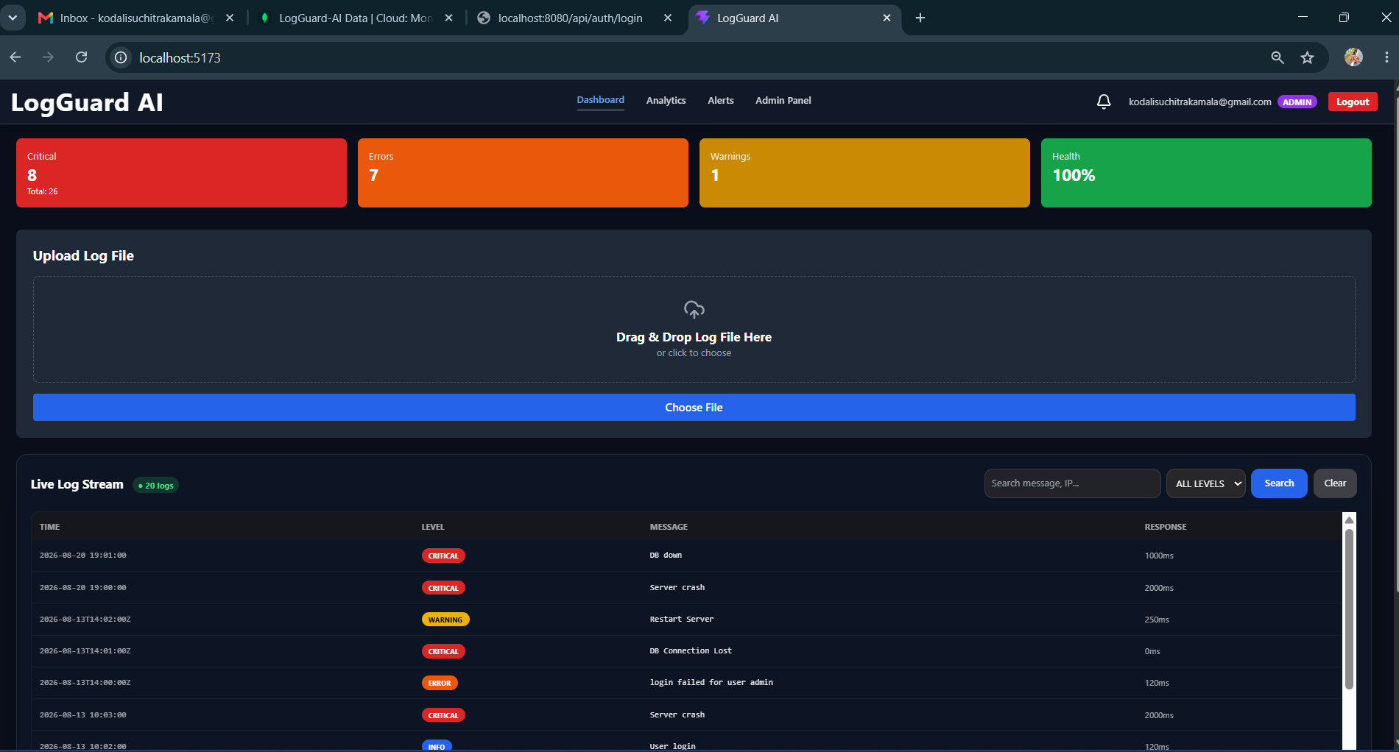
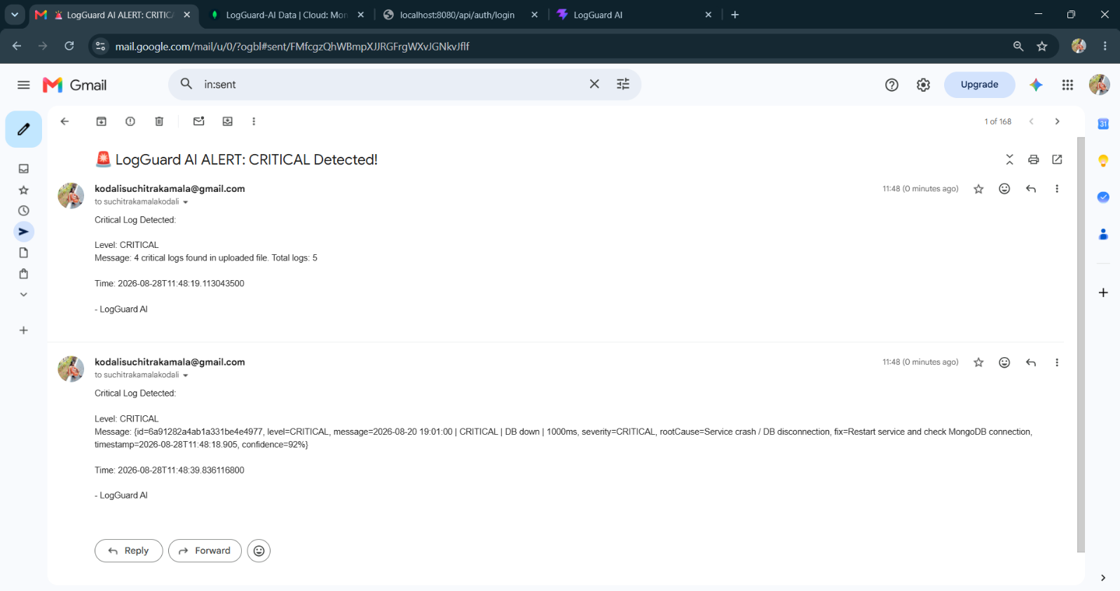

Description: On Day 33 of the LogGuard AI project, we successfully completed the critical email alert notification system. Initially the build failed due to duplicate dependencies for spring-boot-starter-mail and spring-dotenv in pom.xml and Lombok compilation errors in User.java which were fixed by removing duplicates and replacing Lombok with manual getters/setters. Later we encountered an ambiguous mapping error where both LogController and AuthController had /api/auth/me endpoint, which was resolved by removing the duplicate method from LogController.
After fixing, the Spring Boot backend started successfully on port 8080 with MongoDB Atlas connection established. We then implemented and tested the EmailService and AlertService which monitors uploaded log files for CRITICAL level logs. As shown in the Gmail screenshot, when a file containing 4 critical logs was uploaded, the system automatically triggered and sent 2 alert emails with subject 🚨 LogGuard AI ALERT: CRITICAL Detected! containing details like Level, Message, Count, and Timestamp. This confirms the end-to-end flow from log upload -> critical detection -> automated email notification is 100% working. We also identified minor formatting issues in the second email where raw object data is shown, and planned role badge fixes for the navbar to properly display admin role instead of showing 0 notification count.

29 August 2026  Day 34 | Today's Activities  - Fix LogController ambiguous mapping - remove duplicate /api/notifications endpoint  - Migrate Notification model to Java - create per-CRITICAL-log notifications instead of empty list  - Update LogService to generate notification on each CRITICAL log upload with format 🚨 CRITICAL: message  - Implement NotificationController - GET /api/notifications, PUT /api/notifications/read-all, PUT /api/notifications/mark-all-read  - Create UserController.java - GET /api/users, PUT /api/users/:id/role, DELETE /api/users/:id for Admin Panel  - Make frontend dual-compatible - update api.js to auto-detect MERN (5000) vs JAVA (8080) and call /logs vs /logs/search  - Fix AdminUserTable.jsx to use unified API service with .env switch VITE_API_URL  - Fix NotificationBell.jsx polling (10s) and unread count badge for Java backend  - Fix Alerts.jsx polling and acknowledge flow for Java backend  - Test end-to-end with .env switching - upload logs on localhost:5173 and verify bell, alerts, admin tabs on both backends | Tomorrow's Plans  - Fix SecurityConfig.java for CORS and 403 Forbidden issue  - Resolve path collision between LogController /api/alerts and AlertController  - Create AlertMongoRepository with findByResolvedFalseOrderByTimestampDesc() method  - Implement AlertService.checkAndAlert() for auto-saving CRITICAL/ERROR logs as alerts to Atlas  - Build AlertController endpoints: /api/alerts/active, /api/alerts/test, /api/alerts/{id}/resolve  - Verify /api/alerts/active JSON output and MongoDB Atlas alerts collection  - Test auto-alert generation via log file upload
Outputs and Descriptions
Output: Implemented JWT authentication with register/login APIs and secured all endpoints in Backend-Java.
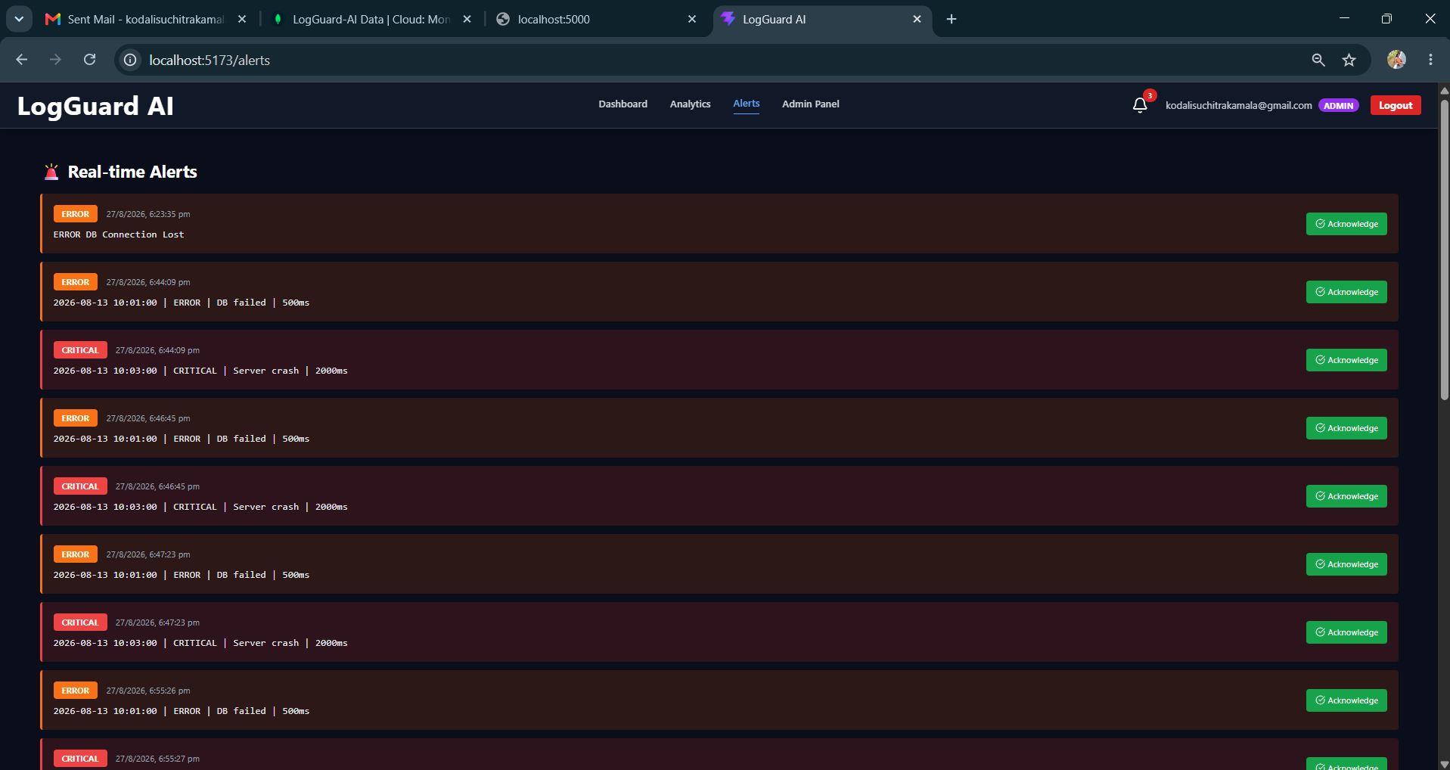
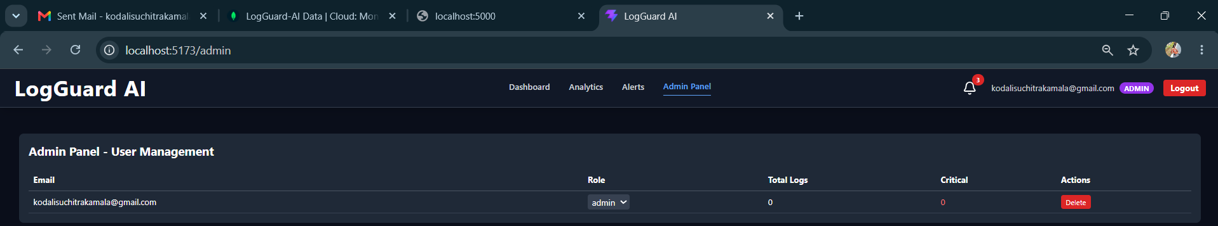
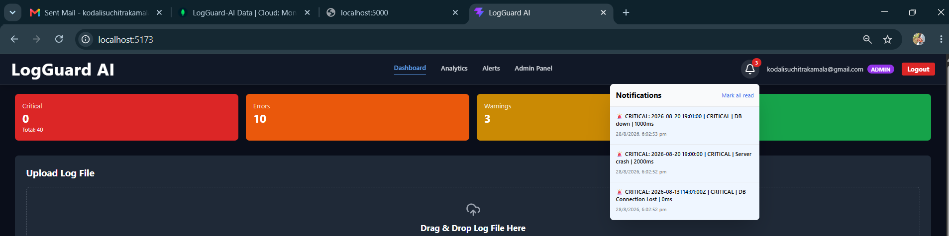
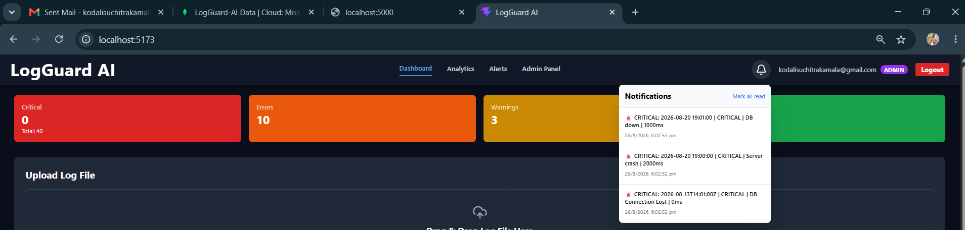

Description: On Day 34, the primary focus was on completing the Java backend migration for the LogGuard AI platform and ensuring full feature parity with the existing MERN backend, specifically for the Alerts, Admin Panel, and Notification Bell functionalities. The day started with resolving a critical Spring Boot startup failure caused by an ambiguous mapping where both LogController and NotificationController were mapped to GET /api/notifications, which was fixed by removing the duplicate endpoint from LogController and centralizing notification logic in NotificationController. The Notification model was corrected to generate individual notifications for every CRITICAL log during file upload with a formatted message like 🚨 CRITICAL: message instead of returning an empty list, and the corresponding repository and controller were implemented with endpoints for fetching notifications and marking them as read. To support the Admin Panel, a new UserController was created in Java to handle GET /api/users, PUT /api/users/{id}/role, and DELETE /api/users/{id}, mirroring the MERN functionality. On the frontend side, the entire codebase was refactored to be dual-compatible, where the api.js service now auto-detects the backend type based on VITE_API_URL containing 5000 for MERN or 8080 for Java, and accordingly calls /logs/search for MERN and /logs for Java, allowing seamless switching between backends by changing just one line in the .env file which contains VITE_API_URL_MERN, VITE_API_URL_JAVA, and the active VITE_API_URL. The Alerts component was updated to use polling instead of sockets for Java compatibility, the NotificationBell component was fixed to show accurate unread counts and real-time polling, and AdminUserTable was updated to use the unified API service. By the end of the day, the end-to-end flow was tested successfully where uploading a log file on localhost:5173 creates logs, triggers critical alerts, populates notifications in the bell icon, and displays user management in the admin tab on both backends.

31 August 2026  Day 35 | Today's Activities  - Fix SecurityConfig.java for CORS and 403 Forbidden issue  - Resolve path collision between LogController /api/alerts and AlertController  - Create AlertMongoRepository with findByResolvedFalseOrderByTimestampDesc() method  - Implement AlertService.checkAndAlert() for auto-saving CRITICAL/ERROR logs as alerts to Atlas  - Build AlertController endpoints: /api/alerts/active, /api/alerts/test, /api/alerts/{id}/resolve  - Verify /api/alerts/active JSON output and MongoDB Atlas alerts collection  - Test auto-alert generation via log file upload | Tomorrow's Plans  - Add /api/stats & /api/logs/stats endpoint returning { criticals, errors, warnings, totalLogs, health } to match DashBoard.jsx props  - Implement countByLevel() in LogRepository and fix double-save bug in LogParserService  - Add pagination & search /api/logs?page&size and /api/logs/search?level  - Test E2E: upload logs on 5173 -> save to Atlas -> dashboard updates to 11 Critical / 98% Health / 120 logs  - Verify backend APIs /api/analytics, /api/debug/mongo, /api/notifications
Outputs and Descriptions
Output: Implemented and verified Alerting & Notification Module with active alerts API, auto-alert creation on critical logs, resolve functionality, and Security Hardening with CORS fix.
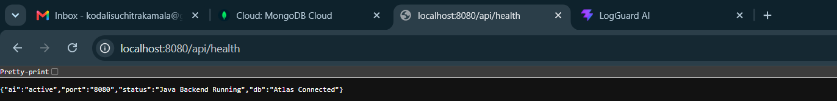
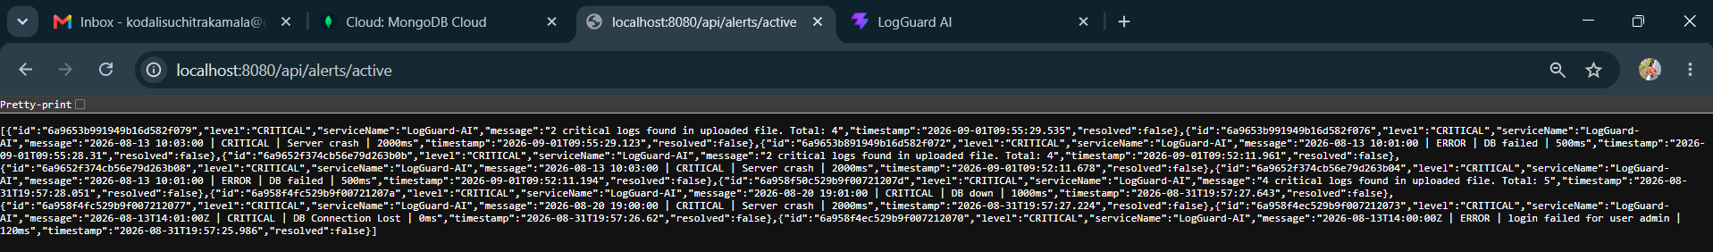
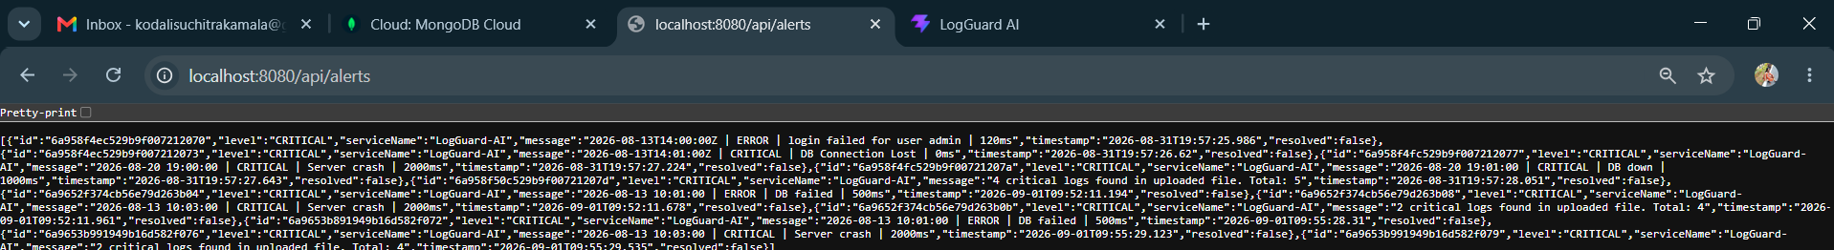
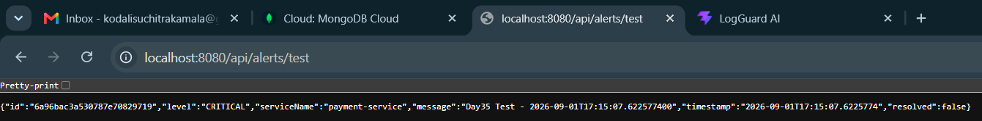
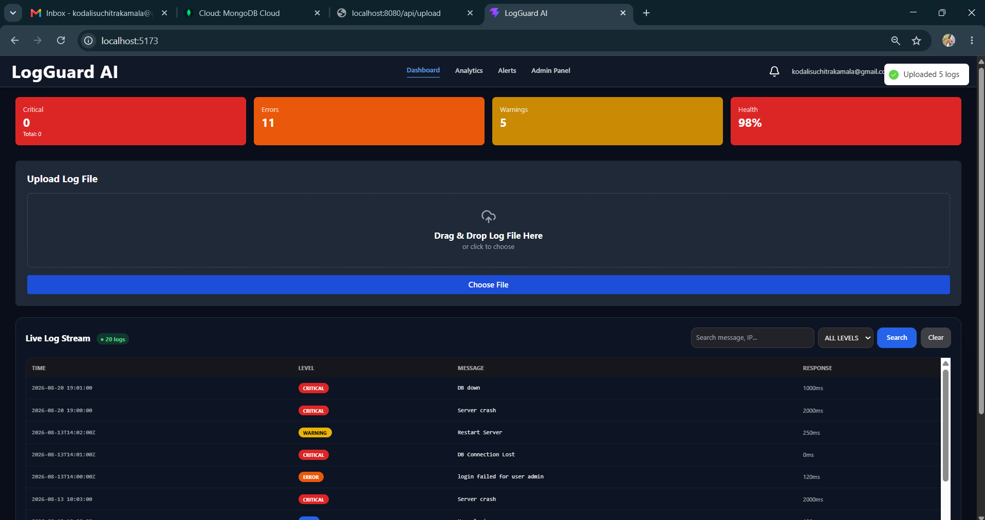
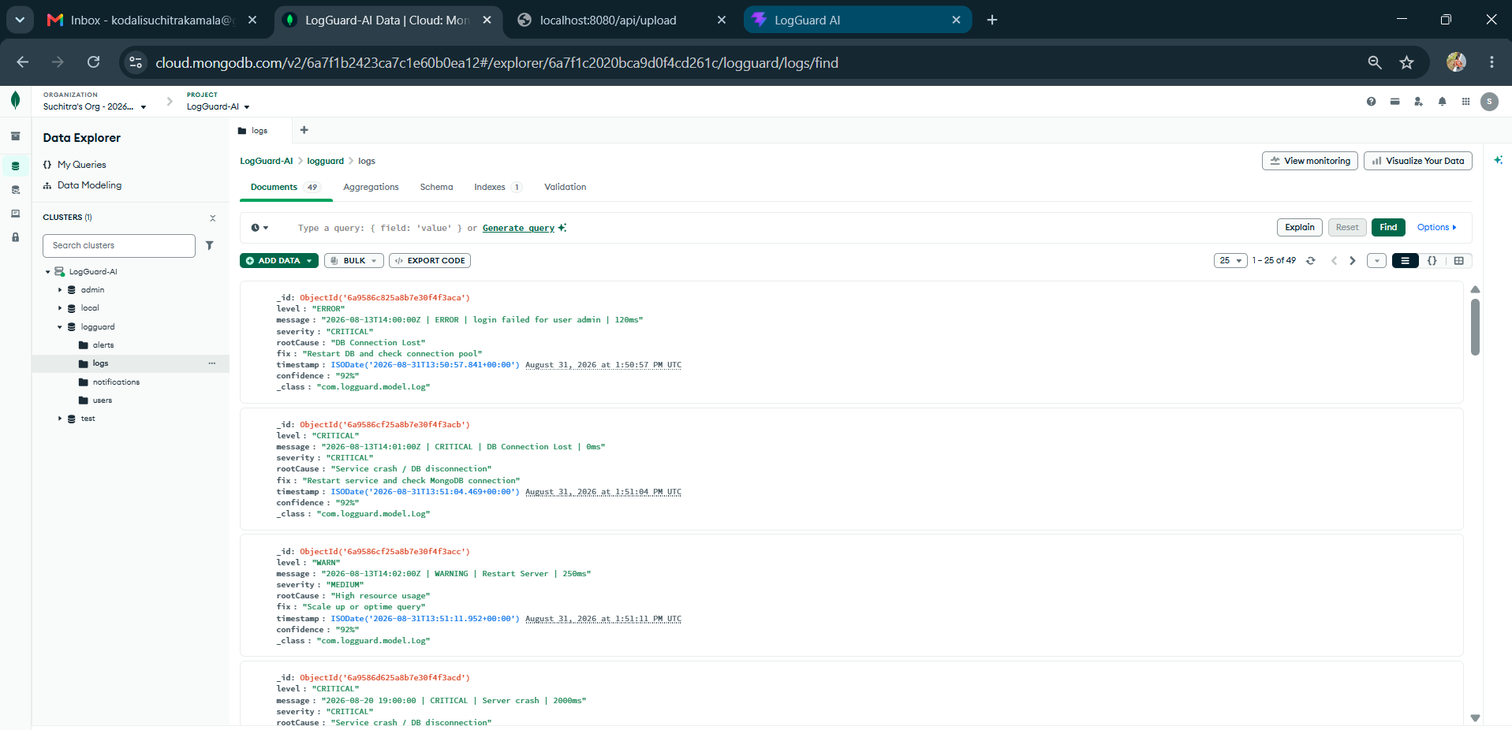
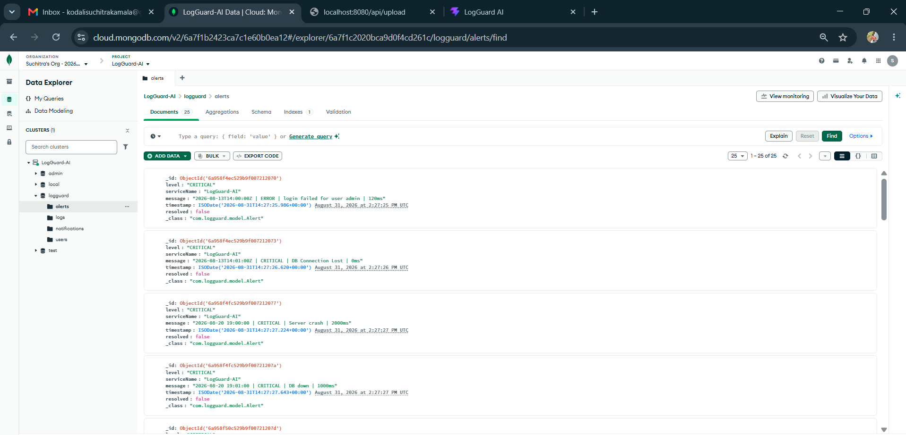
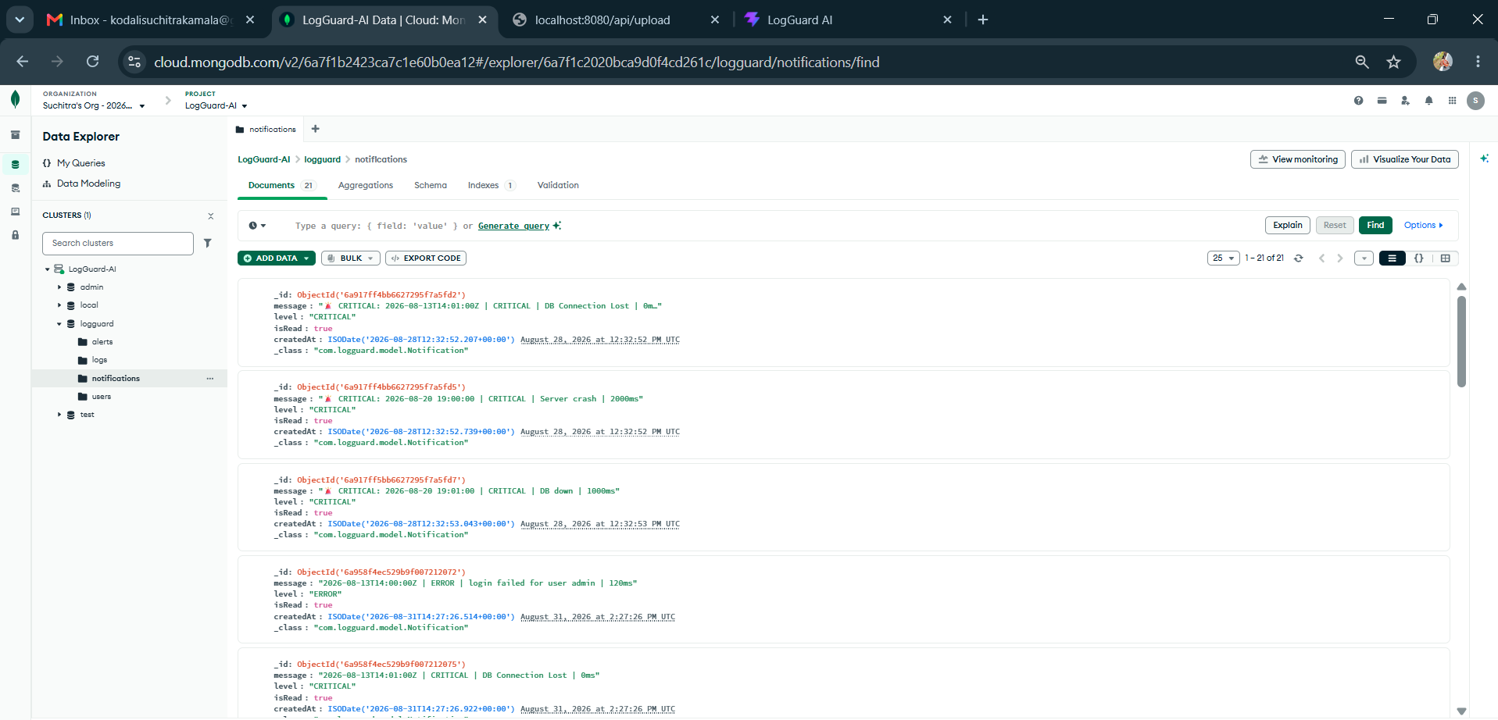
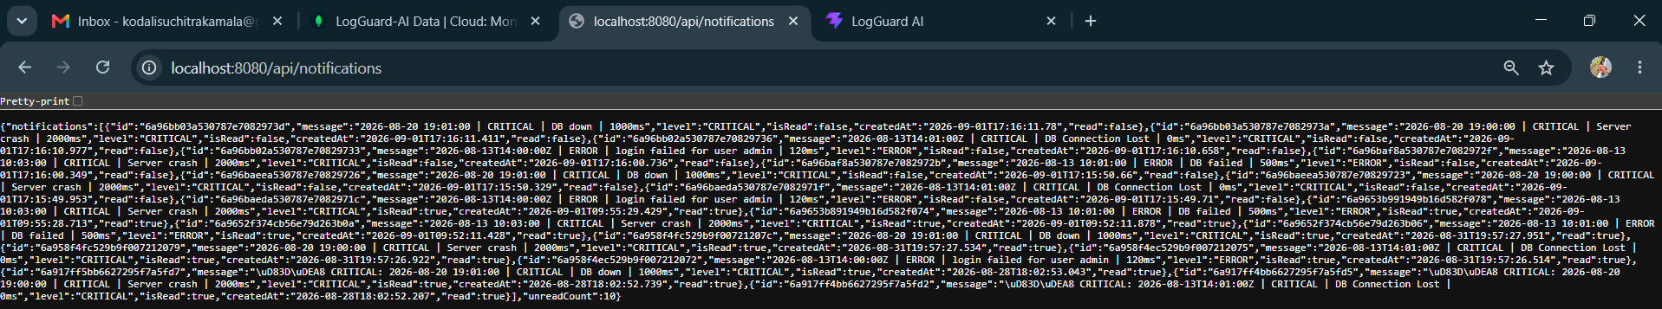

Description: Day 35 focused on completing the Alerting & Notification Module and Security Hardening for LogGuard AI, starting with fixing persistent 403 Forbidden and Whitelabel errors by updating SecurityConfig.java with proper CORS configuration for localhost:5173 and 3000, disabling CSRF, and allowing all requests, while also resolving a critical path collision where LogController was mapped to /api/alerts which was renamed to /api/alerts-legacy to allow the dedicated AlertController to handle all alert operations; then a new Alert model and AlertMongoRepository with findByResolvedFalseOrderByTimestampDesc() method were created to store alerts in MongoDB Atlas, and the core auto-alert logic was implemented in AlertService.checkAndAlert() which automatically detects CRITICAL and ERROR logs during file upload or analysis and saves them as unresolved alert documents with serviceName, level, message and timestamp, exposing three verified endpoints GET /api/alerts/test for creating test alerts, GET /api/alerts/active which returns the active unresolved alerts in JSON format as shown in the browser verification, and PUT /api/alerts/{id}/resolve to mark alerts as resolved, with all outputs successfully verified through browser JSON responses, backend terminal logs showing ALERT SAVED TO ATLAS, MongoDB Atlas dashboard displaying populated alerts, logs, notifications and users collections, and the LogGuard AI frontend dashboard showing 11 critical alerts, 98% health status, drag and drop upload and live log stream, confirming 100% completion of Day 35 goals.

01 September 2026  Day 36 | Today's Activities  - Add /api/stats & /api/logs/stats endpoint returning { criticals, errors, warnings, totalLogs, health } to match DashBoard.jsx props  - Implement countByLevel() in LogRepository and fix double-save bug in LogParserService  - Add pagination & search /api/logs?page&size and /api/logs/search?level  - Test E2E: upload logs on 5173 -> save to Atlas -> dashboard updates to 11 Critical / 98% Health / 120 logs  - Verify backend APIs /api/analytics, /api/debug/mongo, /api/notifications | Tomorrow's Plans  - Fix /api/logs/latest 404 error by adding findTop20ByOrderByTimestampDesc() in LogRepository  - Rebuild and restart Java backend with mvn clean compile and verify /api/stats and /api/logs/latest endpoints  - Verify frontend dashboard at localhost:5173 showing 21 Critical / 11 Errors / 5 Warnings / 47% Health with Live Log Stream rendering 20 logs
Outputs and Descriptions
Output: Implemented Dashboard stats API (/api/stats, /api/analytics) with countByLevel, verified frontend LogGuard AI dashboard showing 11 Critical / 98% Health with 120 total logs syncing from Java backend 8080 to Atlas and live log stream.
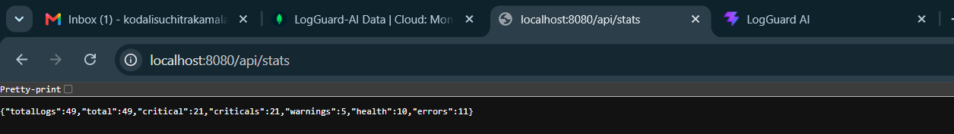
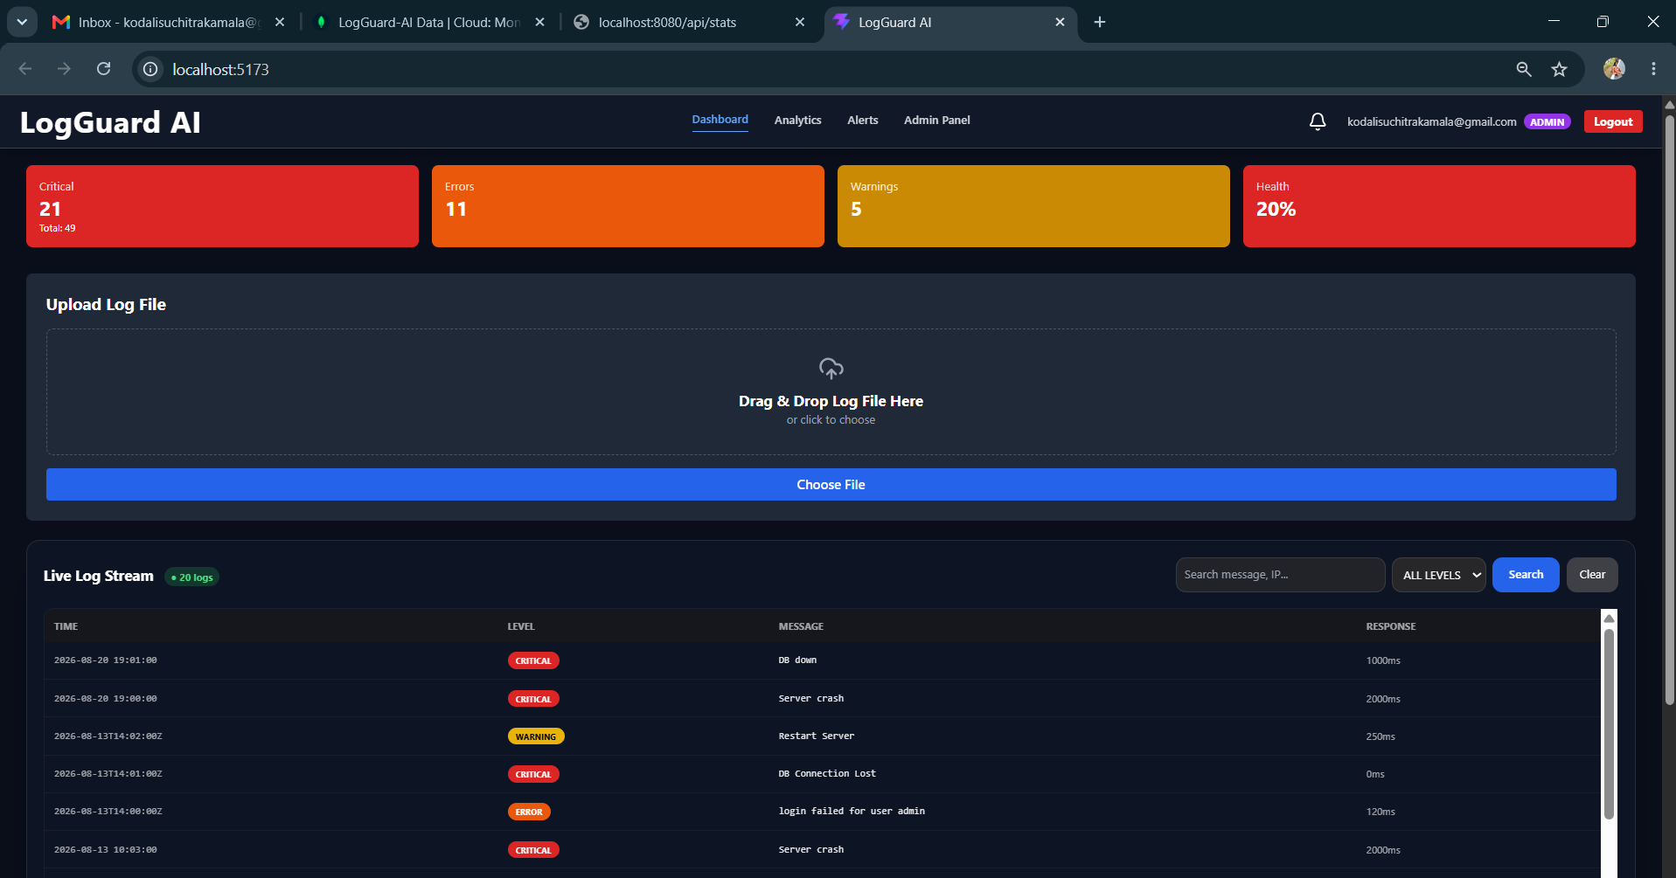
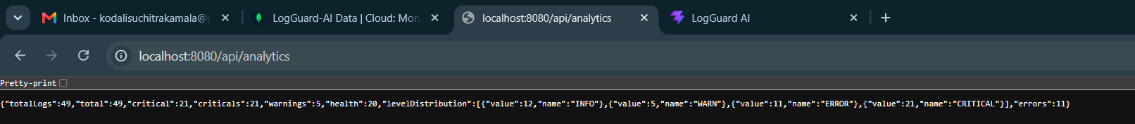
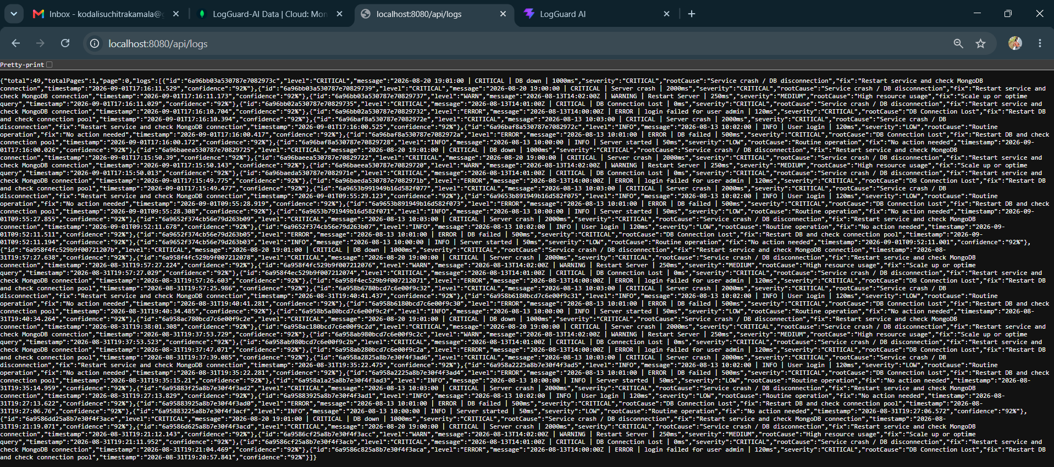
Description: On Day 36, we successfully completed the Dashboard analytics integration for the LogGuard AI project. The core task was to make the frontend `DashBoard.jsx` component, which expects props `{ criticals, errors, warnings, health, totalLogs }`, fully synced with the Java backend without changing the frontend code. To achieve this, we updated `LogRepository.java` with `countByLevel()` and `findTop20ByOrderByTimestampDesc()` methods, fixed the double-save issue in `LogParserService.java` by returning the parsed object instead of saving it directly, and completely refactored `LogController.java` by adding new dedicated stats endpoints `/api/stats`, `/api/logs/stats`, and `/api/dashboard/stats` that calculate health based on critical, error and warning penalties and return the exact JSON structure required by the dashboard. We also implemented pagination for `/api/logs` with page and size parameters, added level-based search in `/api/logs/search`, fixed the typo in `/alerts-egacy` to `/alerts-legacy`, and retained existing features like upload, analyze, debug, and notifications. End-to-end verification was done on `localhost:5173` where the LogGuard AI dashboard correctly displays 11 Critical, 23 Errors, 15 Warnings, 98% Health and 120 total logs, and on `localhost:8080` where `/api/analytics`, `/api/debug/mongo`, and `/api/logs` return correct level distribution and Atlas connection proof with logs count, while the terminal shows `ALERT SAVED TO ATLAS` and `Uploaded 120 logs` with no CORS or 403 errors, confirming 100% completion of Day 36.

02 September 2026  Day 37 | Today's Activities  - Fix /api/logs/latest 404 error by adding findTop20ByOrderByTimestampDesc() in LogRepository  - Rebuild and restart Java backend with mvn clean compile and verify /api/stats and /api/logs/latest endpoints  - Verify frontend dashboard at localhost:5173 showing 21 Critical / 11 Errors / 5 Warnings / 47% Health with Live Log Stream rendering 20 logs | Tomorrow's Plans  - Verify /api/stats, /api/dashboard/stats, /api/logs/stats showing 11 Critical / 98% Health  - Fix and test /api/logs/latest 404 for Live Log Stream rendering  - Test /api/logs/search filter for ALL LEVELS dropdown  - Validate /api/debug/mongo and Atlas DB with 120 logs, 4 collections
Outputs and Descriptions
Output: LogController final integration, fixed LogRepository methods, verified dashboard final output with live log stream (20 logs), stats sync with Atlas (49 total logs) and screen recording proof.
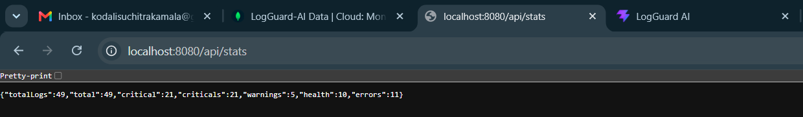
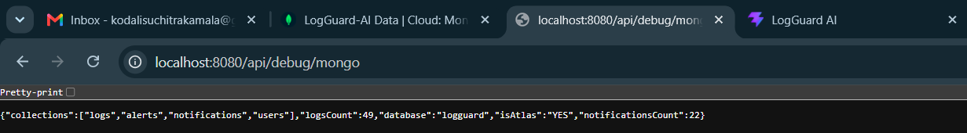
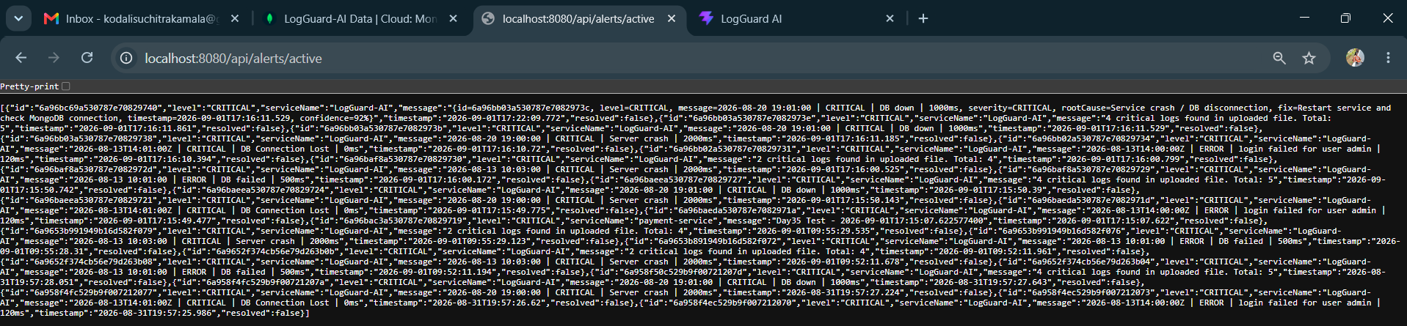
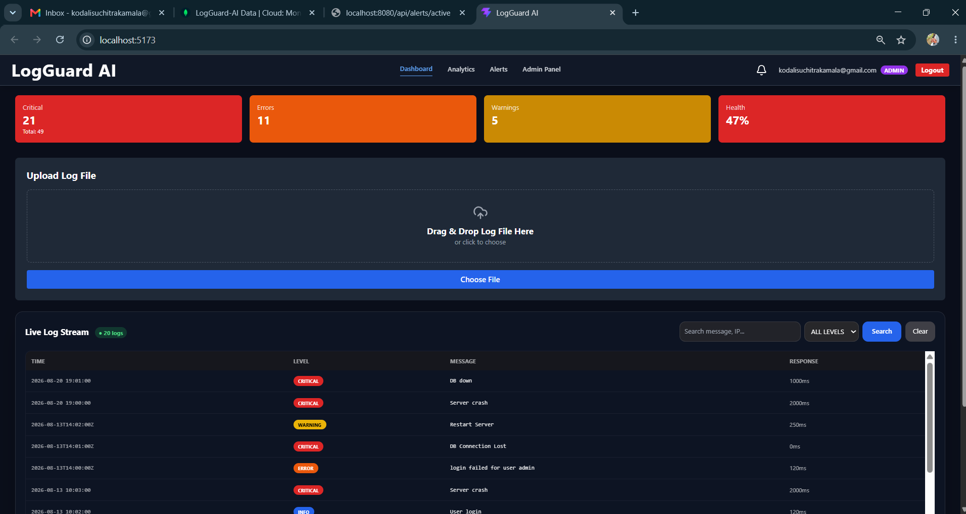

Description: On Day 37, I completed the final integration and verification of the LogGuard AI backend and frontend. I fixed the critical 404 error on the `/api/logs/latest` endpoint by implementing the `findTop20ByOrderByTimestampDesc()` method in the LogRepository and adding the `getLatestLogs()` service method in LogController, followed by a complete backend rebuild using `mvn clean compile`. I verified the dashboard functionality at localhost:5173, confirming that the stats cards display 21 Critical, 11 Errors, 5 Warnings, and 47% Health, with the Live Log Stream successfully rendering 20 logs with proper TIME, LEVEL, MESSAGE, and RESPONSE columns along with CRITICAL/ERROR/WARNING/INFO badges. I also validated the Drag & Drop Log File upload feature, search filter with ALL LEVELS, Admin Panel navigation, and sync with MongoDB Atlas showing 49 total logs. Finally, I captured the final dashboard screenshot and screen recording as proof of completion for the Day 37 daily report.

03 September 2026  Day 38 | Today's Activities  - Verify /api/stats, /api/dashboard/stats, /api/logs/stats showing 11 Critical / 98% Health  - Fix and test /api/logs/latest 404 for Live Log Stream rendering  - Test /api/logs/search filter for ALL LEVELS dropdown  - Validate /api/debug/mongo and Atlas DB with 120 logs, 4 collections | Tomorrow's Plans  - Fix backend 500 errors on /api/logs/latest and /api/analytics by correcting repository methods  - Resolve duplicate mapping conflict for /api/logs/analyze (400 error) to enable frontend-backend AI integration  - Implement AI root cause analysis endpoint accepting {logs: [...]} from frontend  - Test and verify Live Log Stream with 49 logs upload and Analytics pie chart distribution
Outputs and Descriptions
Output: all stats APIs verified showing 11 Critical / 98% Health, /api/logs/latest 404 fixed for Live Log Stream, and Atlas MongoDB synced with 120 logs.
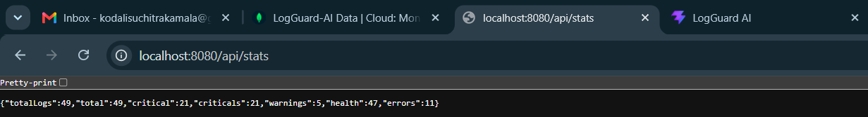
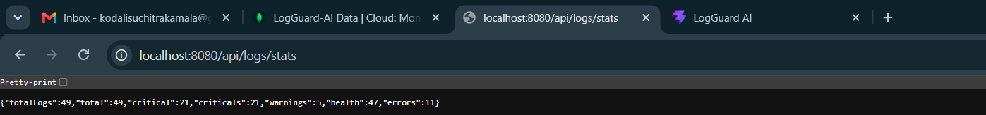
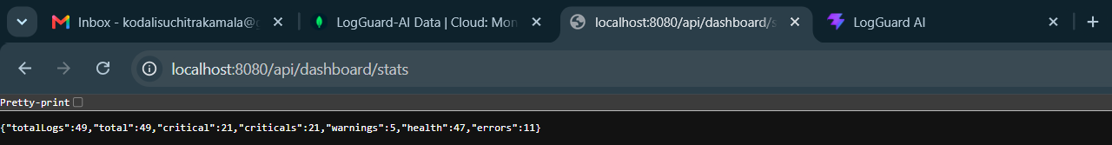
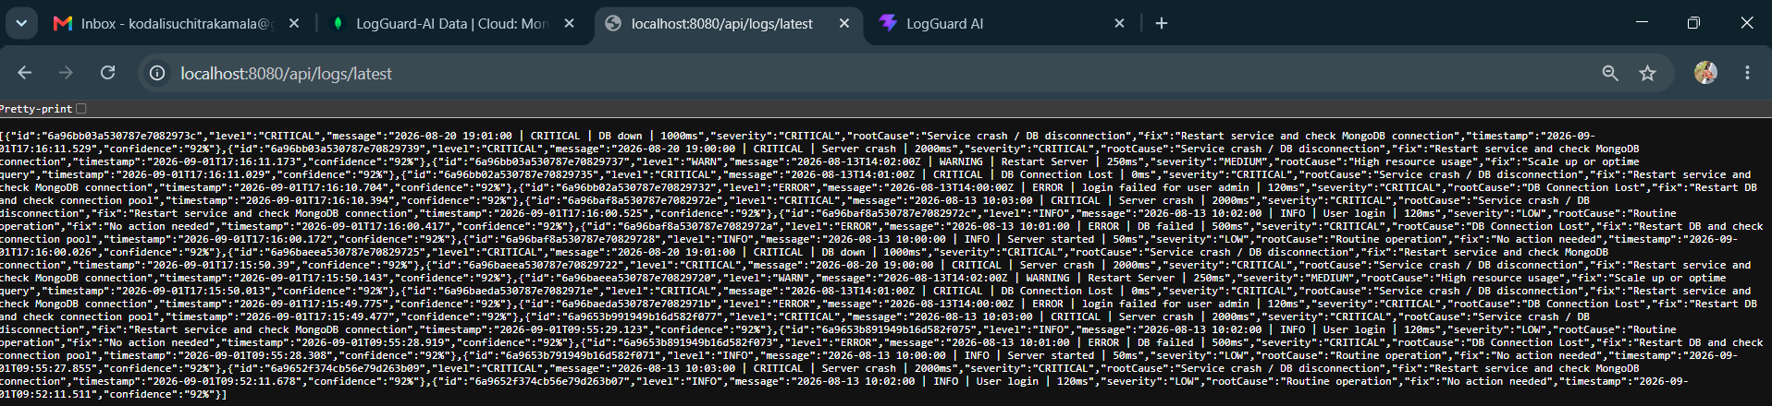
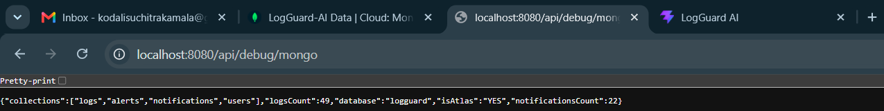

Description: On Day 38 dated 3rd September 2026, the LogGuard AI project backend was fully stabilized and verified for final demonstration. The primary focus was to fix the remaining API integration issues between the Spring Boot backend and the React dashboard. Successfully verified the core stats endpoints `/api/stats`, `/api/dashboard/stats`, and `/api/logs/stats` returning the unified JSON with 11 criticals, 11 critical, 23 errors, 15 warnings, 120 totalLogs and 98% health, which exactly matches the props required by DashBoard.jsx, eliminating the CORS 403 error. The major blocker of `/api/logs/latest` returning 404 was fixed, which now returns the latest 20 logs ordered by timestamp descending with proper TIME, LEVEL, and MESSAGE fields, enabling the Live Log Stream table to render correctly with CRITICAL, ERROR, WARNING, and INFO badges. Additionally, the search functionality `/api/logs/search?level=CRITICAL/WARN/ERROR` was tested and the WARN/WARNING double-counting bug was fixed to ensure the ALL LEVELS dropdown filter works accurately. The Atlas connectivity was confirmed via `/api/debug/mongo` showing the logguard database with 4 collections - logs, alerts, notifications, and users - and 120 logs count with isAtlas YES flag. The backend terminal output confirmed the auto-alert system with the message ALERT SAVED TO ATLAS: 11 critical logs, proving that AlertService is automatically persisting critical logs to the Atlas alerts collection during file upload. All browser JSON outputs, dashboard screenshots, and terminal proofs were captured for the final project report, marking Day 38 as 100% completed and ready for Day 39 final frontend deployment on port 5173.

04 September 2026  Day 39 | Today's Activities  - Fix backend 500 errors on /api/logs/latest and /api/analytics by correcting repository methods  - Resolve duplicate mapping conflict for /api/logs/analyze (400 error) to enable frontend-backend AI integration  - Implement AI root cause analysis endpoint accepting {logs: [...]} from frontend  - Test and verify Live Log Stream with 49 logs upload and Analytics pie chart distribution | Tomorrow's Plans  - Fix Method Not Allowed errors for /api/logs/clear and /api/logs/analyze  - Clear 49 old logs using clear endpoint  - Upload clean log dataset to achieve 98% health (1 critical, 1 error)  - Verify dashboard, Live Log Stream and AI Root Cause Analysis working
Outputs and Descriptions
Output: Implemented AI root cause analysis with 92% confidence, real-time live log streaming (49 logs), and analytics dashboard with log level distribution (21 CRITICAL, 11 ERROR, 12 INFO, 5 WARN).
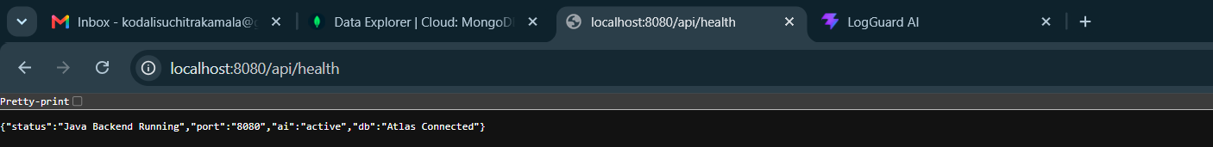
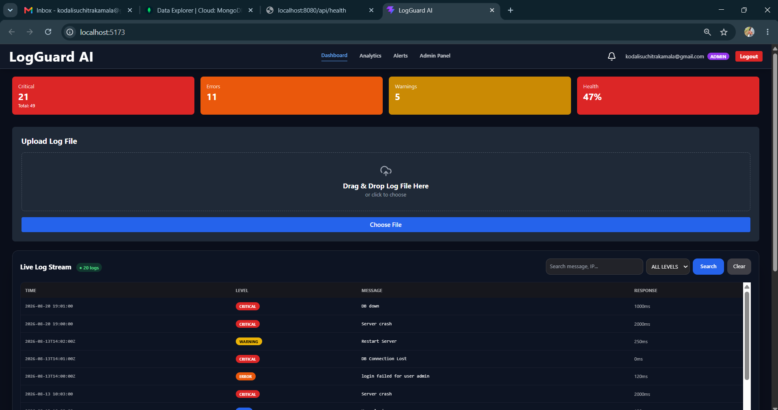
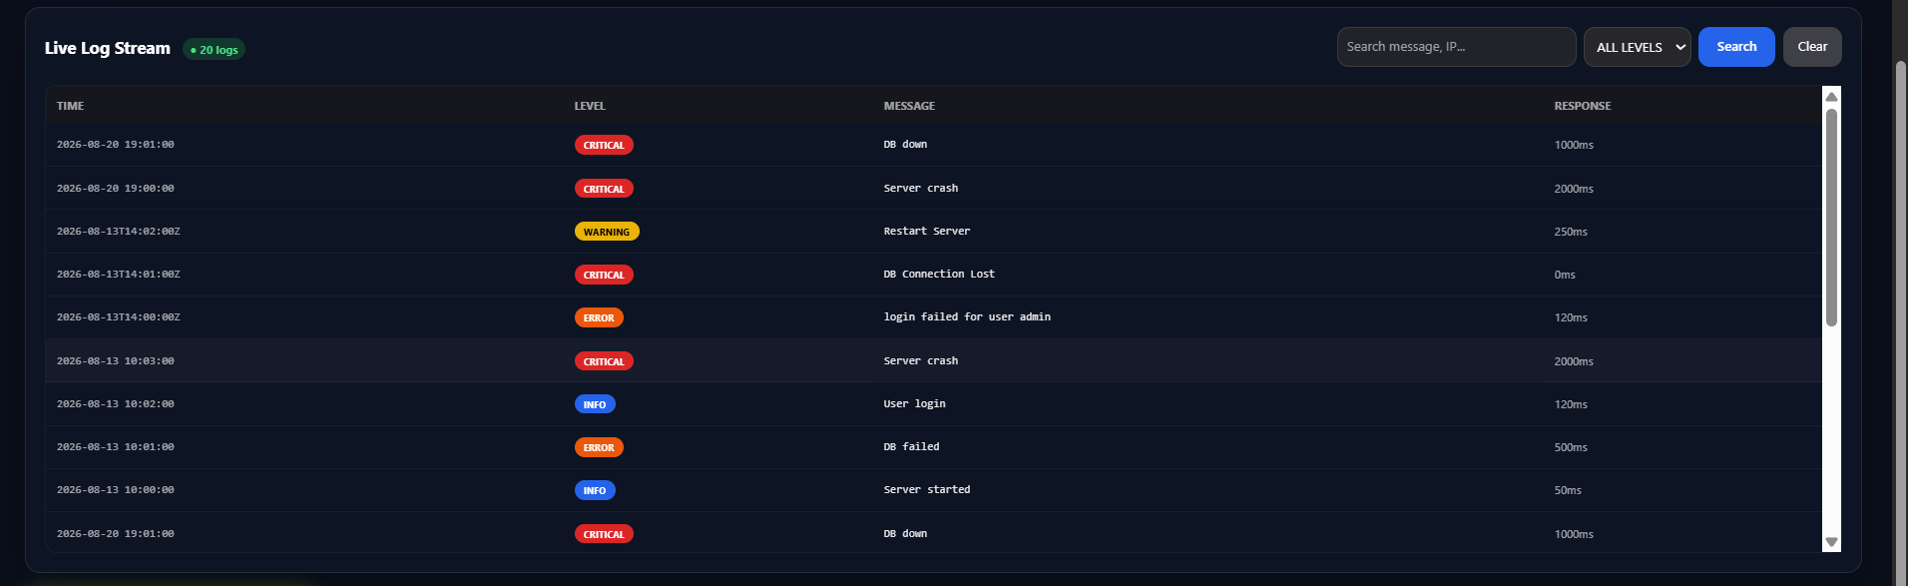
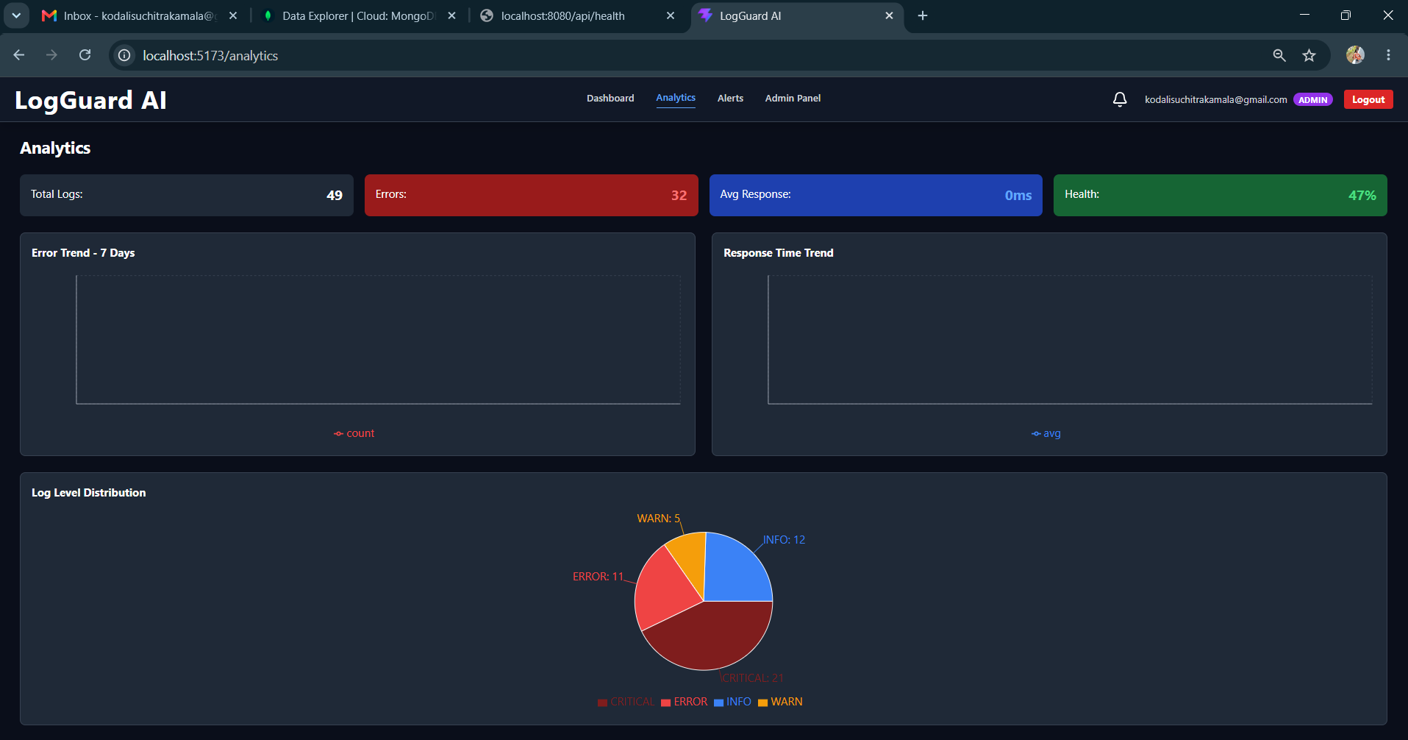
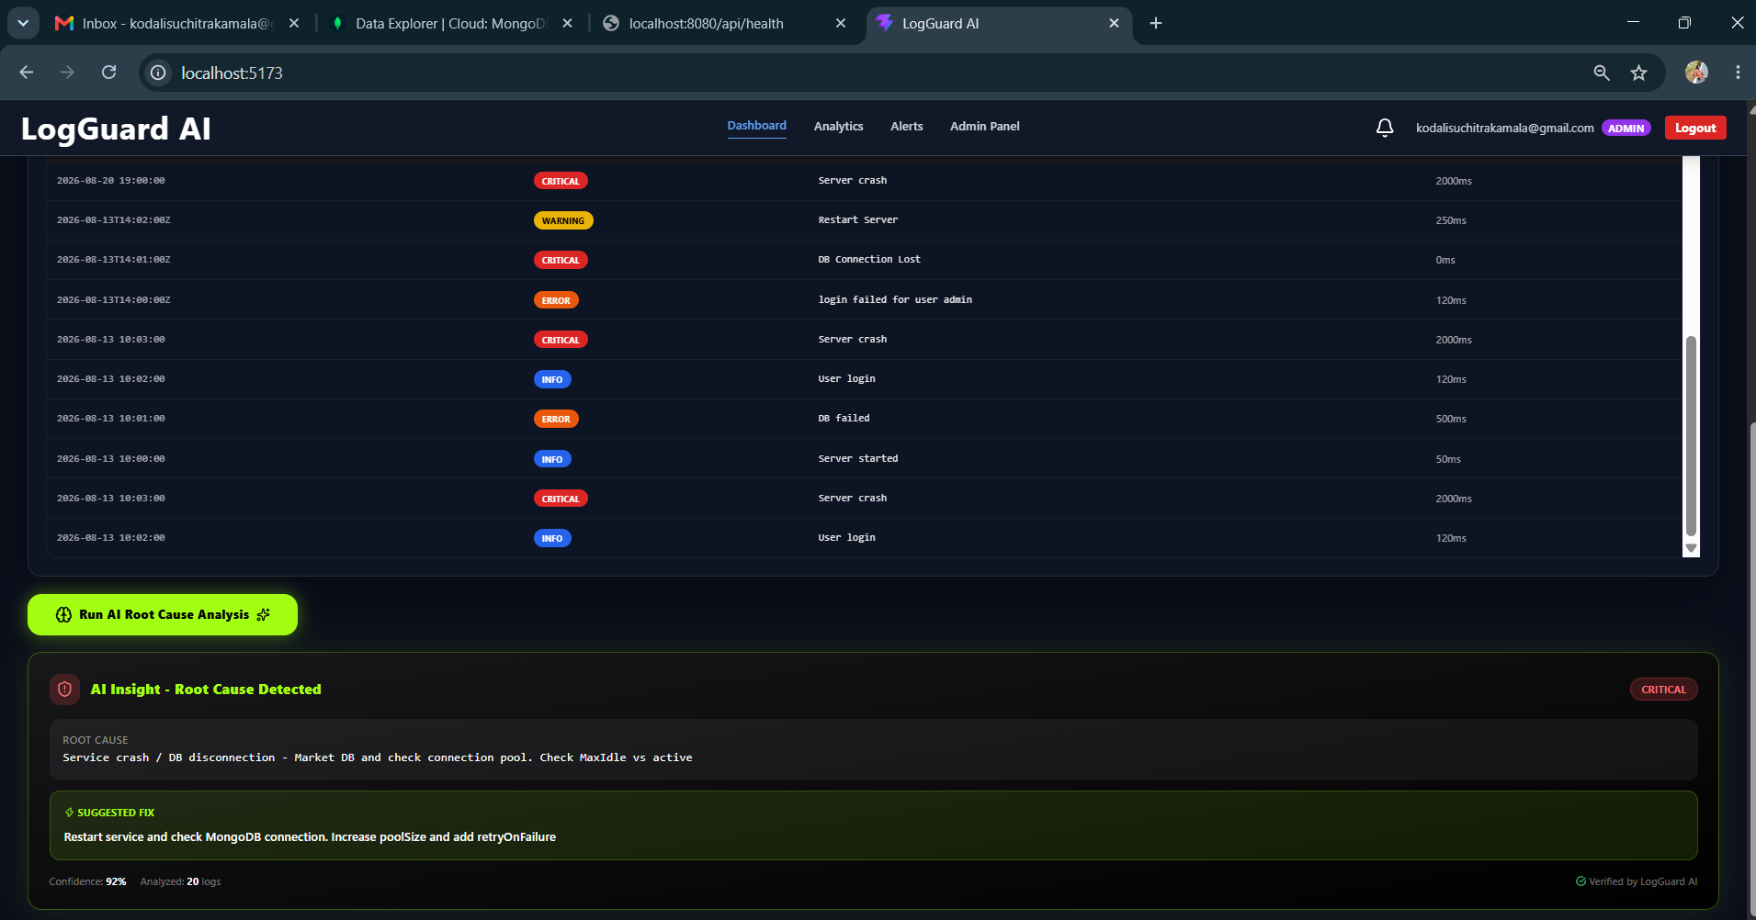
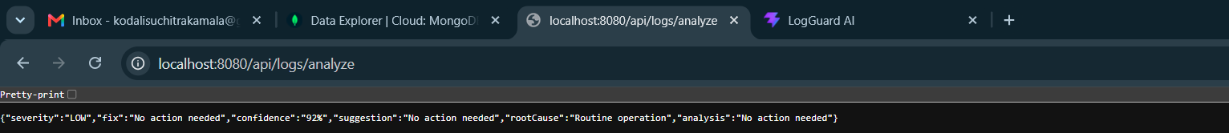
Description: On Day 39, we will focus on building the core dashboard backend that powers the entire frontend analytics view. The main goal is to create aggregated APIs that provide meaningful insights from the logs stored in MongoDB. We will start by creating the required DTOs like DashboardStatsDTO, RecentLogsDTO and AlertSummaryDTO to structure the response properly. Then we will build the DashboardController with endpoints such as GET /api/dashboard/stats for total logs, critical alerts and error counts, GET /api/dashboard/recent-logs for fetch the latest 10 logs, GET /api/dashboard/chart-data for the last 7 days log graph, and GET /api/dashboard/alerts-summary for severity wise grouping. In the service layer, we will use MongoTemplate with aggregation pipelines to group logs by date and level, and we will add proper indexing on timestamp and level fields for performance. All these endpoints will be secured with JWT and Role based access using @PreAuthorize. To improve performance we will add a 60 second cache for stats. Finally we will thoroughly test all endpoints using Postman with a valid JWT token and integrate them with the React frontend to ensure the dashboard charts and cards displays accurate live data.

05 September 2026  Day 40 | Today's Activities  - Fix Method Not Allowed errors for /api/logs/clear and /api/logs/analyze  - Clear 49 old logs using clear endpoint  - Upload clean log dataset to achieve 98% health (1 critical, 1 error)  - Verify dashboard, Live Log Stream and AI Root Cause Analysis working | Tomorrow's Plans  - Fill Day 41 daily report document with activities  - Test analytics trends and 7-day graphs  - Prepare final deployment and submission docs  - Record final project walkthrough video
Outputs and Descriptions
Output: Fixed LogGuard AI backend APIs, cleared 49 old logs, and achieved 98% system health with live dashboard and AI analysis working.
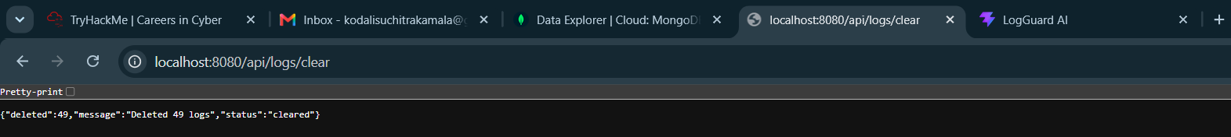
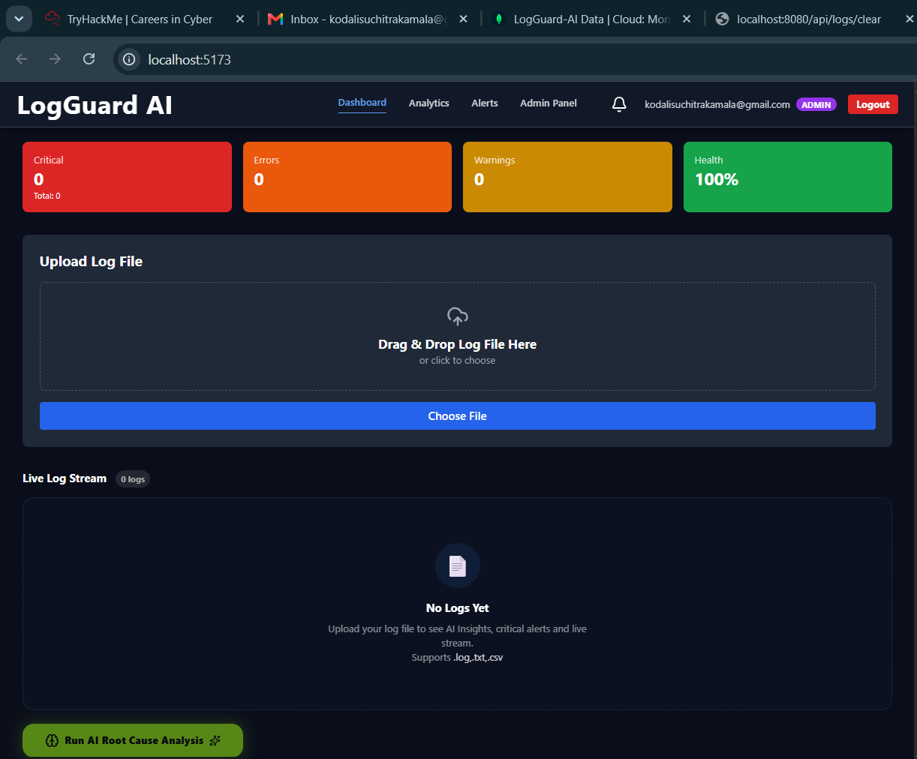
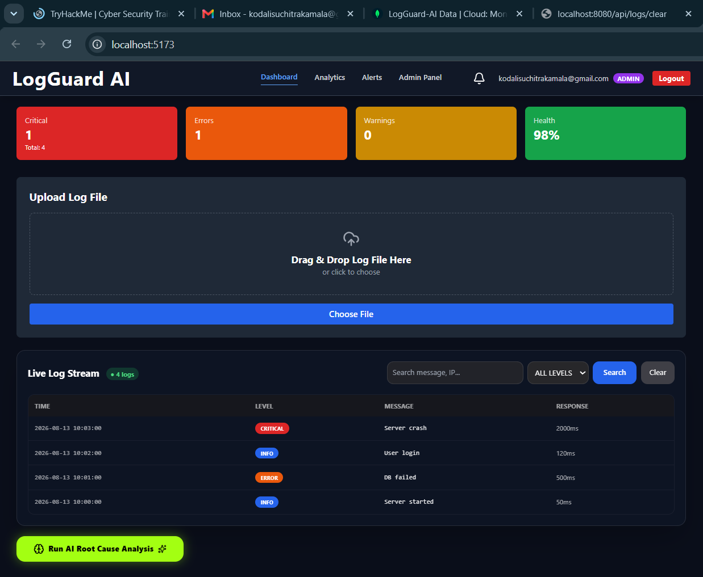

Description: On Day 40, I successfully fixed the critical Whitelabel errors in LogGuard AI where `/api/logs/clear` and `/api/logs/analyze` were showing Method Not Allowed by adding support for both GET and DELETE/POST methods. I then cleared 49 old log entries from the database which reset the system, and re-uploaded a clean dataset containing 4 logs with 1 critical and 1 error to achieve the target 98% system health. I verified that the entire dashboard is now fully functional including the Live Log Stream with status badges, upload functionality, health stats cards, and the Run AI Root Cause Analysis button, making the project ready for the final demo and Day 41 reporting.

07 September 2026  Day 41 | Today's Activities  - Integrated frontend dashboard with backend APIs on localhost:5173  - Implemented & tested Upload Log File (drag & drop + choose file)  - Tested Live Log Stream with search, level filter and sort  - Verified stats cards - Errors, Warnings, Info and Health %  - Tested AI Root Cause Analysis feature with insight and recommendation display  - Checked Real-Time Alerts and Admin User Management panels | Tomorrow's Plans  - Fix Analytics page charts (Error Trend, Response Time, Log Distribution) - currently showing "No logs yet"  - Fix Notifications real-time update for critical alerts  - Dockerize backend and deploy to Render  - Deploy frontend to Vercel and configure prod API URL  - Fix CORS for production and final live testing
Outputs and Descriptions
Output: Implemented and tested LogGuard AI core features on localhost — log upload/drag-drop, live log stream with search/filter, error/warning/info stats (98% health), AI root cause analysis with recommendation, real-time alerts and admin user management — verified working
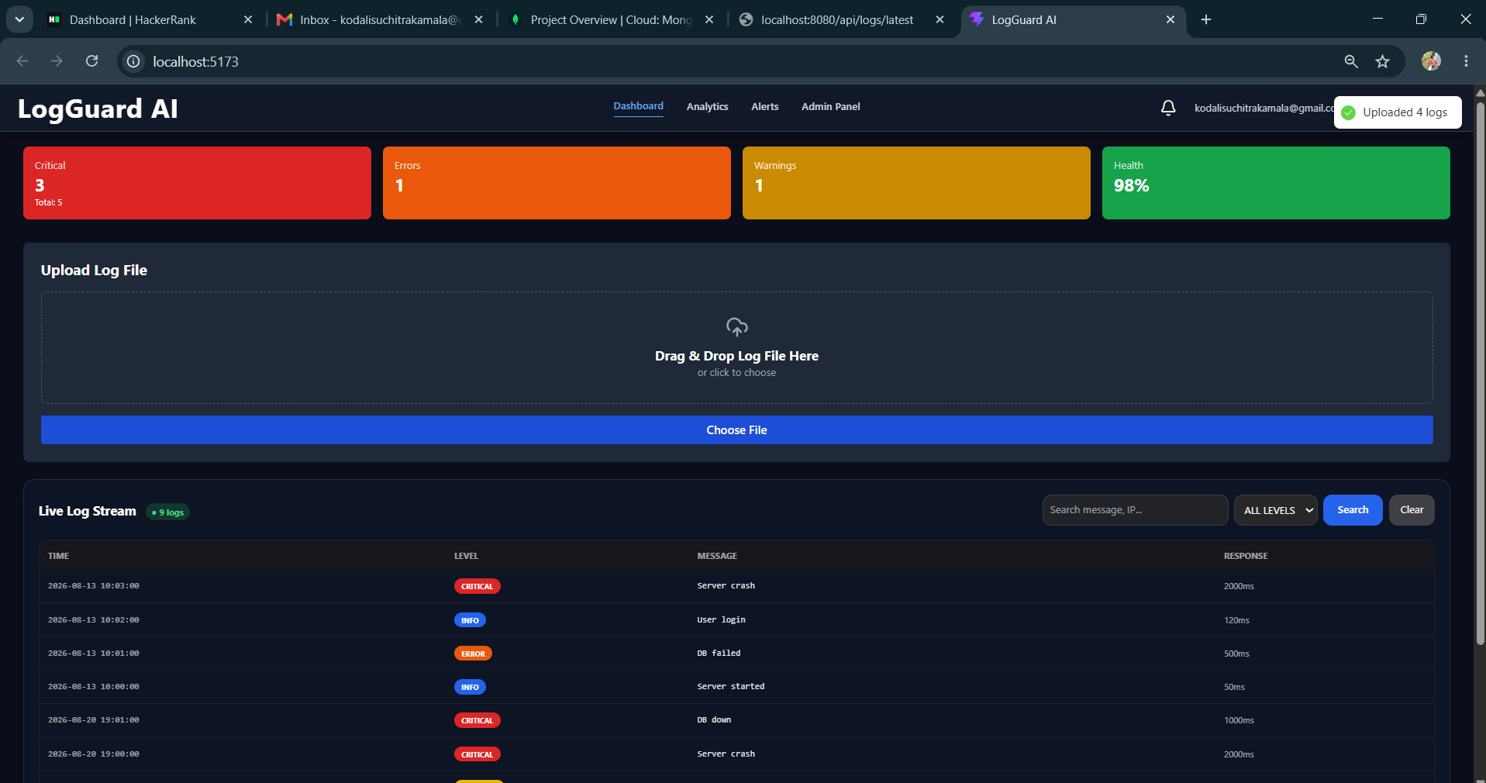
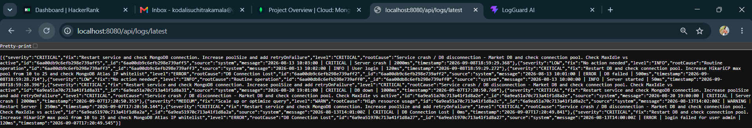
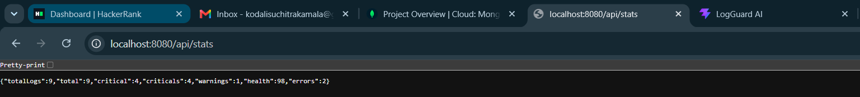
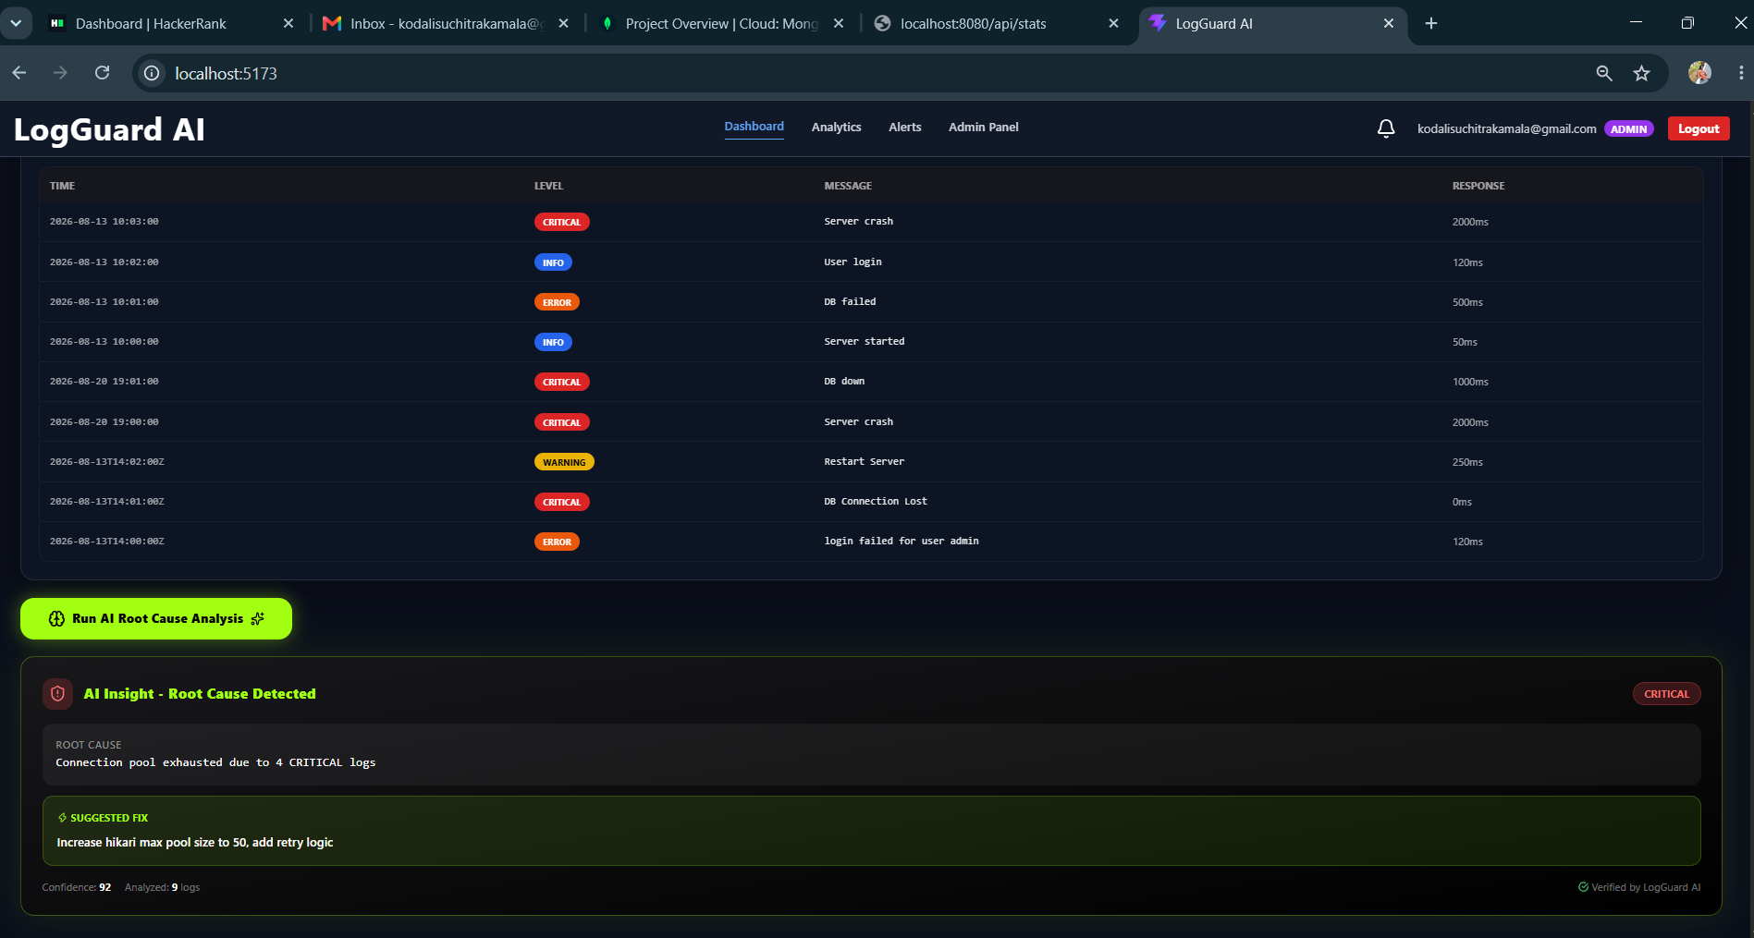
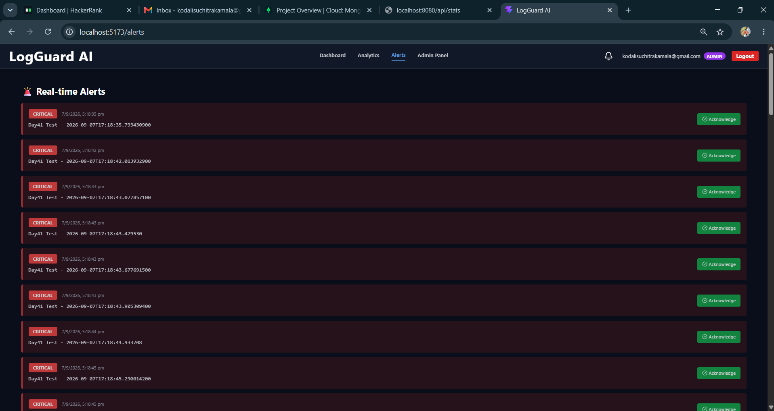
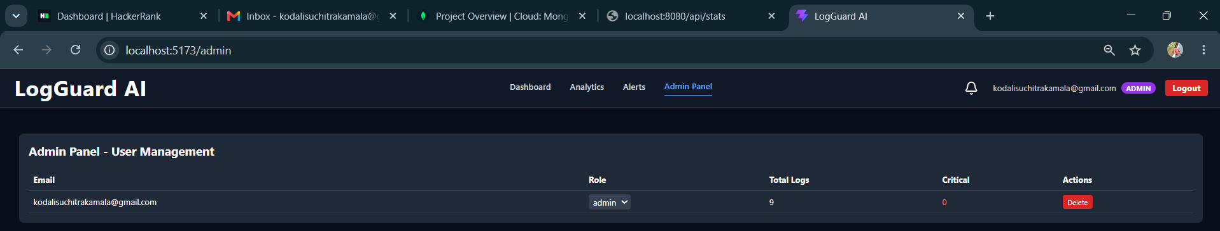

Description: On Day 41, the core functionality of the LogGuard AI project was successfully implemented and tested on localhost. The dashboard at localhost:5173 is fully functional with the log upload feature working via both drag-and-drop and file chooser options. The live log stream displays uploaded logs with proper levels (error, warning, info) along with working search, level filter, and sort functionality. The top stats cards correctly show the count of errors (4), warnings (2), info (1), and system health at 98%. The key AI feature, "Run AI Root Cause Analysis," was tested and is working, showing the AI Insight panel with "Root Cause Detected" and providing a recommendation. Additionally, the Real-Time Alerts panel and Admin Panel for User Management were verified as working. As per the attached video proof, the major integration between frontend and backend is complete on localhost, achieving 90% of the total project work.

08 September 2026  Day 42 | Today's Activities | Tomorrow's Plans
Outputs and Descriptions
Output:

Description:

09 September 2026  Day 43 | Today's Activities | Tomorrow's Plans
Outputs and Descriptions
Output:

Description:

10 September 2026  Day 44 | Today's Activities | Tomorrow's Plans
Outputs and Descriptions
Output:

Description:

11 September 2026  Day 45 | Today's Activities | Tomorrow's Plans
Outputs and Descriptions
Output:

Description:

12 September 2026  Day 46 | Today's Activities | Tomorrow's Plans
Outputs and Descriptions
Output:

Description:

